d

Animal Tracking Collar

Technical User Manual

**Prepared by:**

Ben Lawson

Ben Shewan

Collin Halamka

Collin Maker

Garrett Harris

**Submitted to:**

Dr. Paul Keenlance

Dr. Jeffrey Ward

Dr. Bruce Dunne

EGR 485/486 Senior Project

Spring/Summer Term 2019

**June 2019**

**[This page intentionally left blank]**

**Table of Contents**

**1. Manual and Device Overview** **5**

Mechanical Hardware 5

Electrical Hardware 5

Software and Programming 5

**2. Mechanical Fabrication and Assembly** **6**

2.1 3D Printing enclosure. 7

2.2 Gasket cutting 12

2.3 Enclosure Assembly 14

2.5 Collar Belting Manual Cutting 18

2.6 Collar Belting Laser Cutter Setup 23

2.6 Collar Belting Sleeve Fusing 23

2.7 Dying of Collar Muted Earth Tone 29

2.8 Collar Assembly To Enclosure 30

2.9 Adjusting Device Collar 33

2.10 Stud Plate Fabrication 34

2.11 Epoxy Pouring and Curing of PCB into Enclosure 38

2.12 Small Collar Fabrication (Epoxy Coating, Shrink Tubing, and Fastening) 41

2.12.1 Epoxy Potting - (follow procedure 2.11 above for preparation instructions) 41

2.12.2 Battery and Antenna Placement 43

2.12.3 Shrink Tubing 44

2.12.4 Strap Assembly 45

**3. Electrical Fabrication, Assembly, and Verification** **47**

**3.1 Hardware Overview** **54**

3.2 Board Population/Production 54

3.4 Flashing Microcontroller Firmware 55

3.5 Flashing VHF Beacon Software 59

3.5.1 Hardware Required for Programming 59

3.5.2 Software Required for Programming 60

3.5.3 Hardware Required for Testing 61

3.5.4 Setup for Programming VHF Beacon 62

3.5.5 Programming the VHF Module 64

3.5.6 Testing the VHF 70

3.5.7 Software Downloads for VHF 72

3.6 Setting Device Parameters and Navigating GUI 74

3.7 Software Overview 75

# 1. Manual and Device Overview

This user manual details the technical reproduction, assembly, and setup of the 2019 Wildlife GPS Tracking Collar Device. The device constructed by the senior project team focused on the ability to accurately track the location of wildlife such as Bobcats and the alike. This manual details the fabrication of components, assembly of parts of the device, flashing/uploading software with given parameters, and debugging the device in times of faulty operation if needed.

## Mechanical Hardware

The mechanical enclosure, collar, and fasteners were designed to be easily constructed in-house, or outsourced to a third party vendor. The materials and components chosen for the makeup of the design, and the design of the collar itself are intended to minimize weight, while still optimally performing under the operational conditions. The mechanical fabrication and assembly section (2.0) details how to construct the enclosure and collar, and how to assemble all of the physical components to obtain the final device.

## Electrical Hardware

The electrical hardware was designed to operate under optimum conditions while minimizing the footprint of the printed circuit board (PCB). The printed circuit board and components chosen were found to be of optimal performance given the specifications stated in the detailed design documentation. The electrical fabrication, assembly, and verification section details how to combine all of the chosen electrical components onto a printed circuit board, and how to verify their functionality.

## Software and Programming

Software of the device was written to ensure that each of the functions of the electrical components operates as it is intended to; without error. Some parameters are easily modifiable within the code of the device, but others are unchangeable after flashing the device with the given software version. This section details operational and performing functions of the software written by the team, as well as how to configure parameters for the device and flashing the software onto the device.

# 2. Mechanical Fabrication and Assembly

All mechanical fabrication and assembly of the parts are detailed in this section of the manual. Starting at the raw materials and fasteners to the completion of the collar. In order to obtain an optimally constructed collar, the following items and tools at the quantities shown should be on hand before starting fabrication or assembly. The necessary sources, or vendors, of the components/items needed for mechanical construction are given in the following table:

**Table 1:** BOM for Mechanical Assembly

|  |  |  |
| --- | --- | --- |
| 750G CARBON FIBER ABS FILAMENT | 1 | [MatterHackers](https://www.3dxtech.com/carbonx-carbon-fiber-abs-3d-printing-filament/) |
| 0.6MM NOZZLE | 1 | [MatterHackers](https://www.3dxtech.com/mk8-hercules-a2-hardened-steel-nozzle/) |
| ENCLOSURE (If printing was outsourced) | 1 |  |
| BELTING | 1 | Sparks Belting: Ultra Kool I (Part #: 03-133) |
| Antenna STRAP (If laser cutting was outsourced) | 1 |  |
| Short STRAP (If laser cutting was outsourced) | 1 |  |
| Epoxy Pigment Dye | 1 | [US Composites](http://www.uscomposites.com/pigments.html) |
| STUD PLATE | 1 | [McMaster Carr](https://www.mcmaster.com/93580a415) |
| 8-32 LOCKING NUT | 2 | [McMaster Carr](https://www.mcmaster.com/90715a009) |
| M3X20 SHCS | 4 | [McMaster Carr](https://www.mcmaster.com/91352a115) |
| M3X6 SHCS | 2 | [McMaster Carr](https://www.mcmaster.com/91239a111) |
| M3 LOCKING NUT | 4 | [McMaster Carr](https://www.mcmaster.com/94205a220) |
| M3 NUT | 2 | [McMaster Carr](https://www.mcmaster.com/90591a250) |
| GASKET | 1 | [Rubber-Cal](http://www.rubbercal.com/sheet-rubber/epdm-rubber/closed-cell-rubber-blend.html) |
| EPOXACAST 650 | 1 | [Smooth-On](https://www.reynoldsam.com/product/epoxacast-650/) |
| PCB (Populated) | 1 |  |
| BATTERY | 1 | [Digi-Key](https://www.digikey.com/product-detail/en/tadiran-batteries/TL-5903-S/439-1014-ND/512516) |
| 6-32X3IN FASTENER | 2 | [Ace Hardware](https://www.acehardware.com/departments/hardware/screws-and-anchors/machine-screws/77133) |
| 6-32 LOCKING NUT | 2 | [McMaster Carr](https://www.mcmaster.com/91831a007) |
| NEODYMIUM DISC MAGNET |  | [McMaster Carr](https://www.mcmaster.com/7048t52) |
| NEEDLE NOSED PLIERS | 1 |  |
| LEATHER PUNCH | 1 |  |
| HEX OR ALLEN KEY METRIC SET | 1 |  |
| PHILLIPS SCREW SCRIVER | 1 |  |
| 3D PRINTER W/ MK8 EXTRUDER & GLASS BED | 1 | JGAURORA A3 WITH MARLIN FIRMWARE |
| ELMER’S PURPLE GLUE STICK | 1 |  |
| LEATHER HOLE PUNCH | 1 | [General Tools Leather Hole Puncher](https://www.generaltools.com/hole-punch) |
| RAZORBLADE/EXACTO KNIFE | 1 |  |
| PRINTED STENCILS FOR STRAP & GASKET | 1 |  |
| STIRRING STICKS |  | MANY |
| PIPET | 1 |  |
| SHRINK TUBING (1.5in Ø X 1ft) | 1 | [McMaster Carr](https://www.mcmaster.com/7856k64-7856K641) |

## 

## 2.1 3D Printing enclosure.

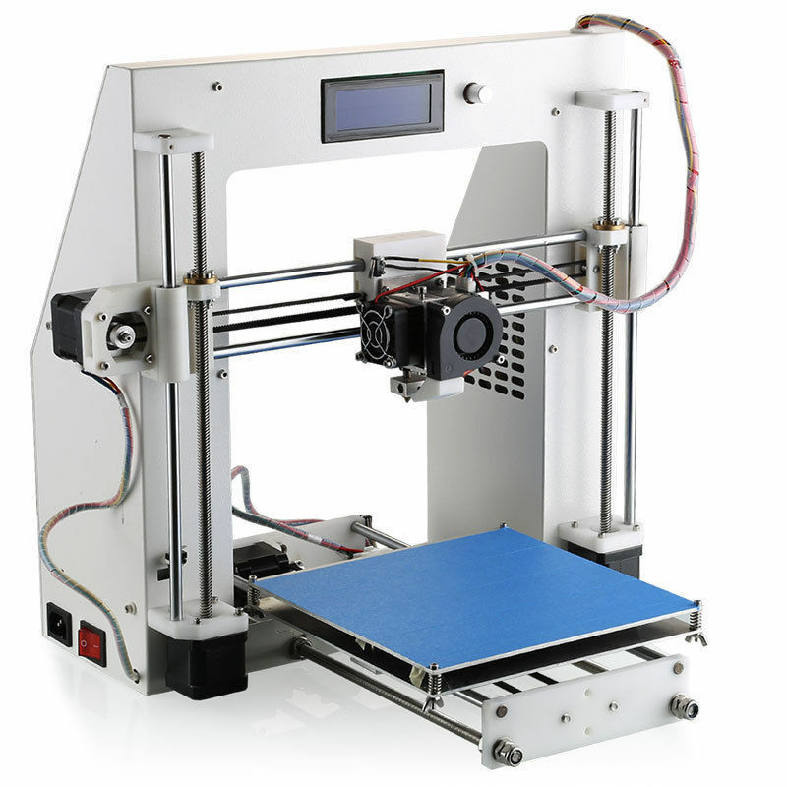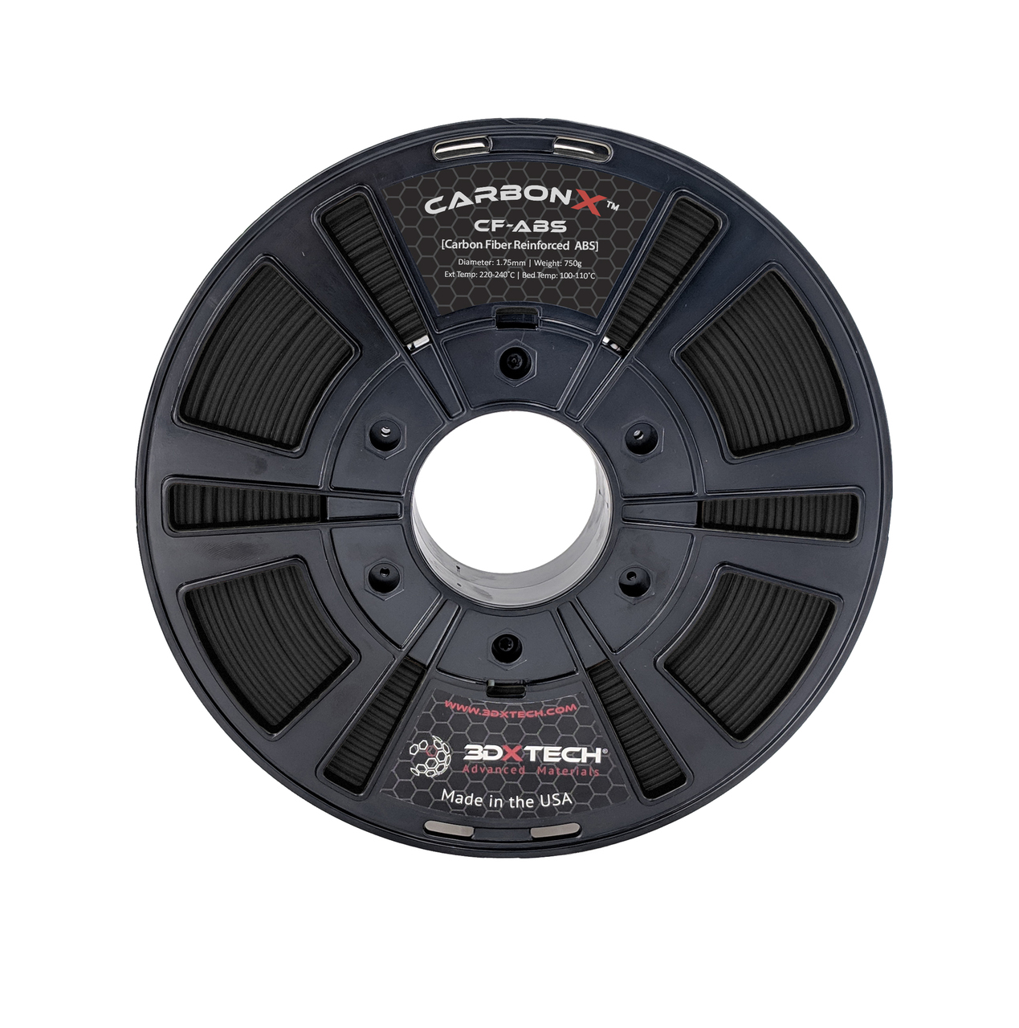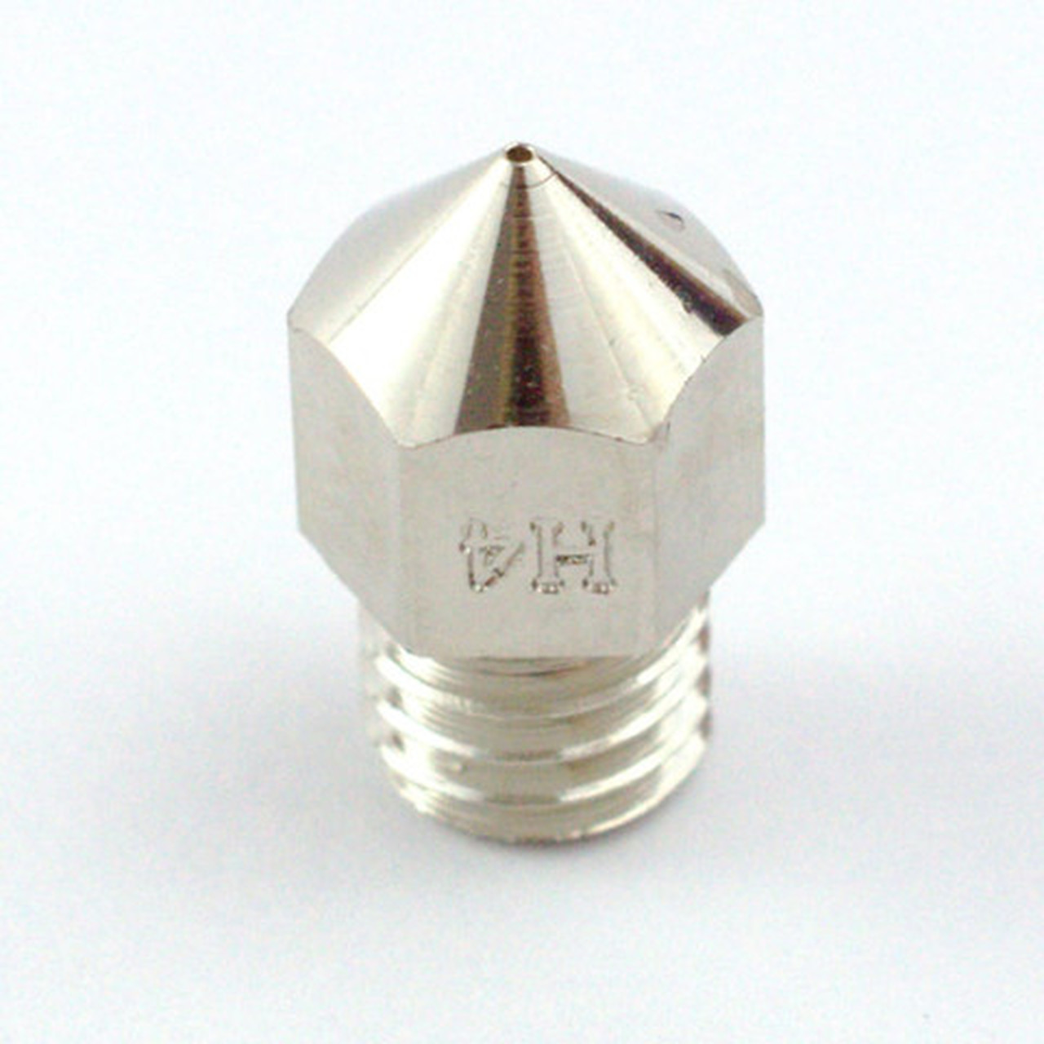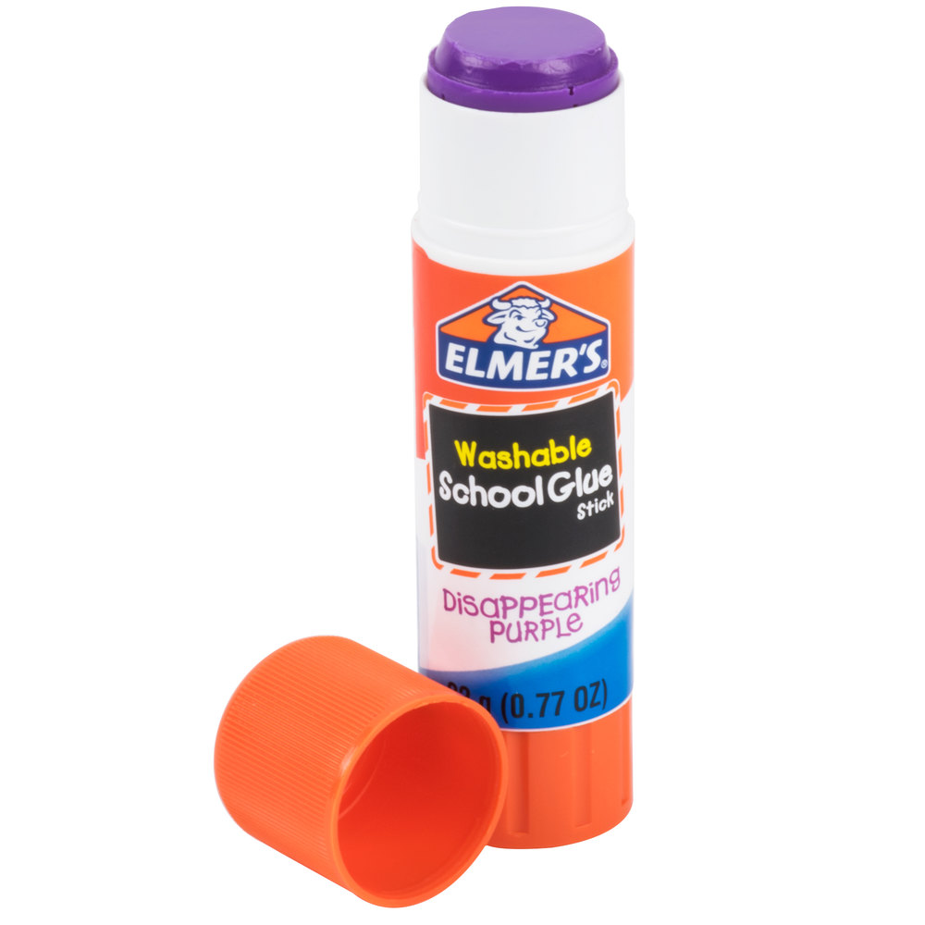

**2.1.1** To print the enclosure a 3D printer able to each a build platform temperature of 100C and a hot end capable of maintaining 245C is required. The current design was printed using the JGAurora A3 printer, any printer that meets these specifications should be capable. The extruder on the JGAurora A3 is an MK8 direct drive extruder with a 26 toothed hob gear. Hobs with smaller teeth may gather filament dust and slip when extruding. The filament will adhere best to a glass plate treated with Elmer's purple glue stick. A glass plate may be added to a printer with an aluminum bed using 4 small binder clips. The carbon fiber filament from 3DXTech can also print on kapton tape, or a glass bed with an abs slurry, though these methods were not tested. A hardened steel nozzle with a diameter of 0.6 mm is required when printing with the carbon fiber filament.

**2.1.2** Cura slicer settings must be changed. It is recommended that a new printer profile is made when using the new nozzle. Changing the nozzle size in the printer settings as shown below. The nozzle temperature recommended setting is 245C, bed temperature 100C, supports enabled, printing with rafts is recommended. Be sure that the slicer is set to print with 100% infill. The Cura profile used can be found along with the STL files in the documentation. Please refer to these settings before printing.

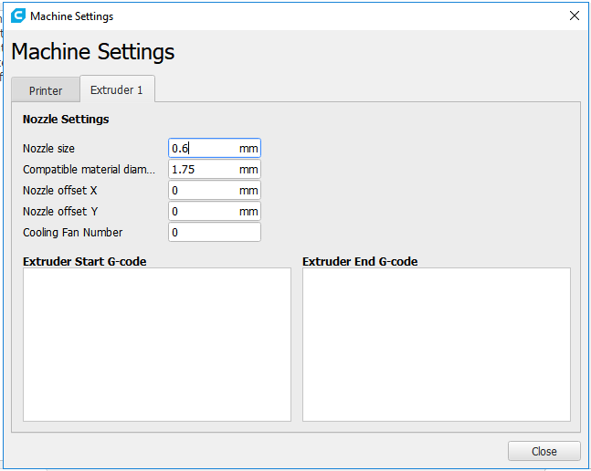

**Figure 1.** Cura machine profile settings to change nozzle to appropriate size.

**2.1.3** The STL files to be printed can be found with this documentation. The two files, ‘3D Printed Concept Bottom.STL’ and ‘3D Printed Concept Lid 11.STL’ can be processed using the Cura slicer software. Supports must be enabled. The lid will print without supports. The Bottom will print face down and will require support for most overhangs. SOME SUPPORTS MUST BE MANUALLY BLOCKED. The supports in the long through holes for the 6-32 fasteners and the supports inside the holes for the M3 nuts must be blocked. This can be achieved using Cura support blocker tool.

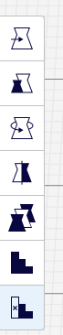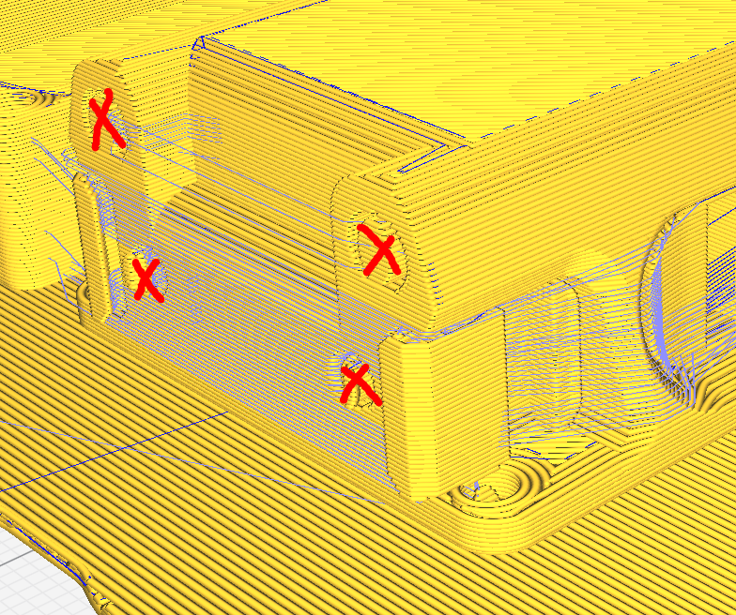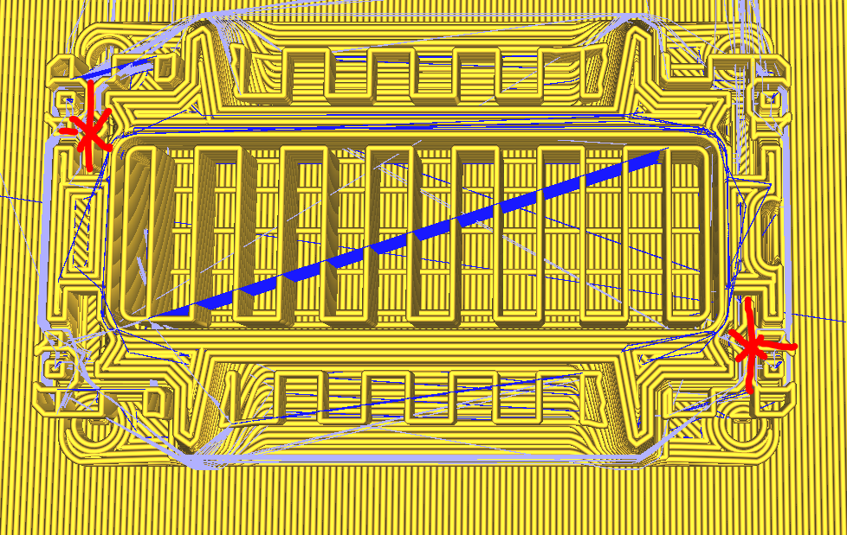

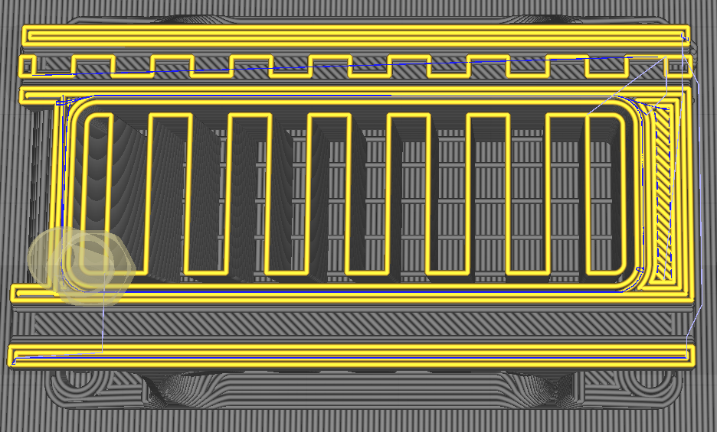

**Figures 2, 3, 4.** The above images show: 1. The support blocker tool button in the sidebar, 2. and 3. The locations of the supports that must be blocked marked in red (must be blocked on both ends), and 4. Properly blocked support not being visible while an improperly blocked support will still be shown in “Preview”.

**2.1.4** Export the file by saving it to the SD card for your printer. (Some printers are networked and can be printed from the computer.**)**

**2.1.5** Now that the slicer has created the g-code, the printer must be prepared. Ensure that the build plate is clean and free from debris. Add adhesive to the build plate as needed. Be sure the nozzle and hot end are clean. Printing inside an enclosure is recommended to help maintain a constant temperature during printing to prevent warping. The door on the enclosure can be left open if the ambient temperature becomes too hot. Be sure the fumes from the ABS can be properly vented, a large box fan in a window to increase air changes per hour can be used.

**2.1.6** Put the SD card in the printer and select the g-code created to start the print. The printer will take some time to heat up. Observe as the print starts to make sure that the extruded filament is adhering to the surface of the build plate. Poor adhesion can result in print failure and warping. Sometimes lowering the print speed can help with print bed adhesion and quality.

**2.1.7** The print will take hours to finish. When complete let the build platform cool and remove the print. Use proper safety gloves and glasses to prevent injury during post processing. The supports can be removed using needle nosed pliers, tweezers, a dental pick, and file. Take care when removing supports as to not damage the structure of the enclosure. A razor blade may also be necessary to separate the print from the raft. Printing at a high temperature allows for better layer adhesion, but can cause the raft to become stuck.

**2.1.8** Dispose the support material responsibly. Clean up any unsightly parts of the print with some sand paper. Ensure that the printer has cooled down completely and shut off the machine. Enclosure production is now complete.

**2.1.1.1 3D Printed Hall Effect Sensor Clip (For both Medium and Small Collar Clips)**

**2.1.1.2** The hall effect sensor clip can be printed using any color PLA filament. The STL file is provided and will clip onto the medium collar enclosure. Open Cura Slicer and set the profile to PLA. Orient the as shown in the image below. Be sure to enable supports.

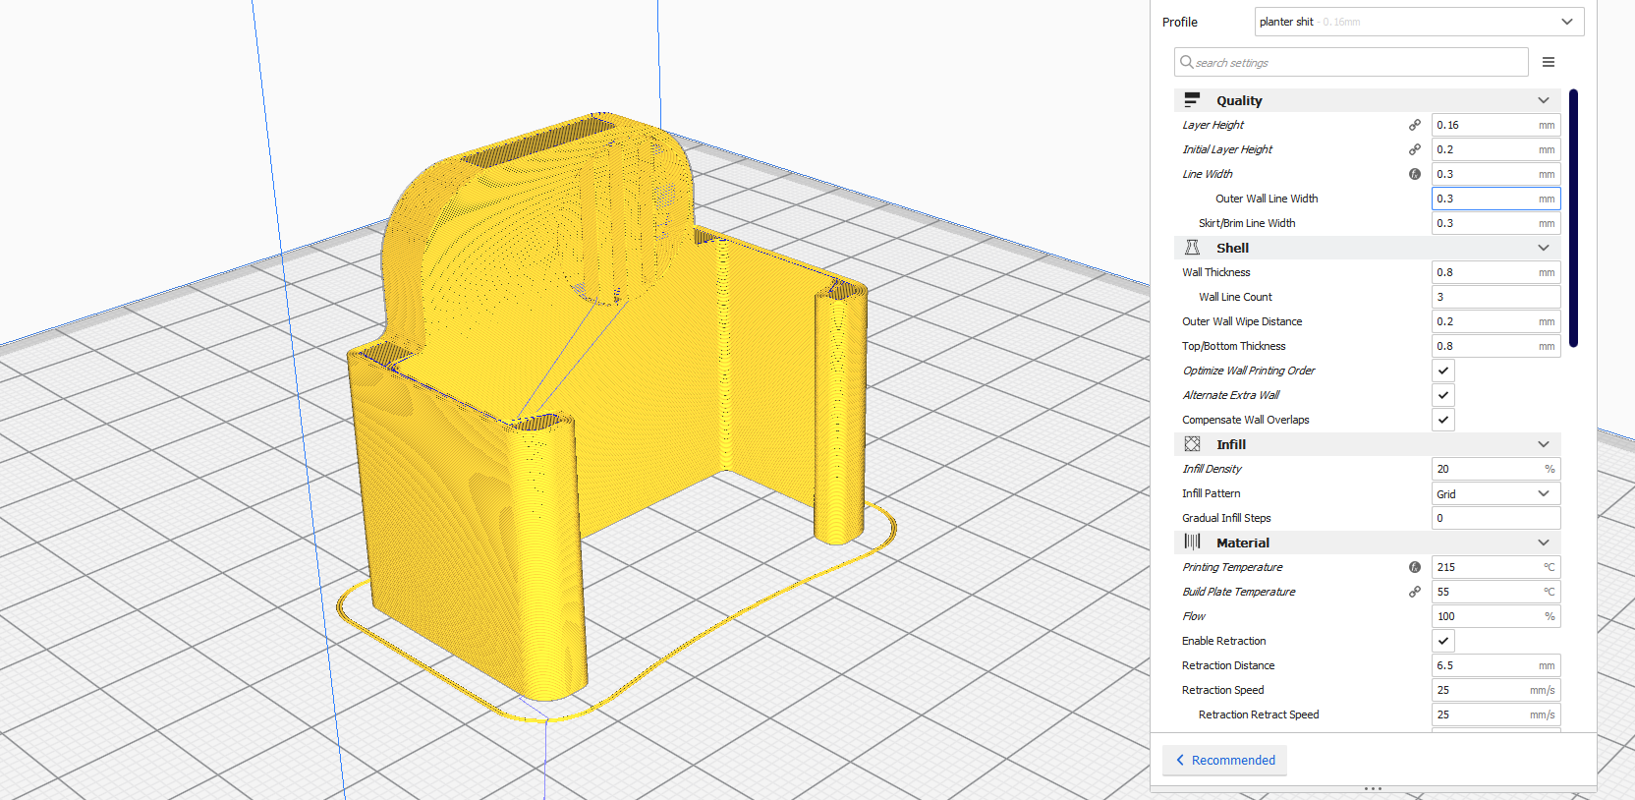

**Figure 5.** Orientation for strongest clip shown in Cura slicer, supports enabled..

**2.1.1.3** Save the g-code to the SD card for your printer, or send it over the network. Start the print. The print platform used for this design was a heated aluminum bed, at 55C, covered in blue painters tape. The nozzle was set to 215C. See profile used in additional documentation.

**2.1.1.4** When the print completes remove the clip from the print platform. Remove the small supports in the magnet pocket. Dispose of plastic supports responsibly.

**2.1.1.5** If the magnet used does not have adhesive, add a small dab of adhesive to the back of the magnet, superglue can be used, and force fit the magnet into the pocket until flush. The hall effect sensor clip is now complete.

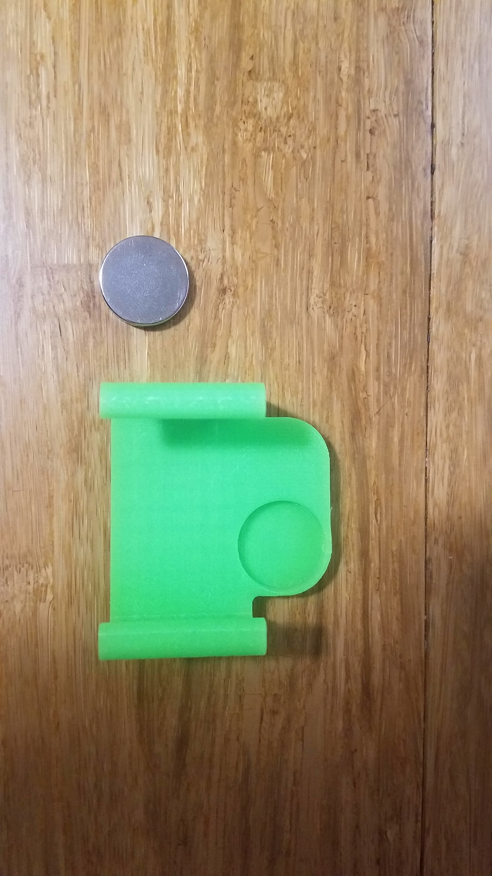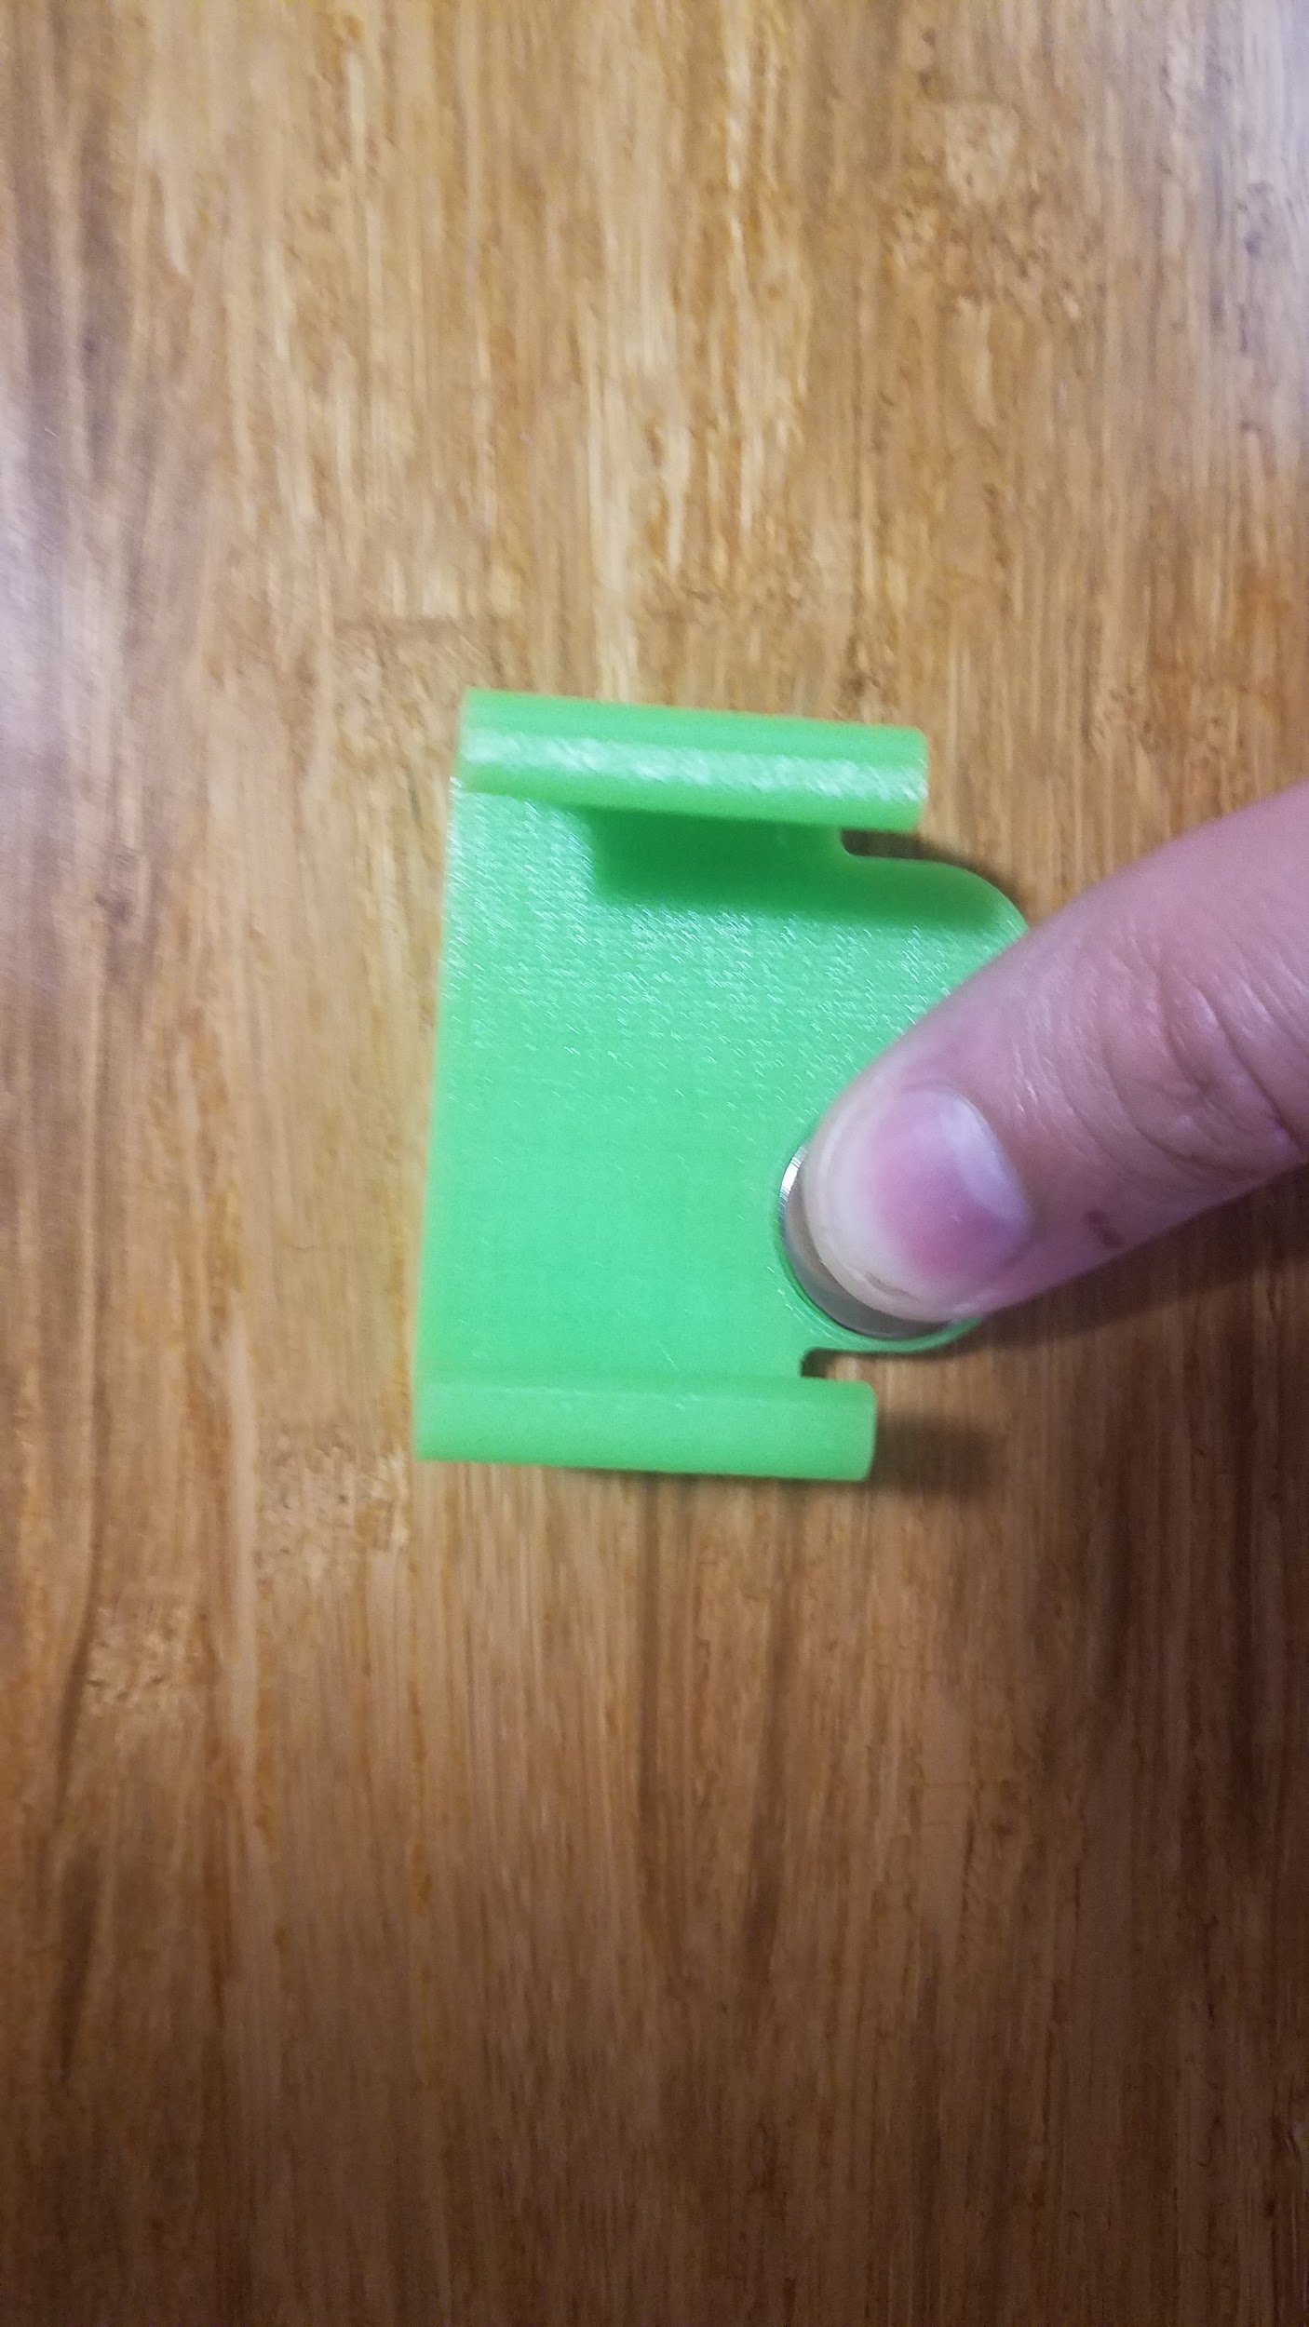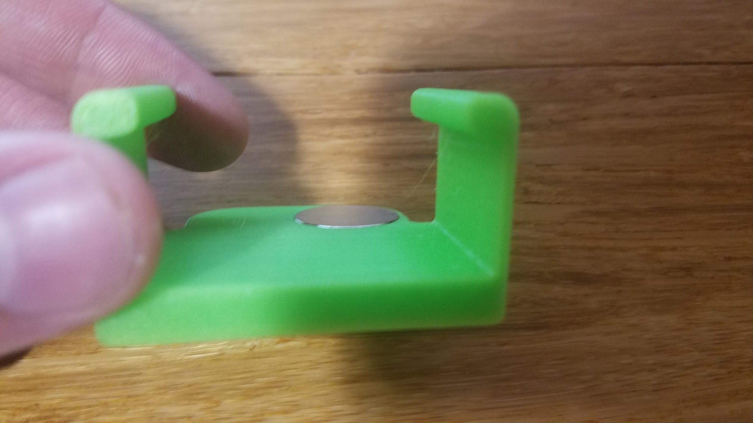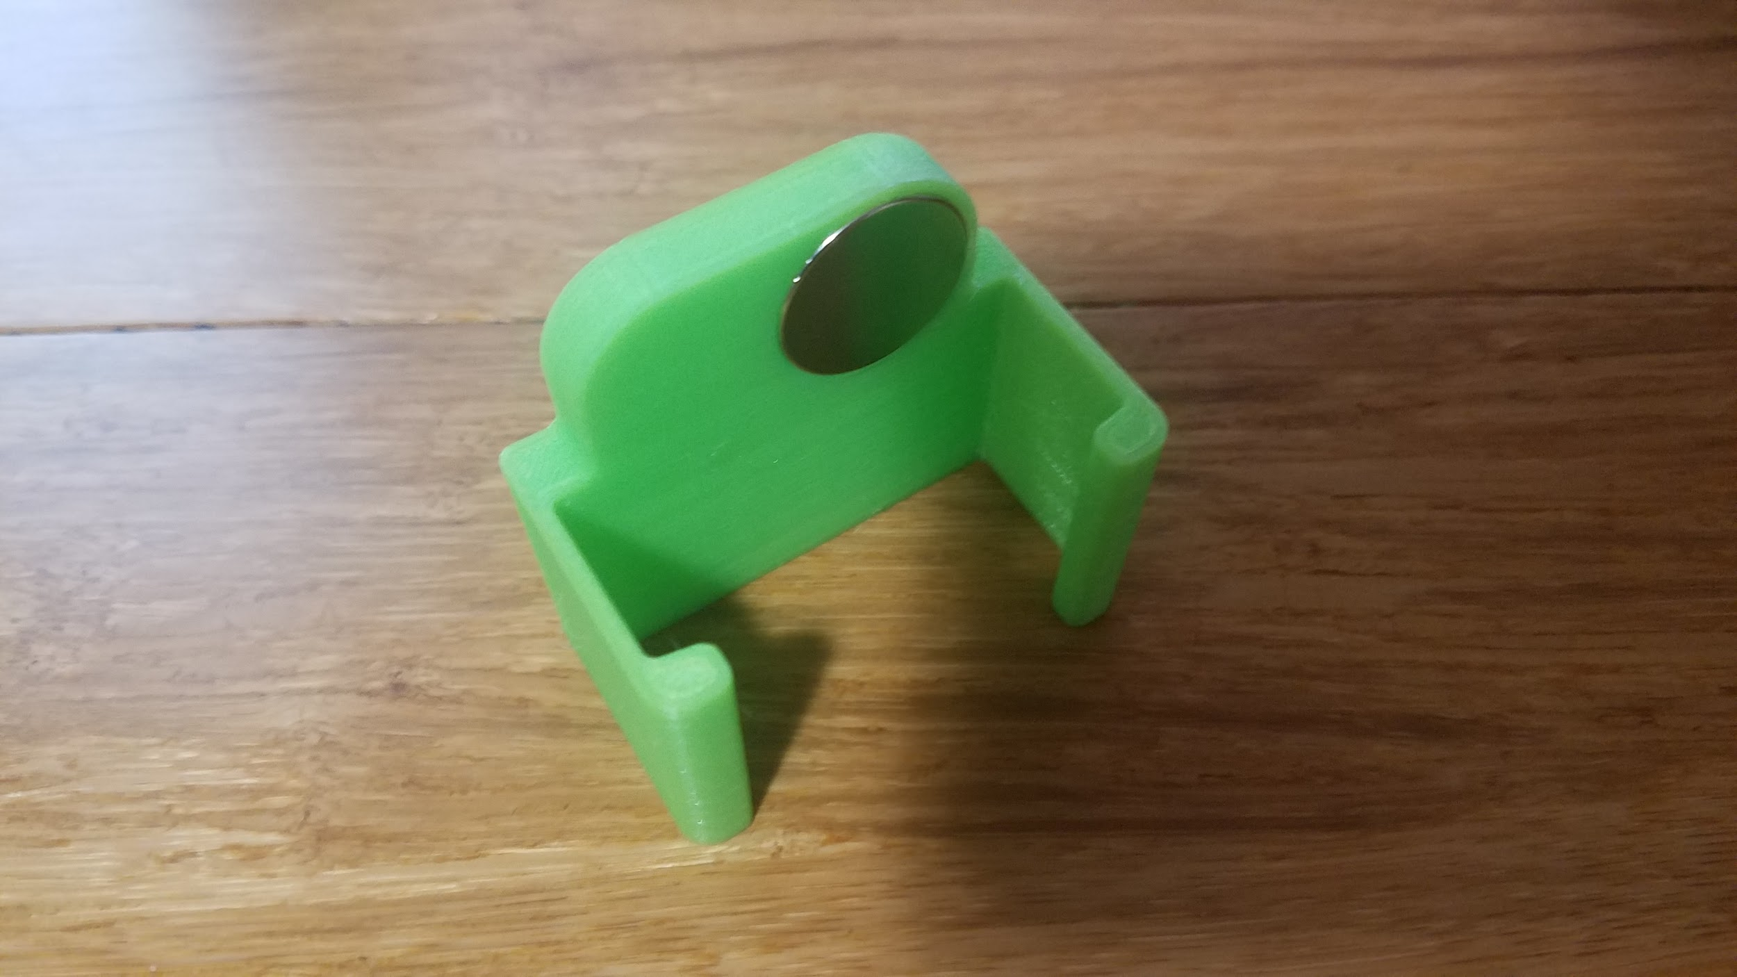

**Figures 6,7,8,9.** Top Left: Magnet and clip. Top Right: Magnet being forced into pocket. Bottom Left: Magnet in place and flush with surface. Bottom Right: Complete Hall sensor clip.

## 2.2 Gasket cutting

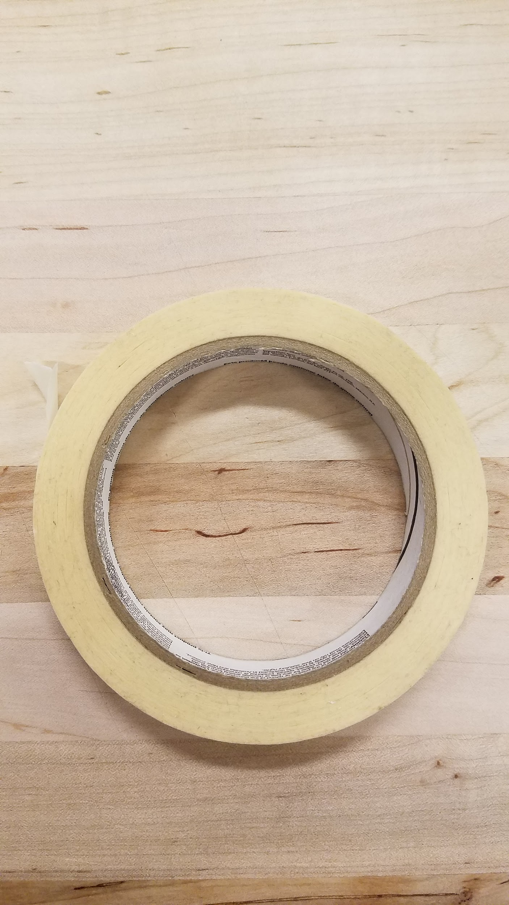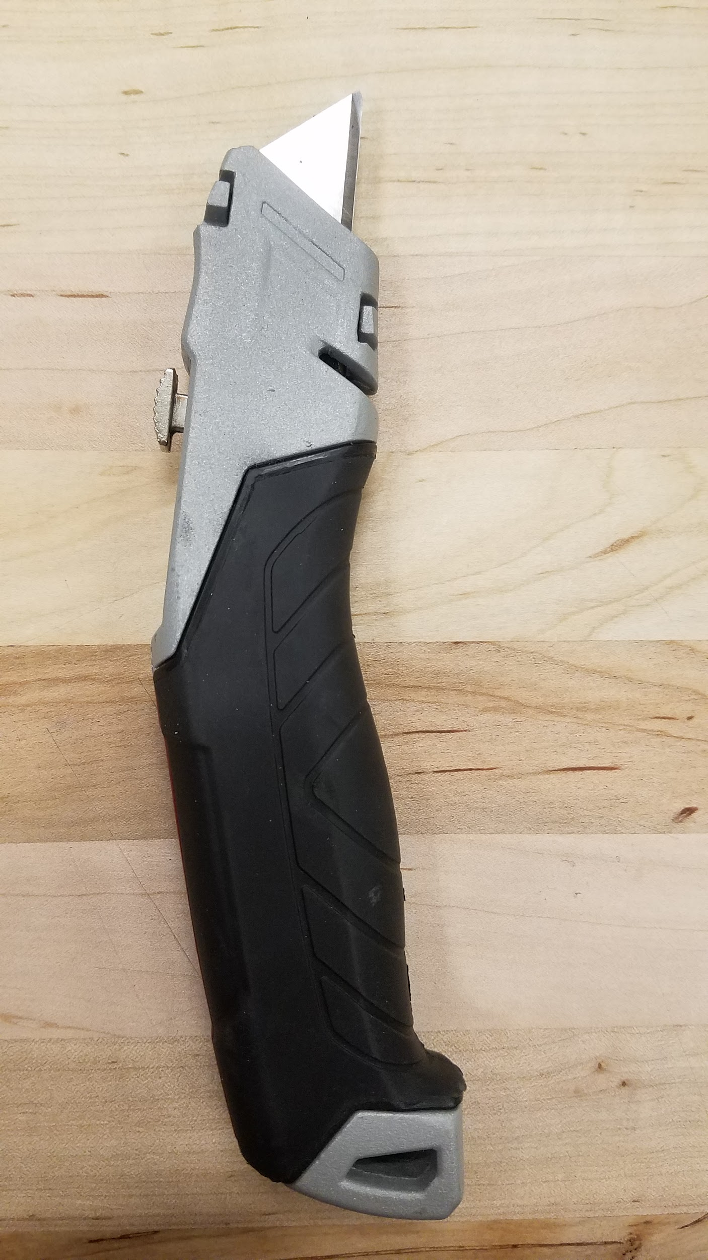

**2.2.1** Print out stencil for EPDM gaskets at 1:1 scale. Use a masking tape to adhere the stencil to the EPDM rubber. The stencil is created by printing a 1:1 drawing of the epdm gasket for a single part. For cutting multiple parts at one time, print ‘Gasket stencil.pdf” at 1:1 scale.

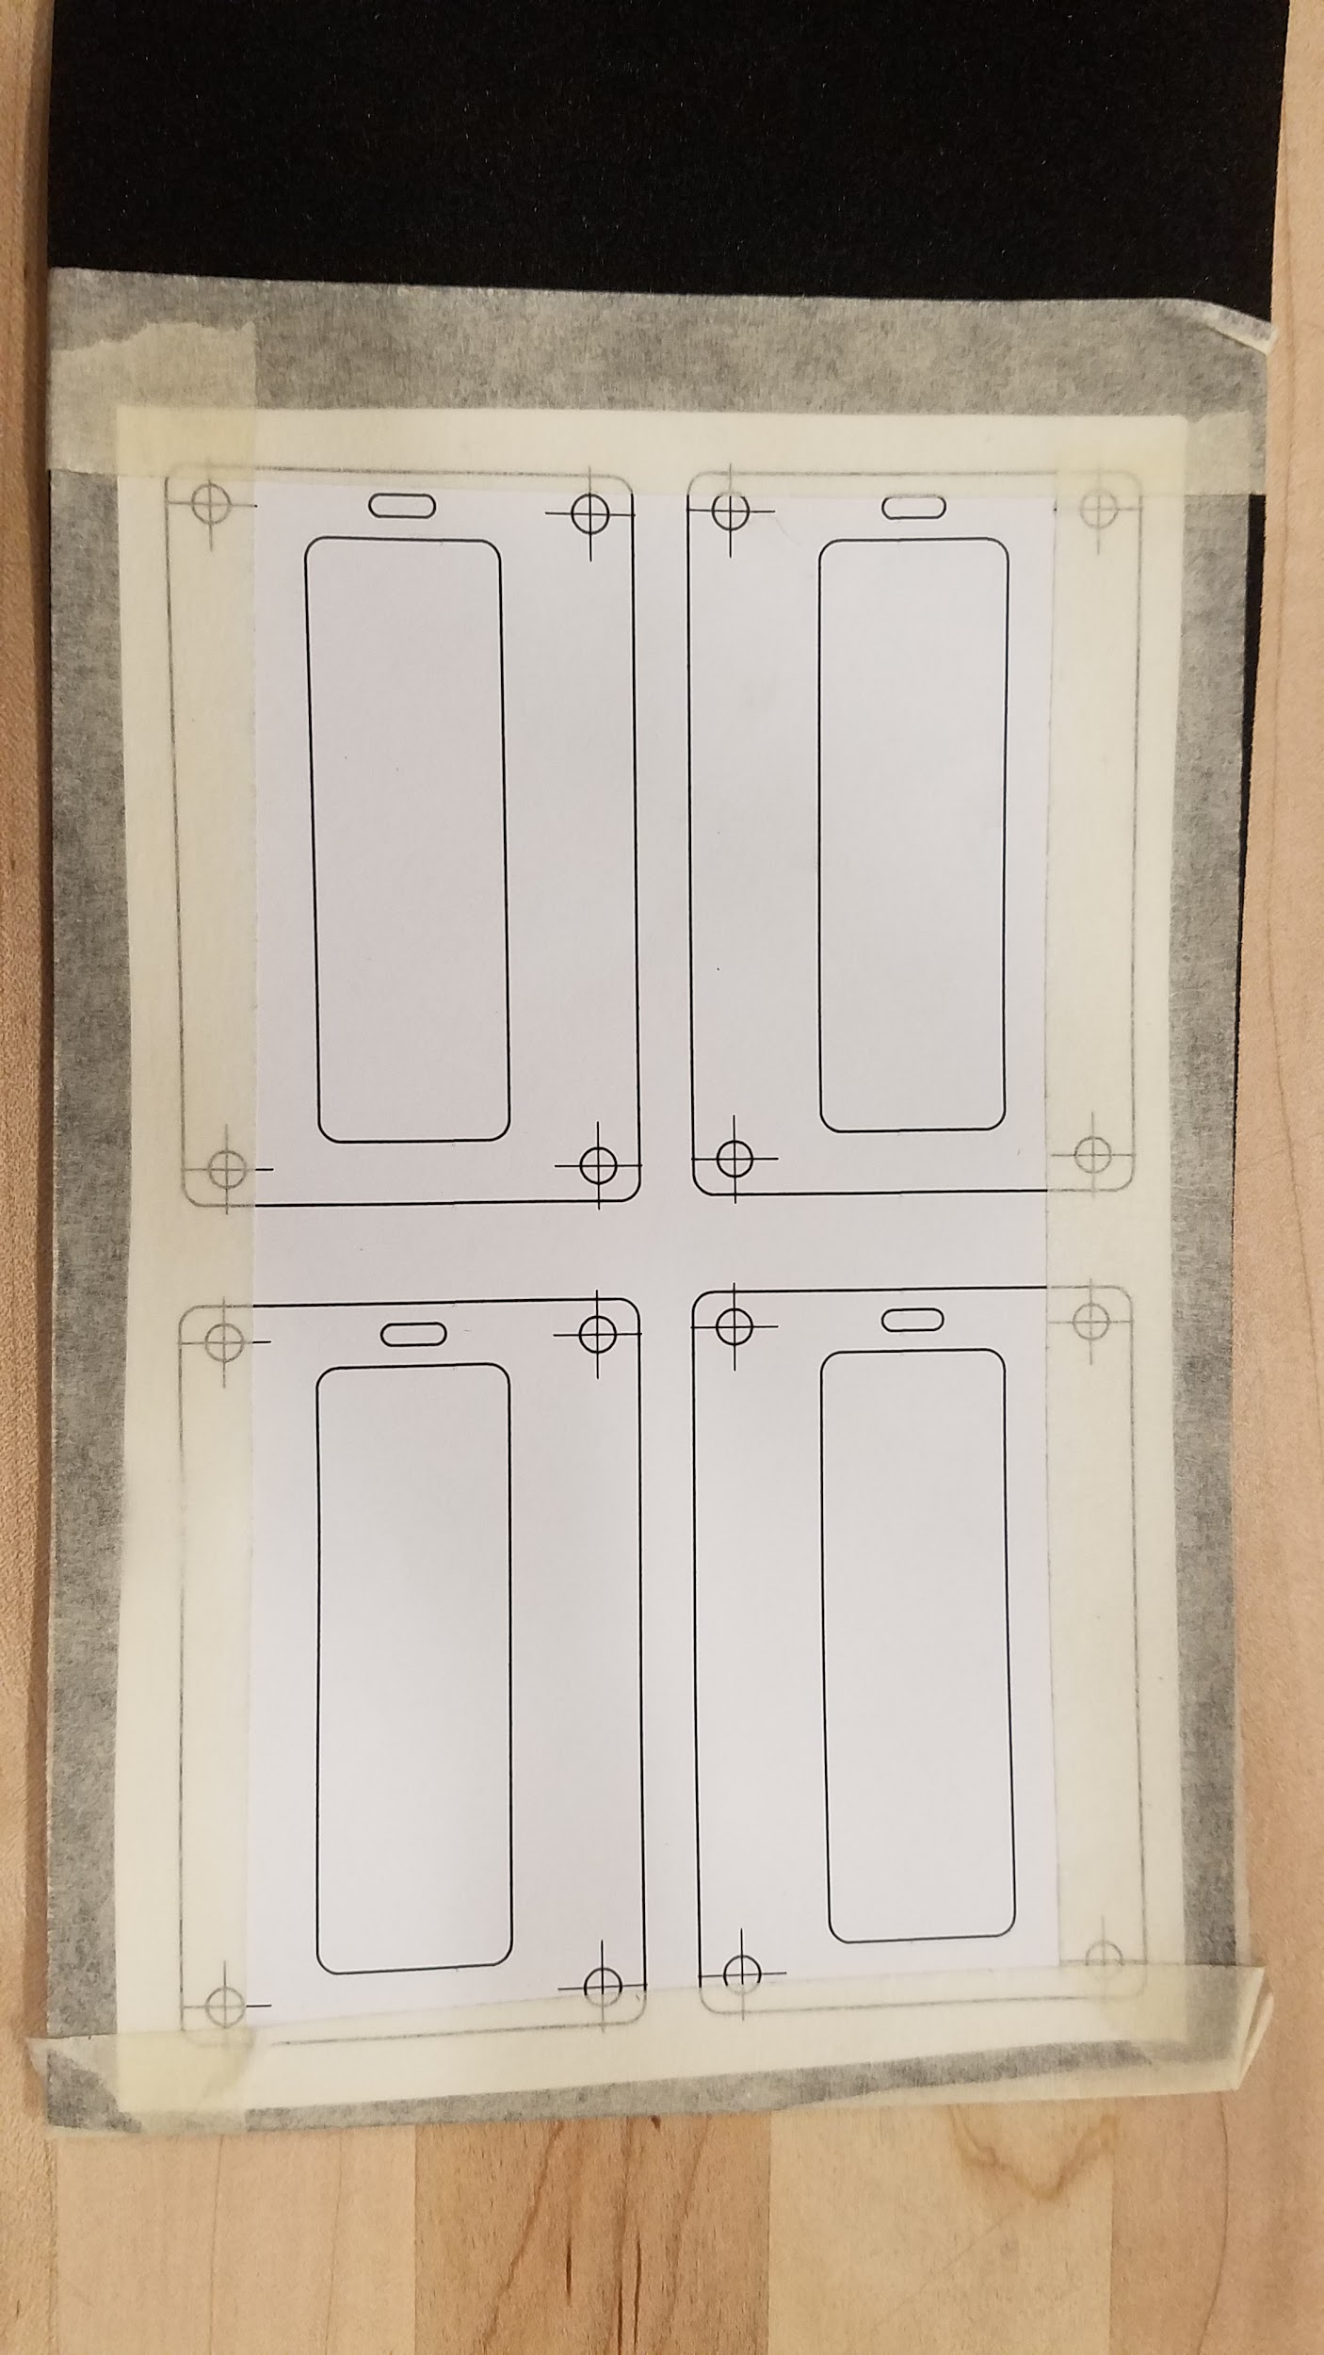

**Figure 10.** EPDM gasket stencil adhered to material

**2.2.2**Carefully cut around the stencil perimeter and large pocket with a razor blade. Be sure to not warp the gasket as you cut. Cut the slot for the three antennas.

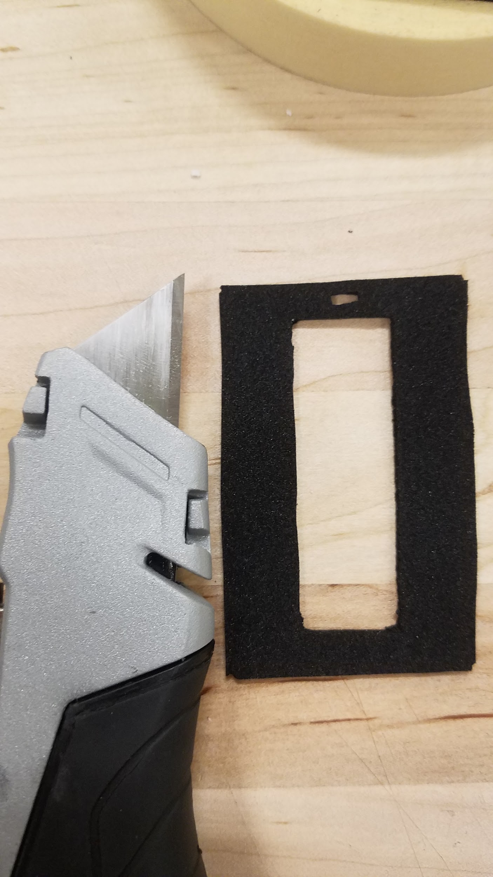

**Figure 11.** EPDM gasket perimeter and pocket cuts

**2.2.3**Center the gasket on the lid and push the m3x20 fastener through the gasket into the four holes on the lid. This acts similar to a punch, creating a perfect hole for the fasteners.

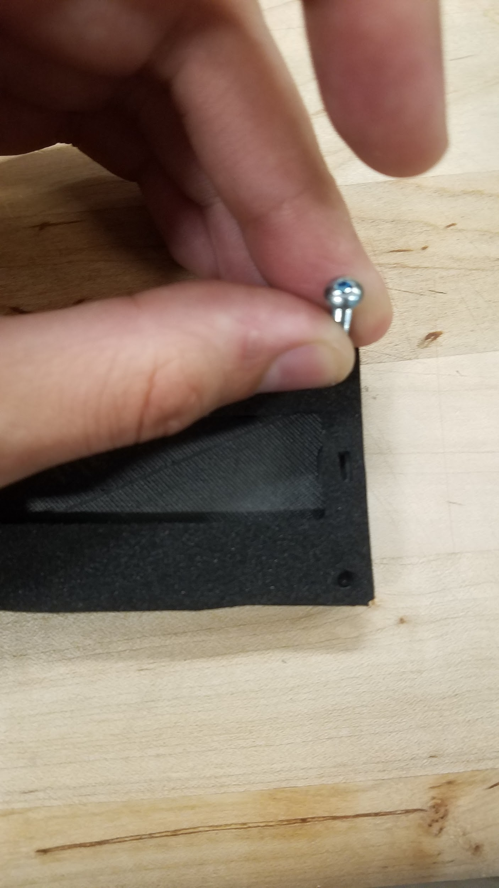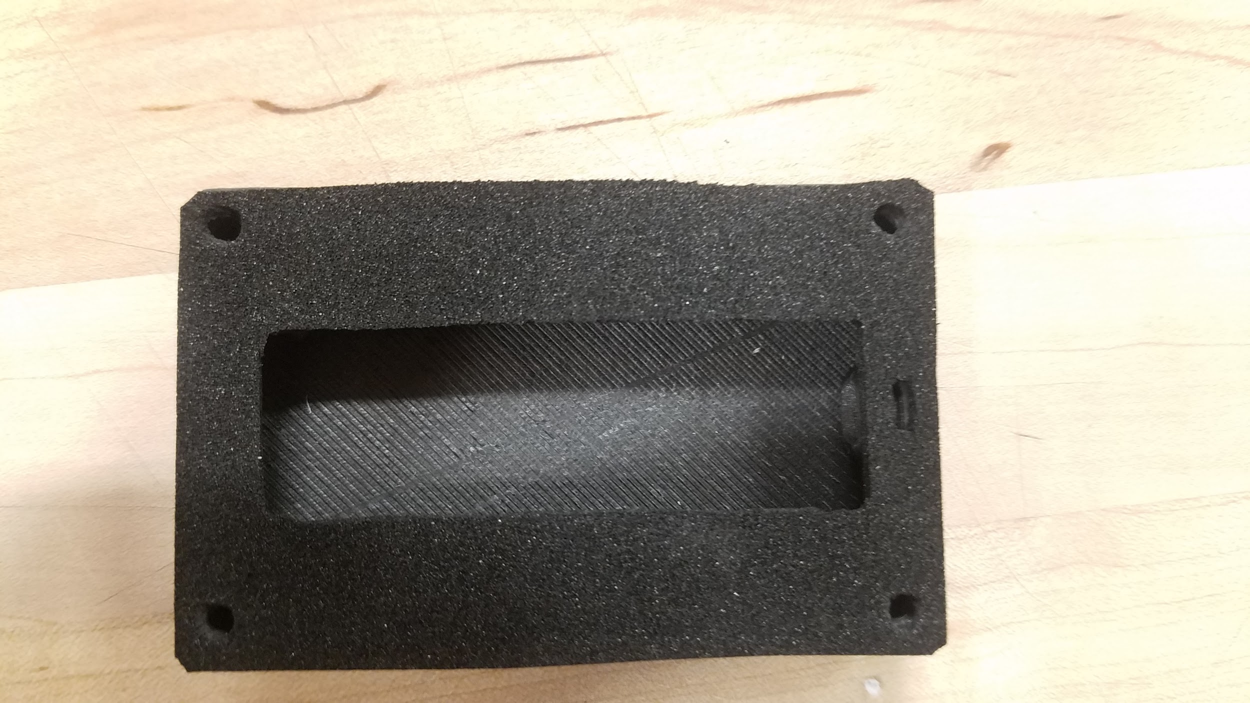

**Figure 12,13.** EPDM gasket complete

## 

## 2.3 Enclosure Assembly

**2.3.1** Gather the tools, components and fasteners needed for assembly.

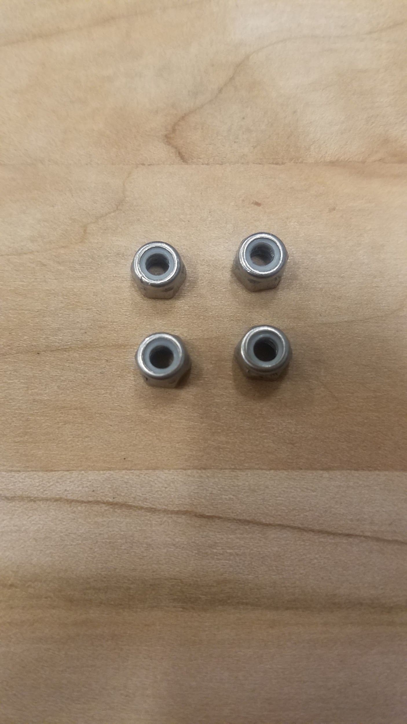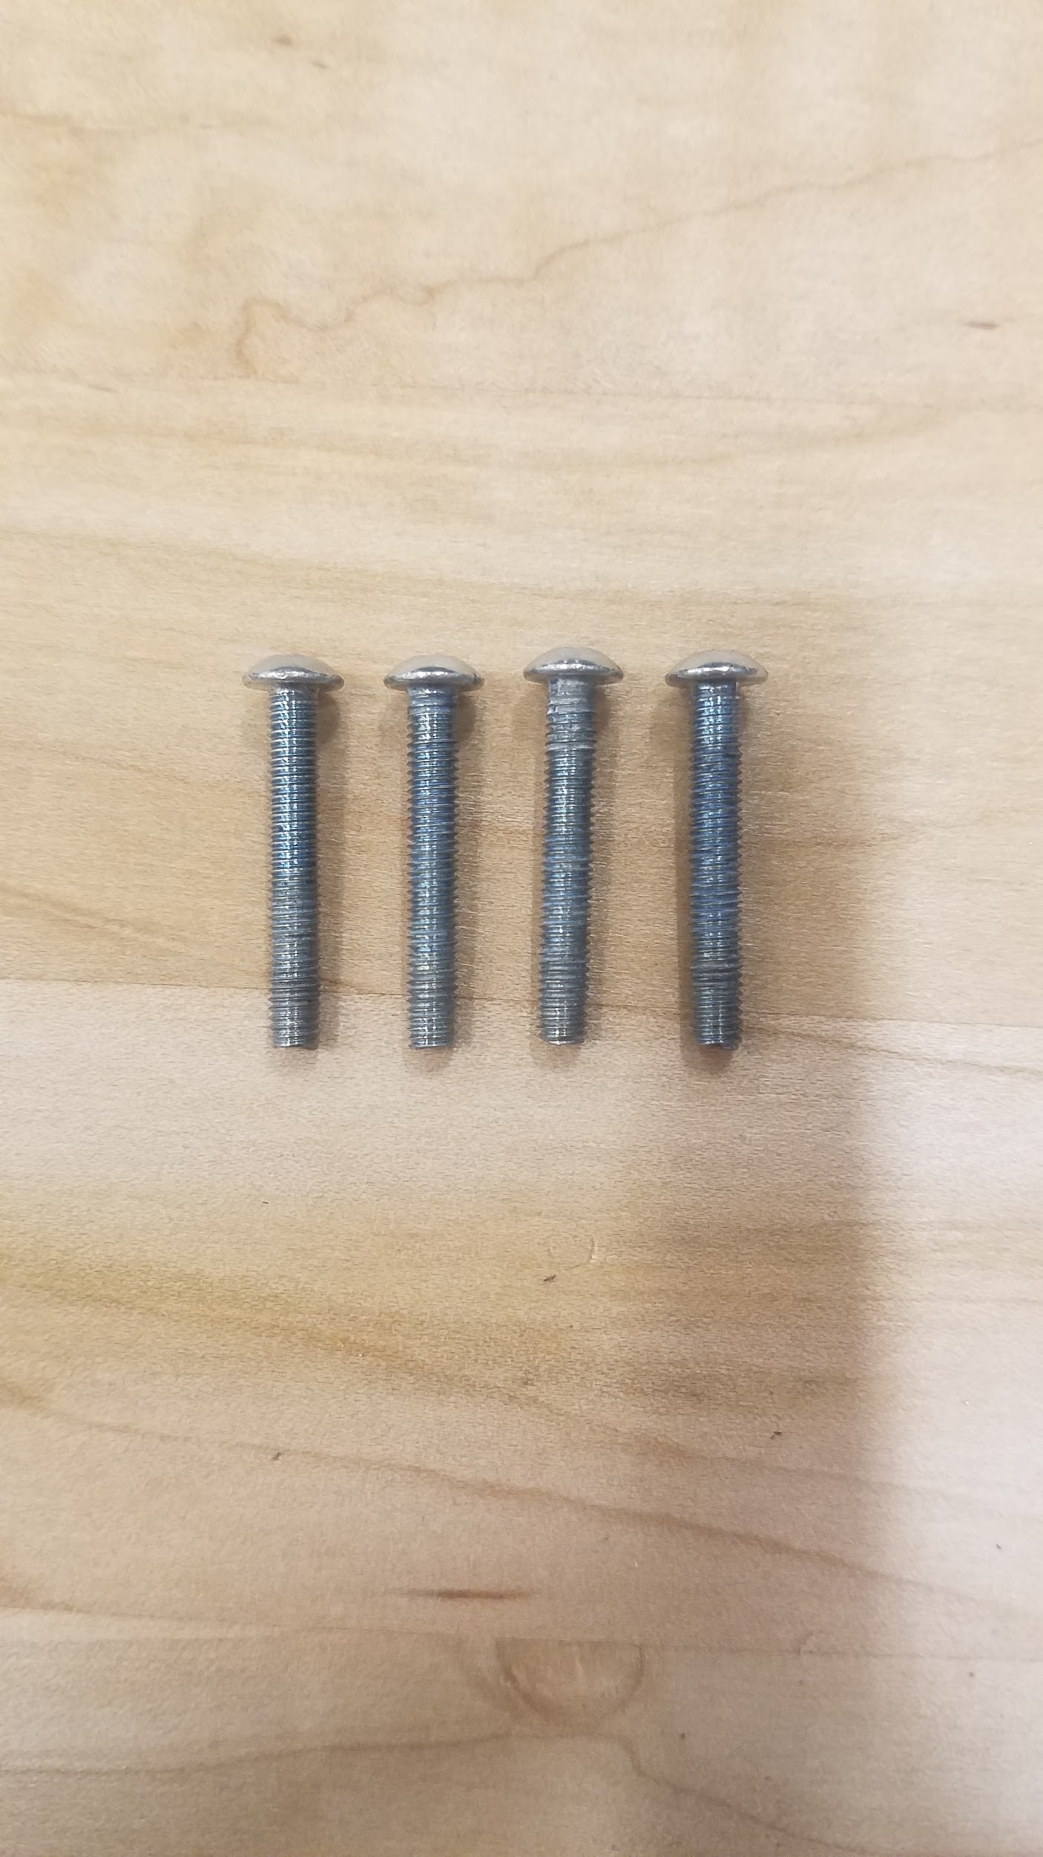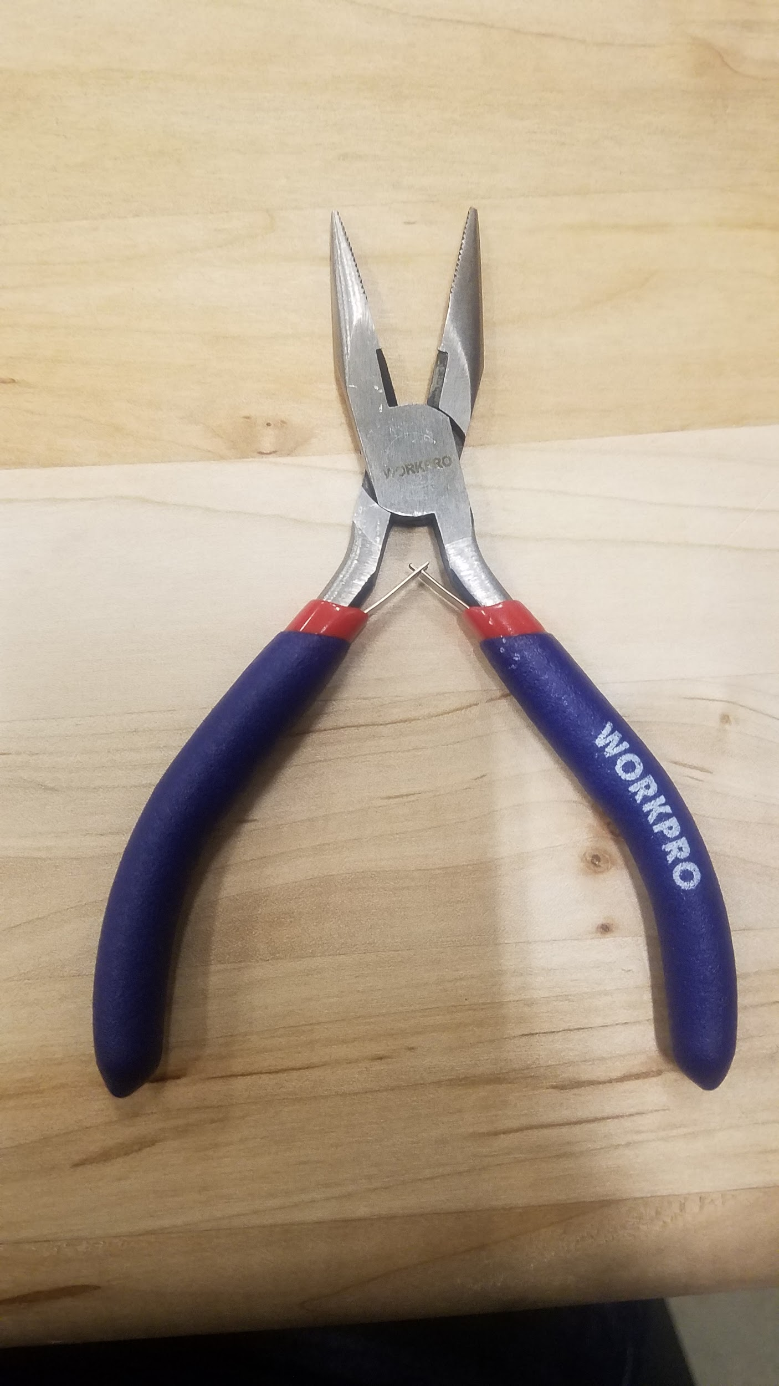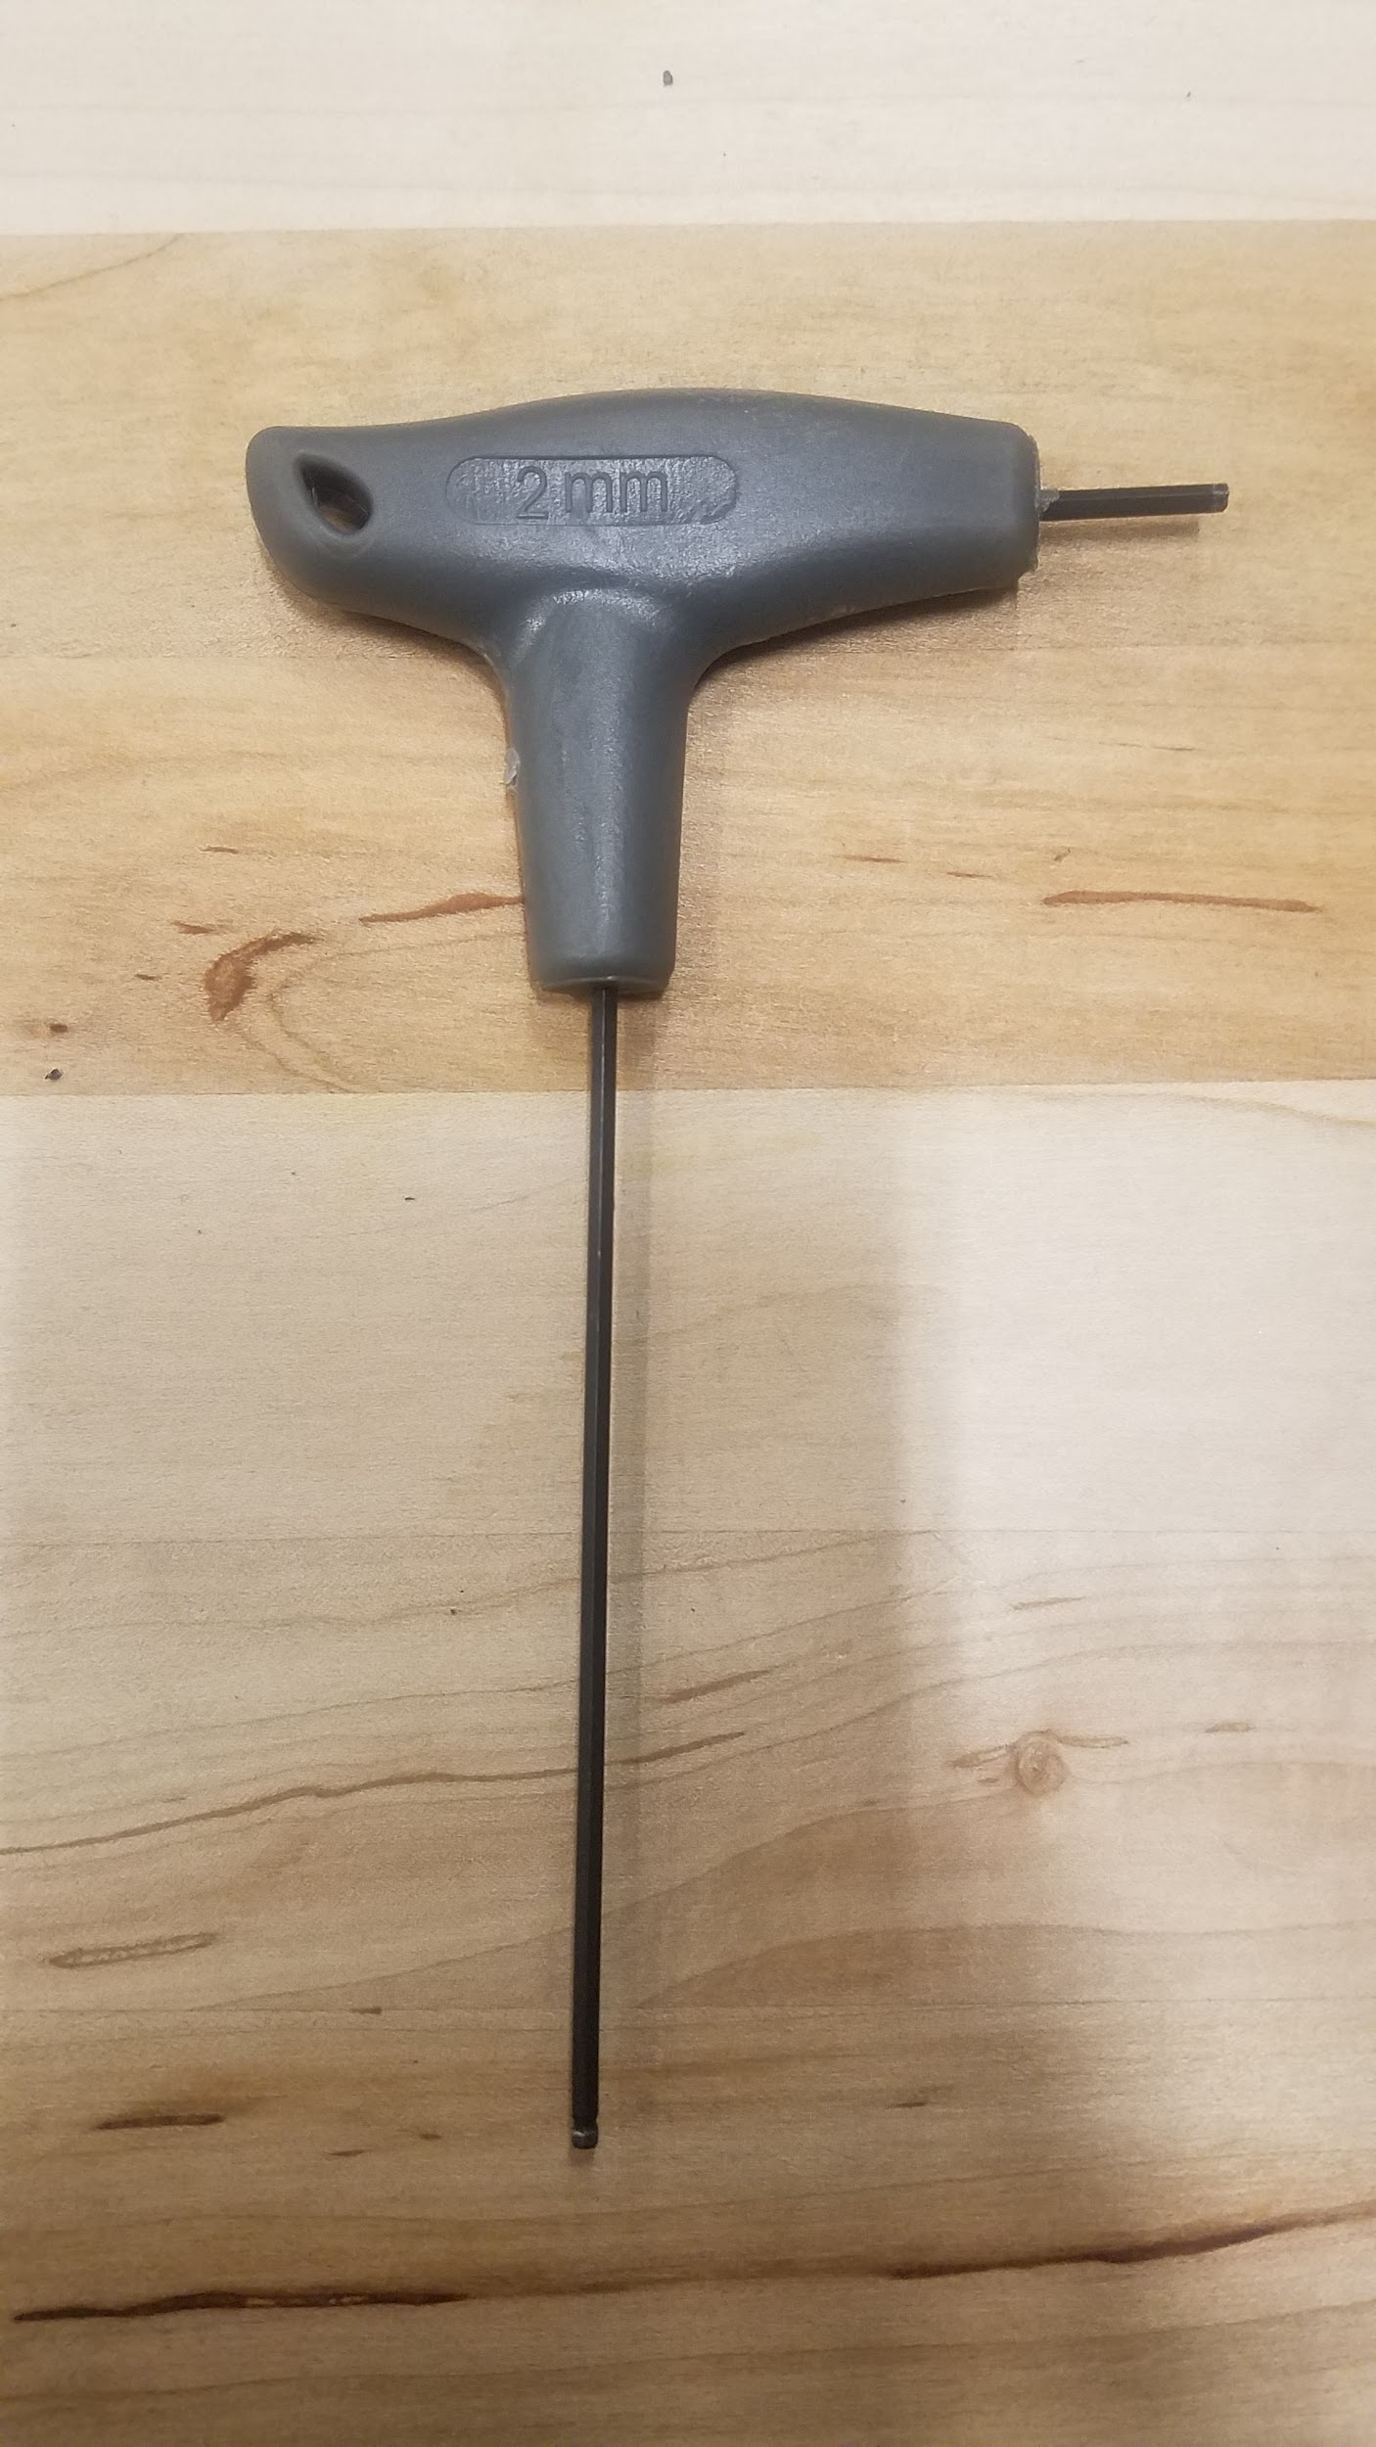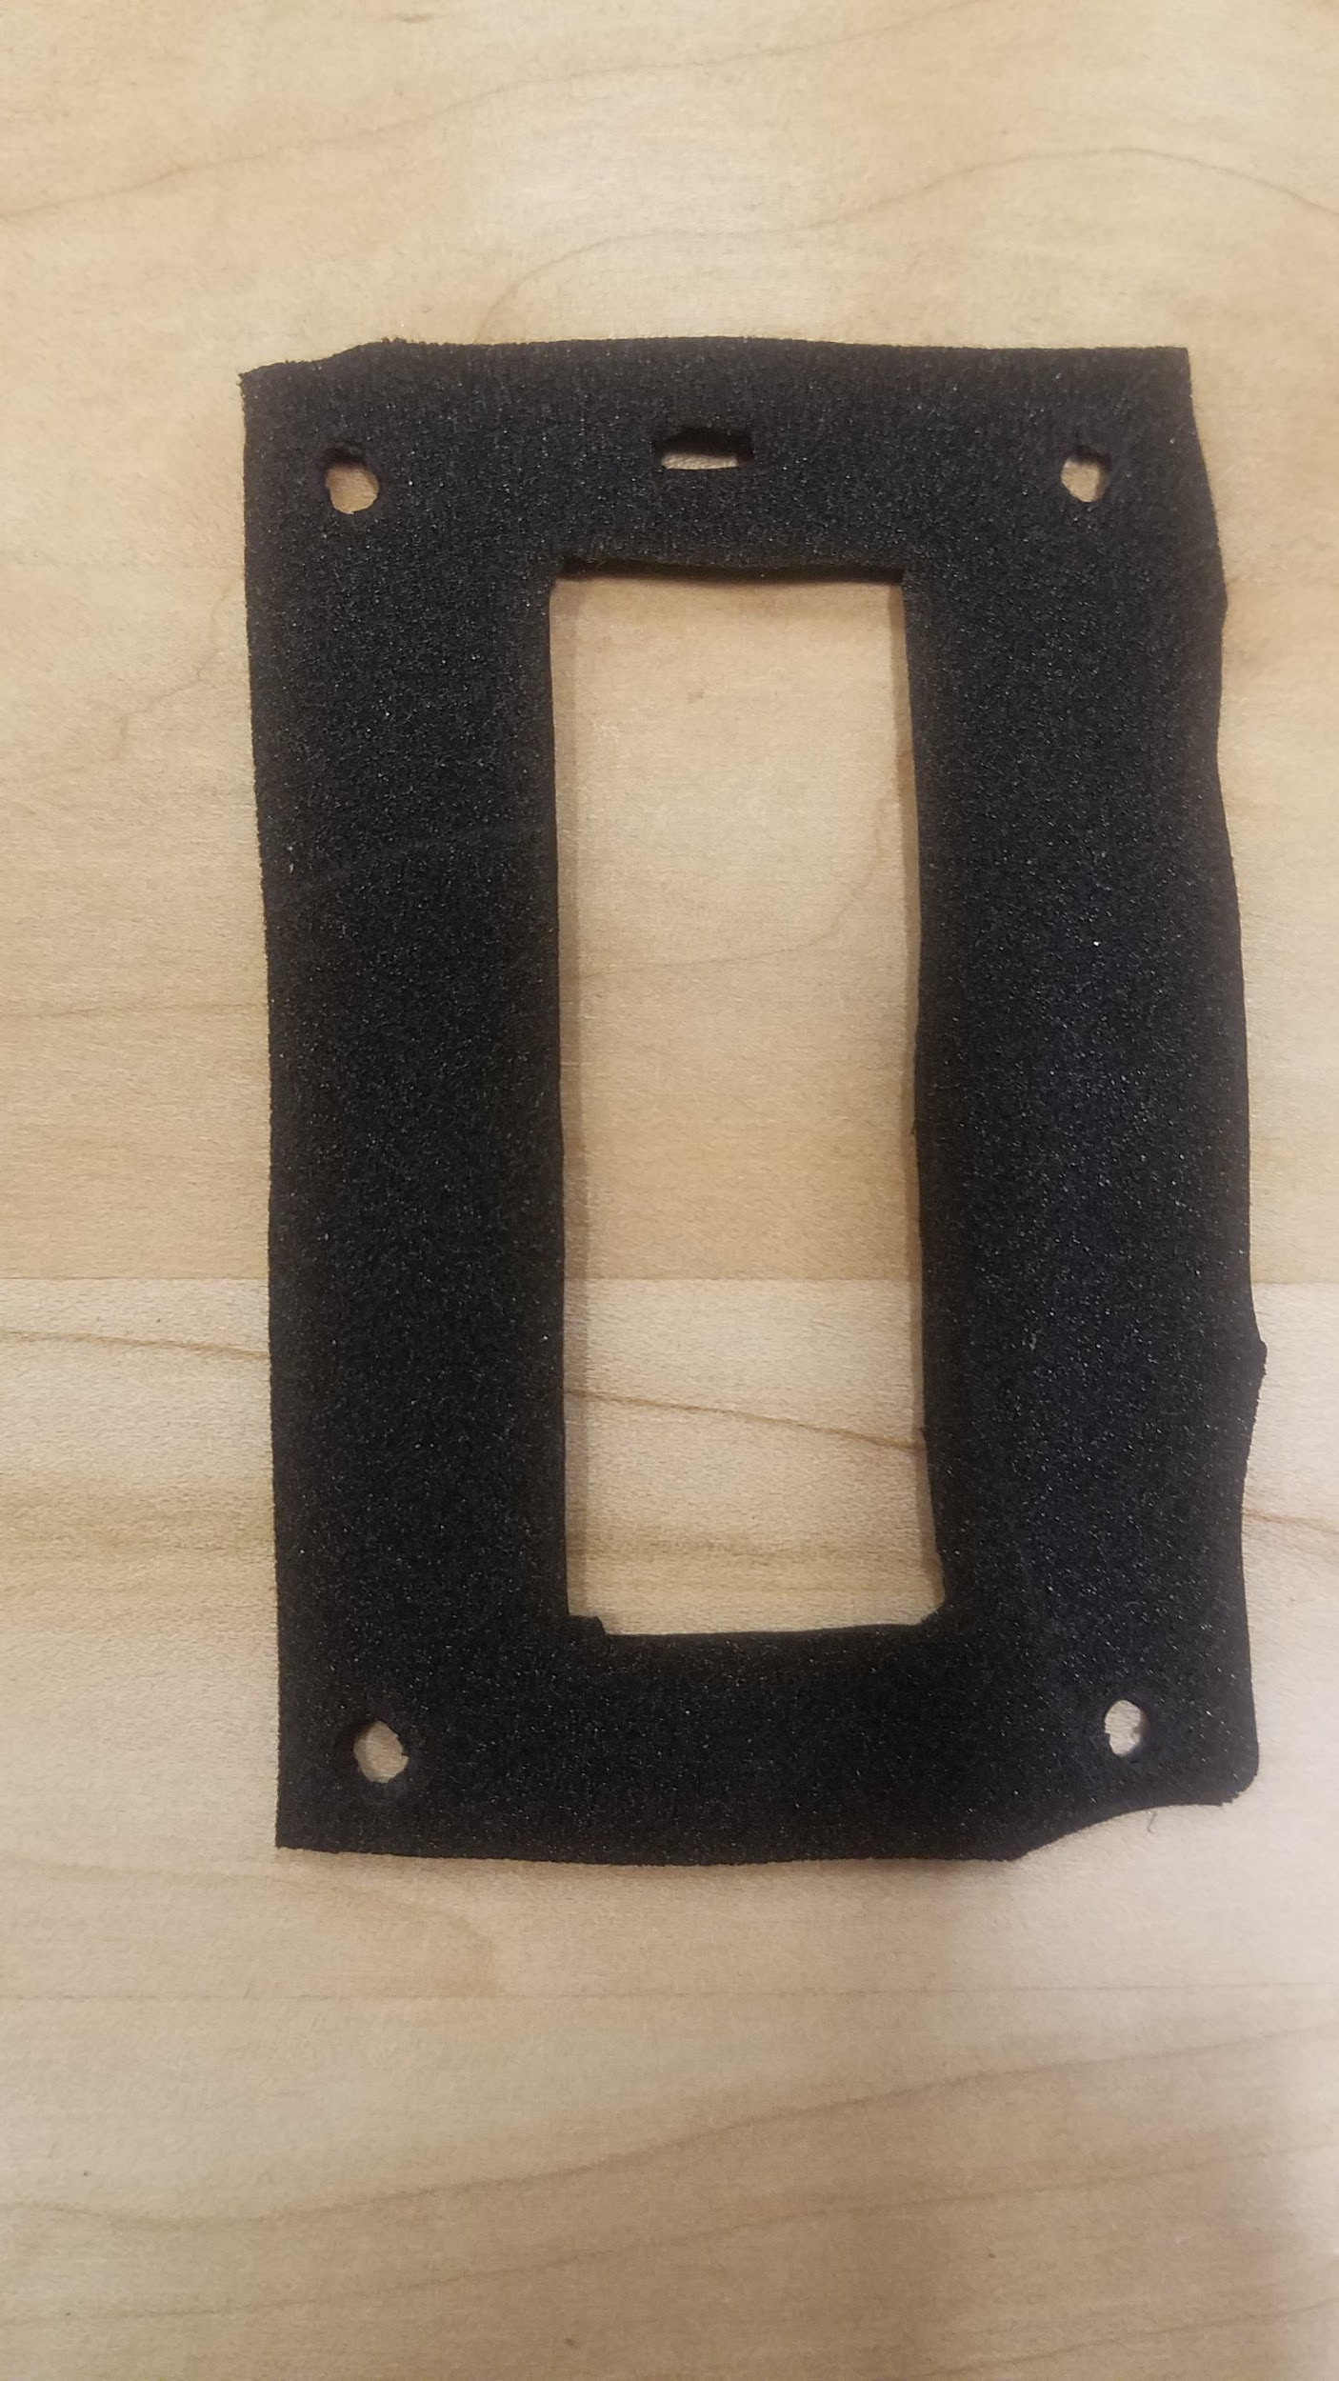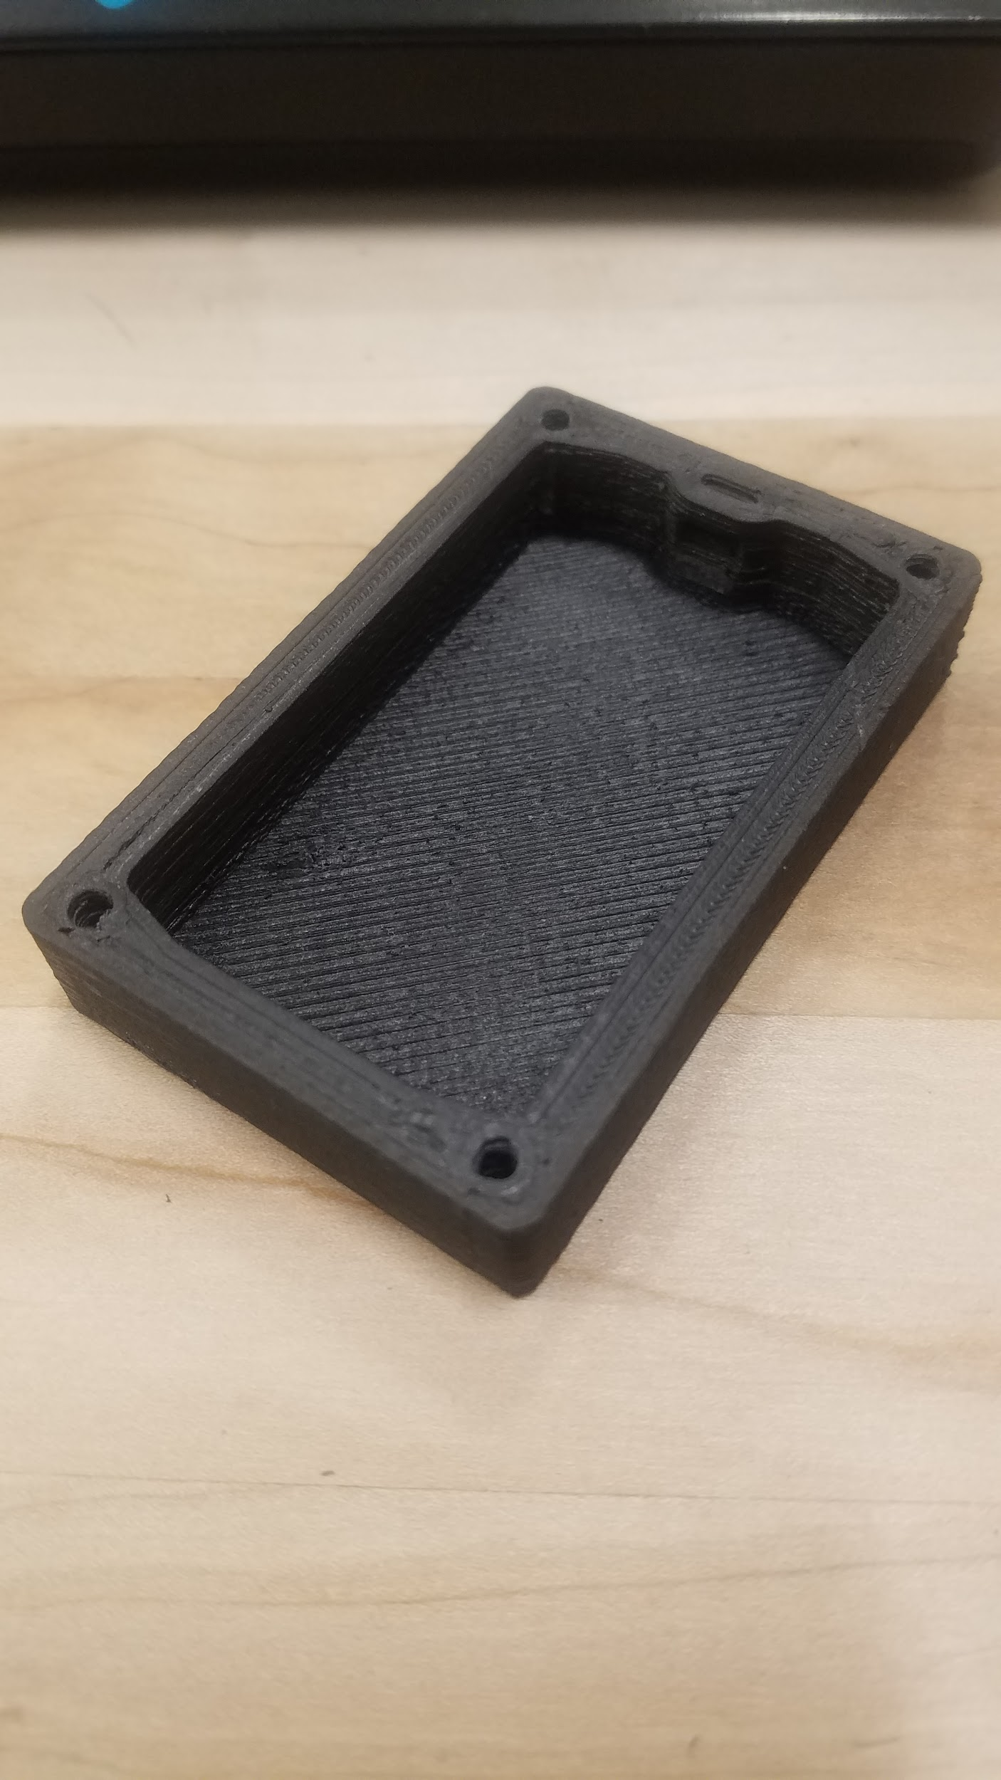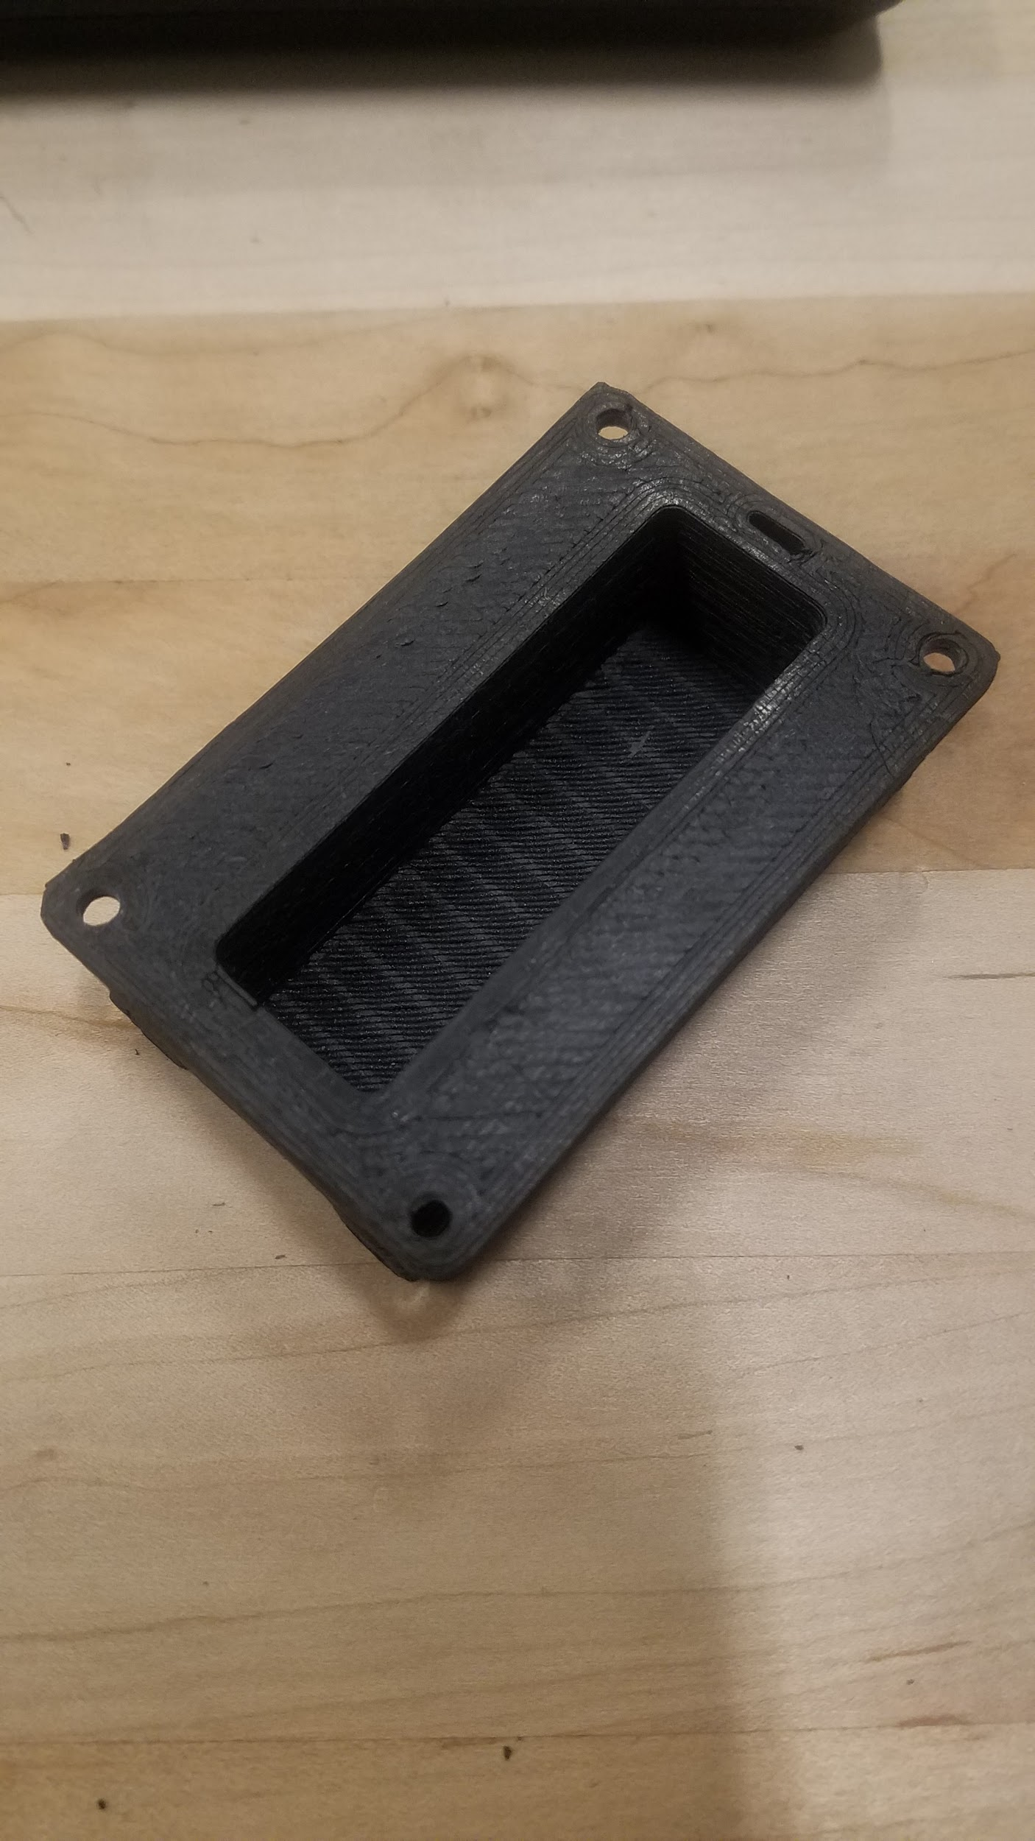

Needed for Assembly Pictured Above: 4 M3 nylon locking nuts, 2 M3 nuts(not pictured), 4 M3x20mm button cap screws, 1 needle nose pliers and a 2mm hex wrench, 1 pre-cut gasket, 1 lid, 1 enclosure bottom.

**2.3.2** Thread 4 fasteners into the lid and align gasket with them on the opposite side.

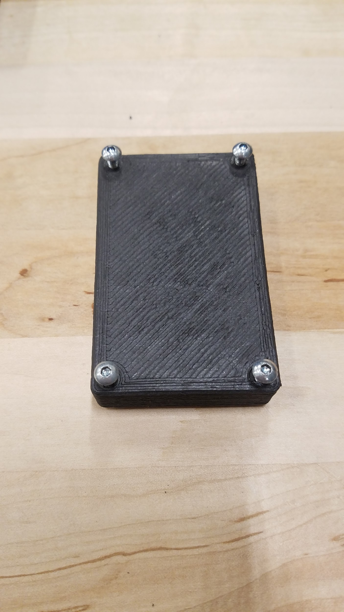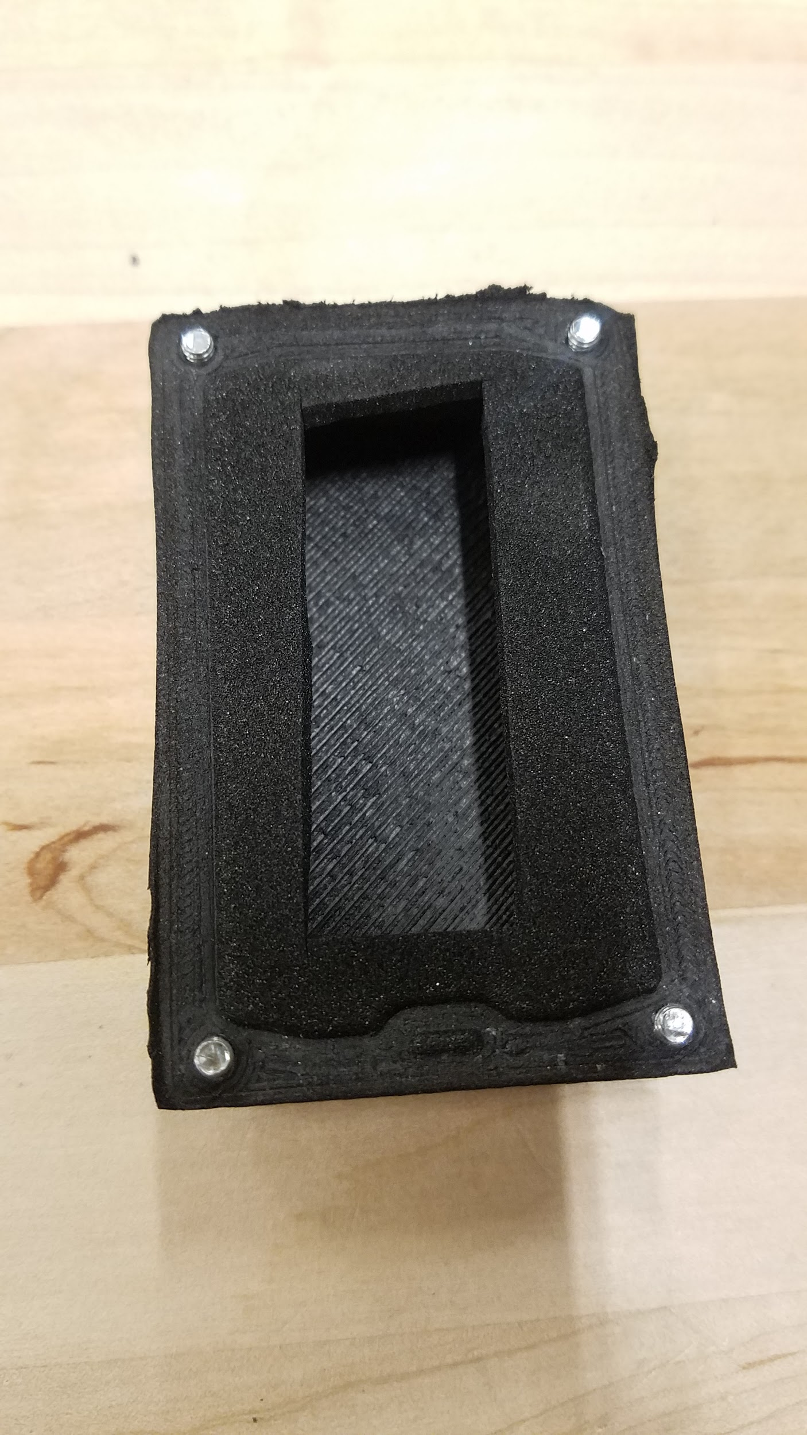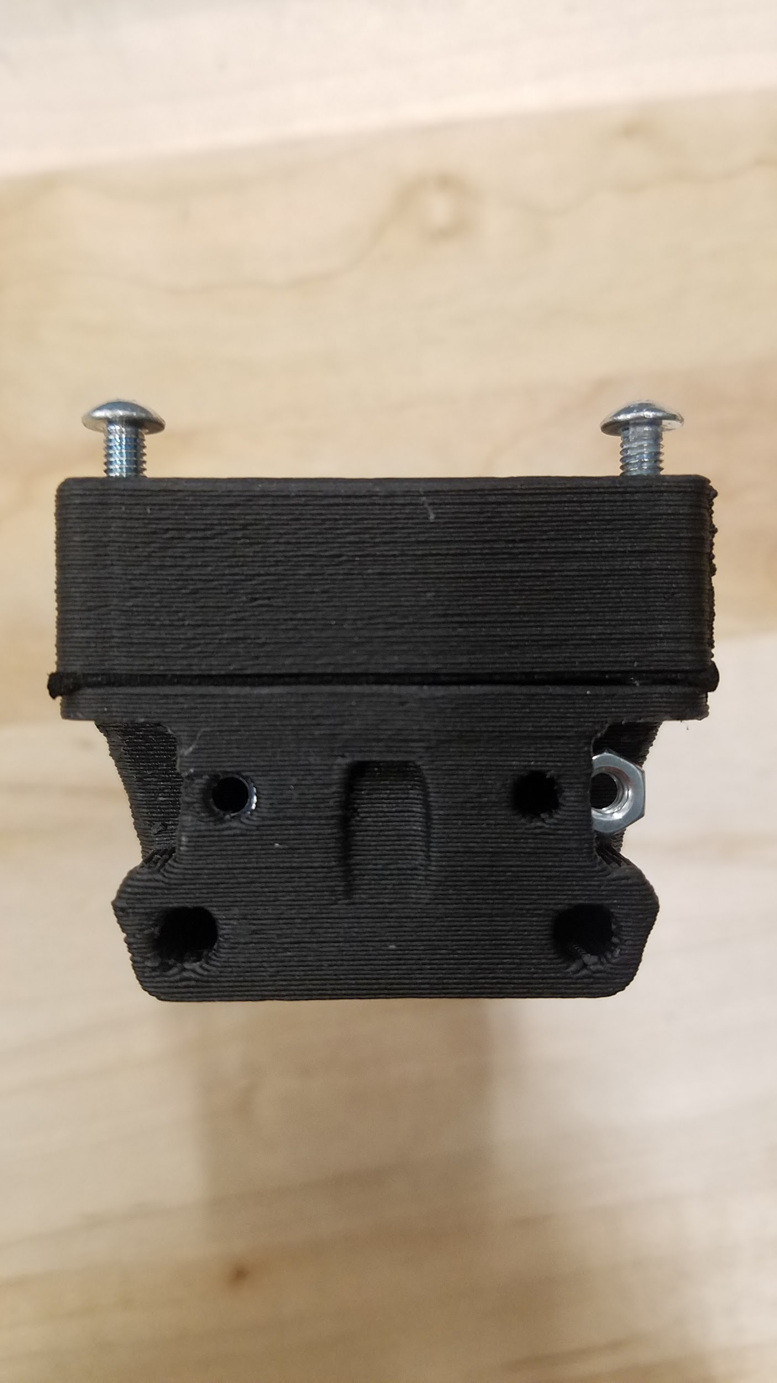**Figures 14,15,16.** Enclosure assembly, attachment of lid to base with gasket seal

**2.3.3** Align enclosure bottom with the 4 fasteners as shown in the image above. Be sure that the antenna hole is on the same side for both the lid and the bottom. Place 2 M3 nuts in the pocketed slots. When fully inserted the nuts need to align with the 3mm clearance holes on the face of the enclosure. Usually the nut will be pressed into place. If there is too much resistance you may use a soldering iron to heat the nut and gently move it into position.

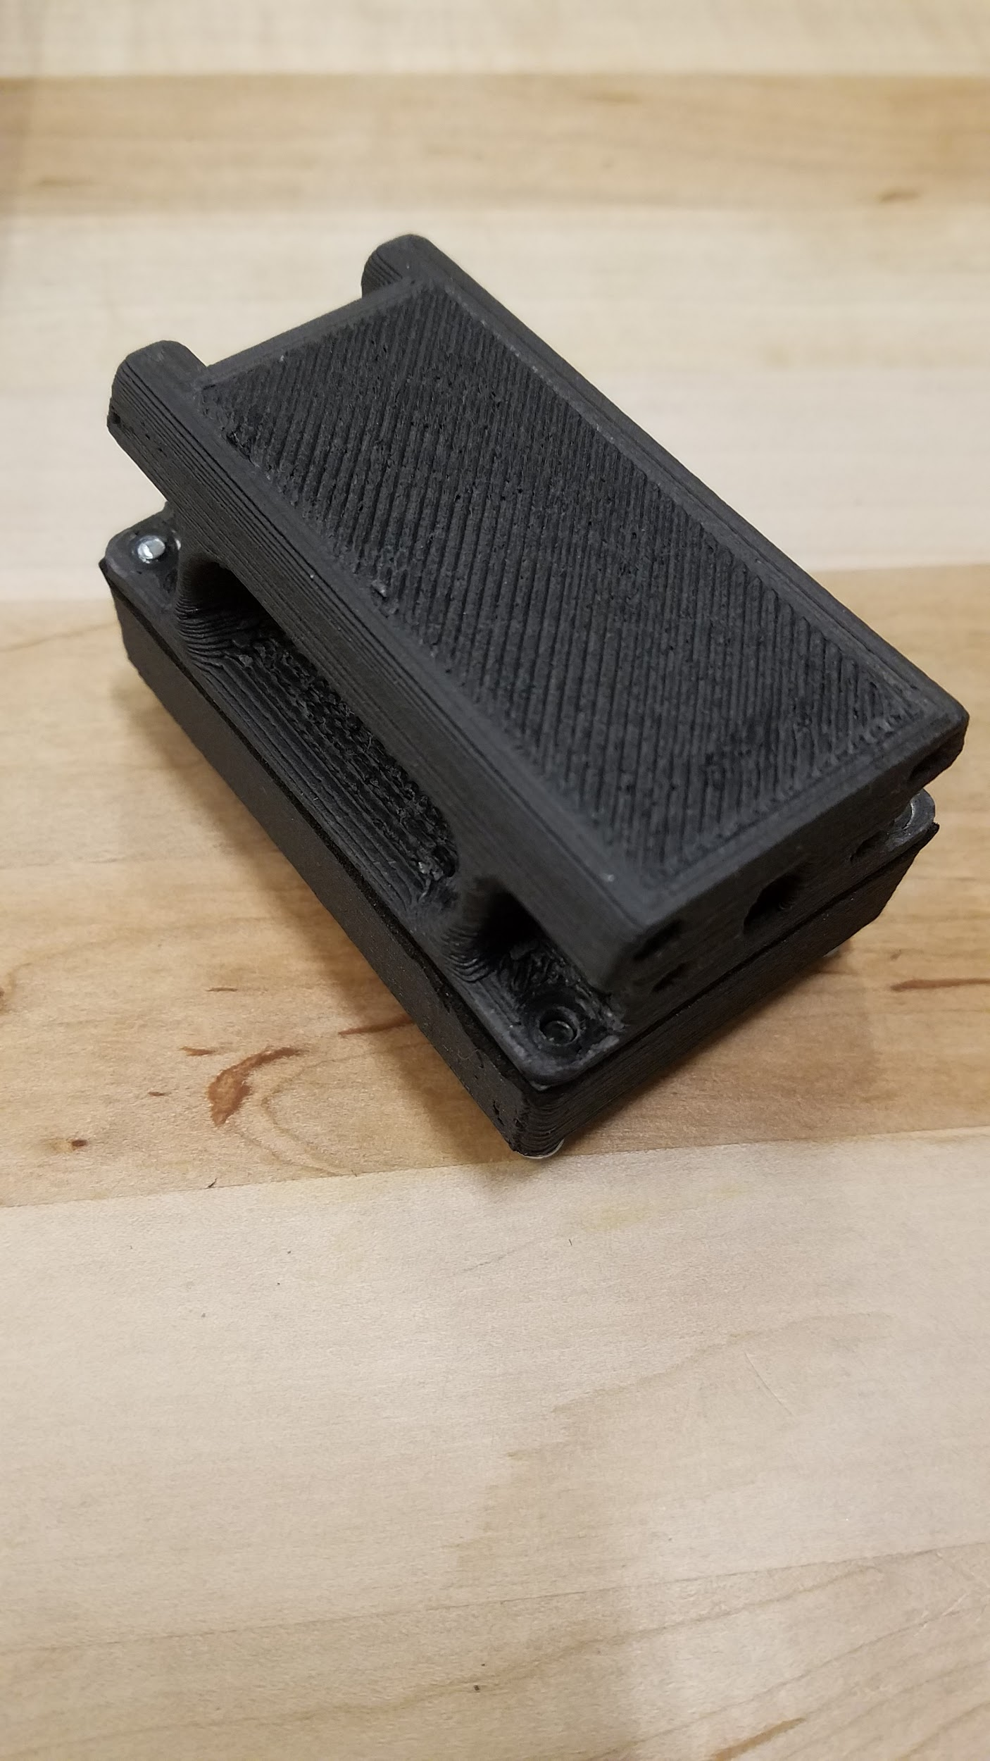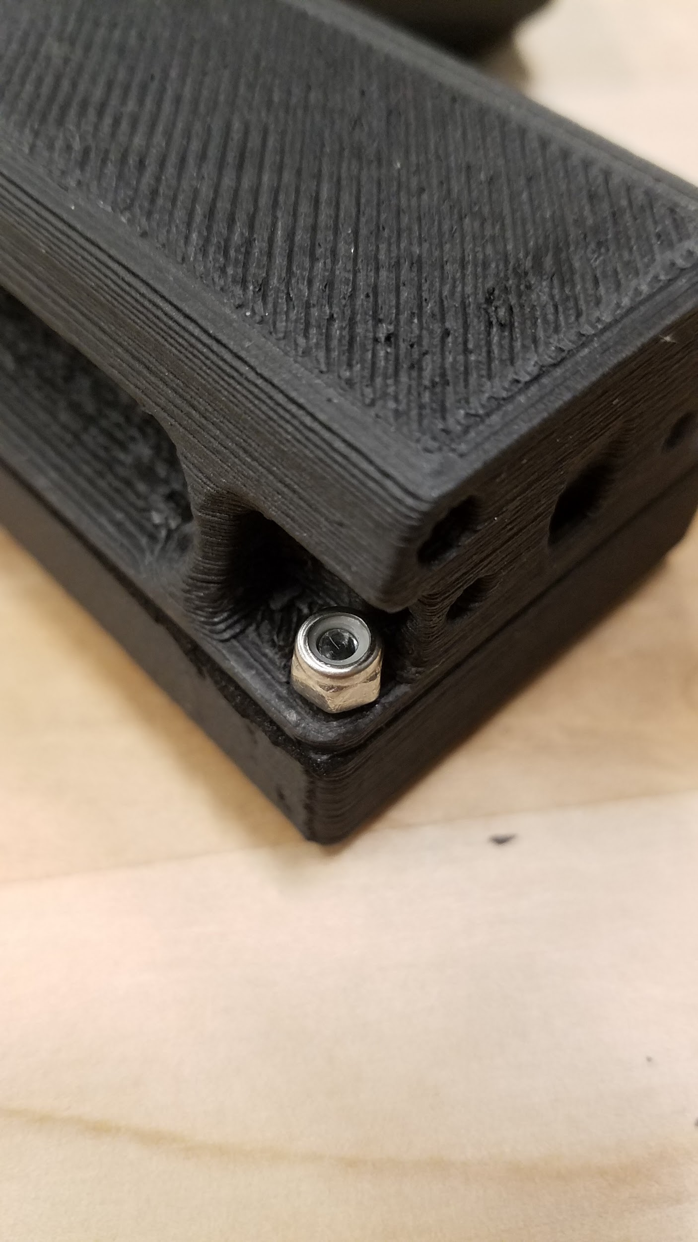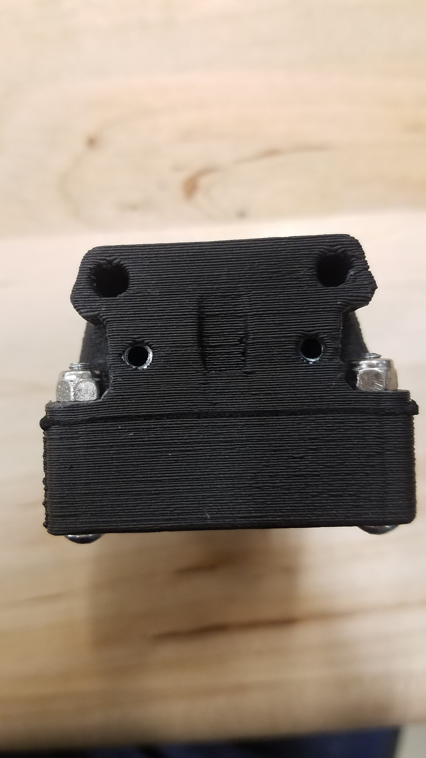

**Figure 17,18,19.** Enclosure lid and bottom evenly tightened together

**2.3.4** Start one of the M3 nylon locking nuts onto each M3x20mm screw. Next use the needle nose pliers to hold the M3 nuts in place as you tighten the screw. Use an even pressure all the way around. When all 4 nuts are tightened depress the lid further, compressing the gasket, and tighten each nut completely. It is important that each nut has full engagement. A small amount of each crew should be visible above each nut as shown in the picture furthest to the right, above.

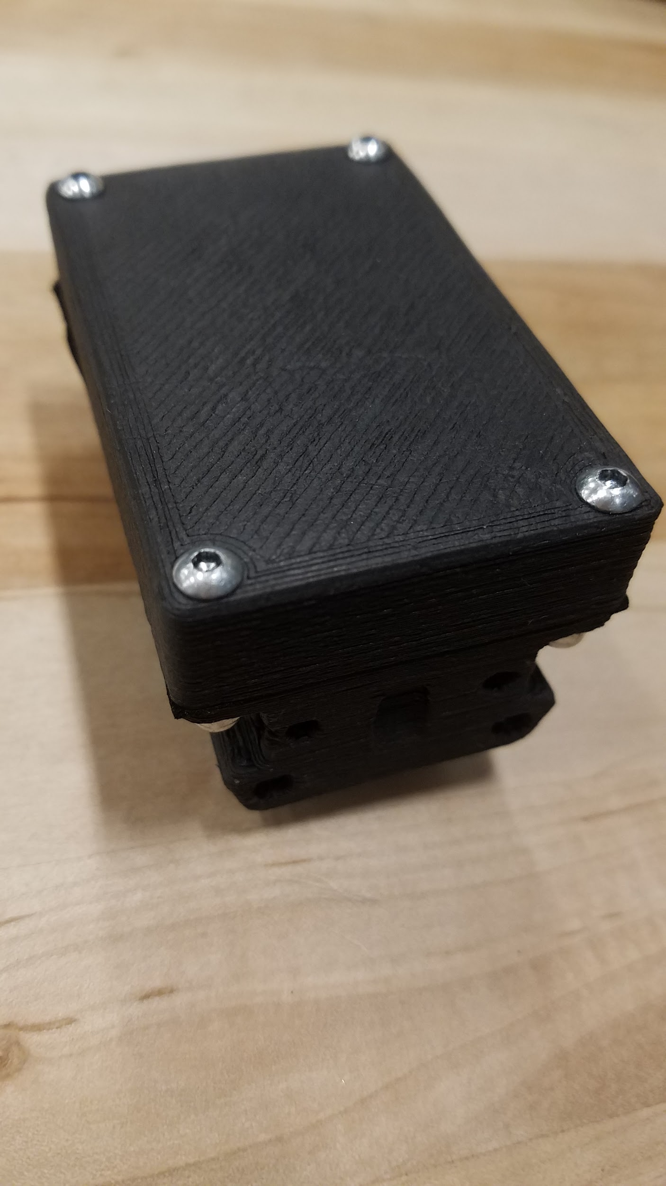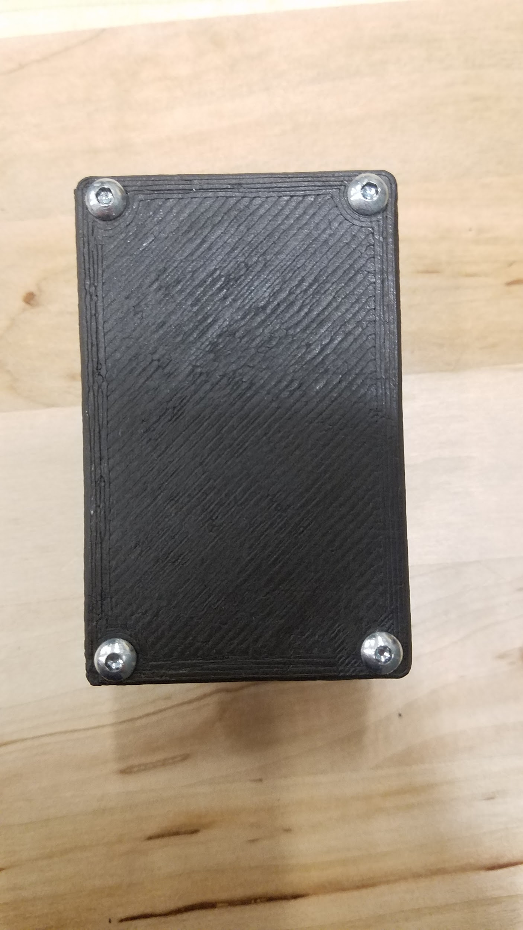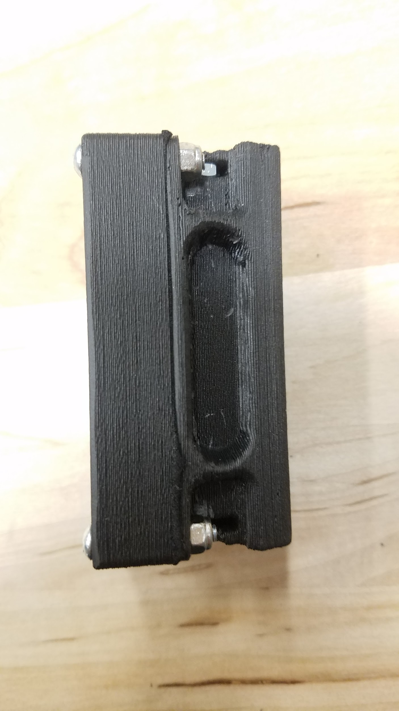

**Figure 20.** Enclosure assembly complete

**2.3.5** Assembled enclosure shown above.

**2.4 Hall Effect Sensor Clip**

**2.4.1** The assembled collar enclosure will accept the hall effect sensor clip. Be sure that the head of the clip faces the antenna side of the enclosure. Failure to do so will allow the collar to remain on and drain the battery.

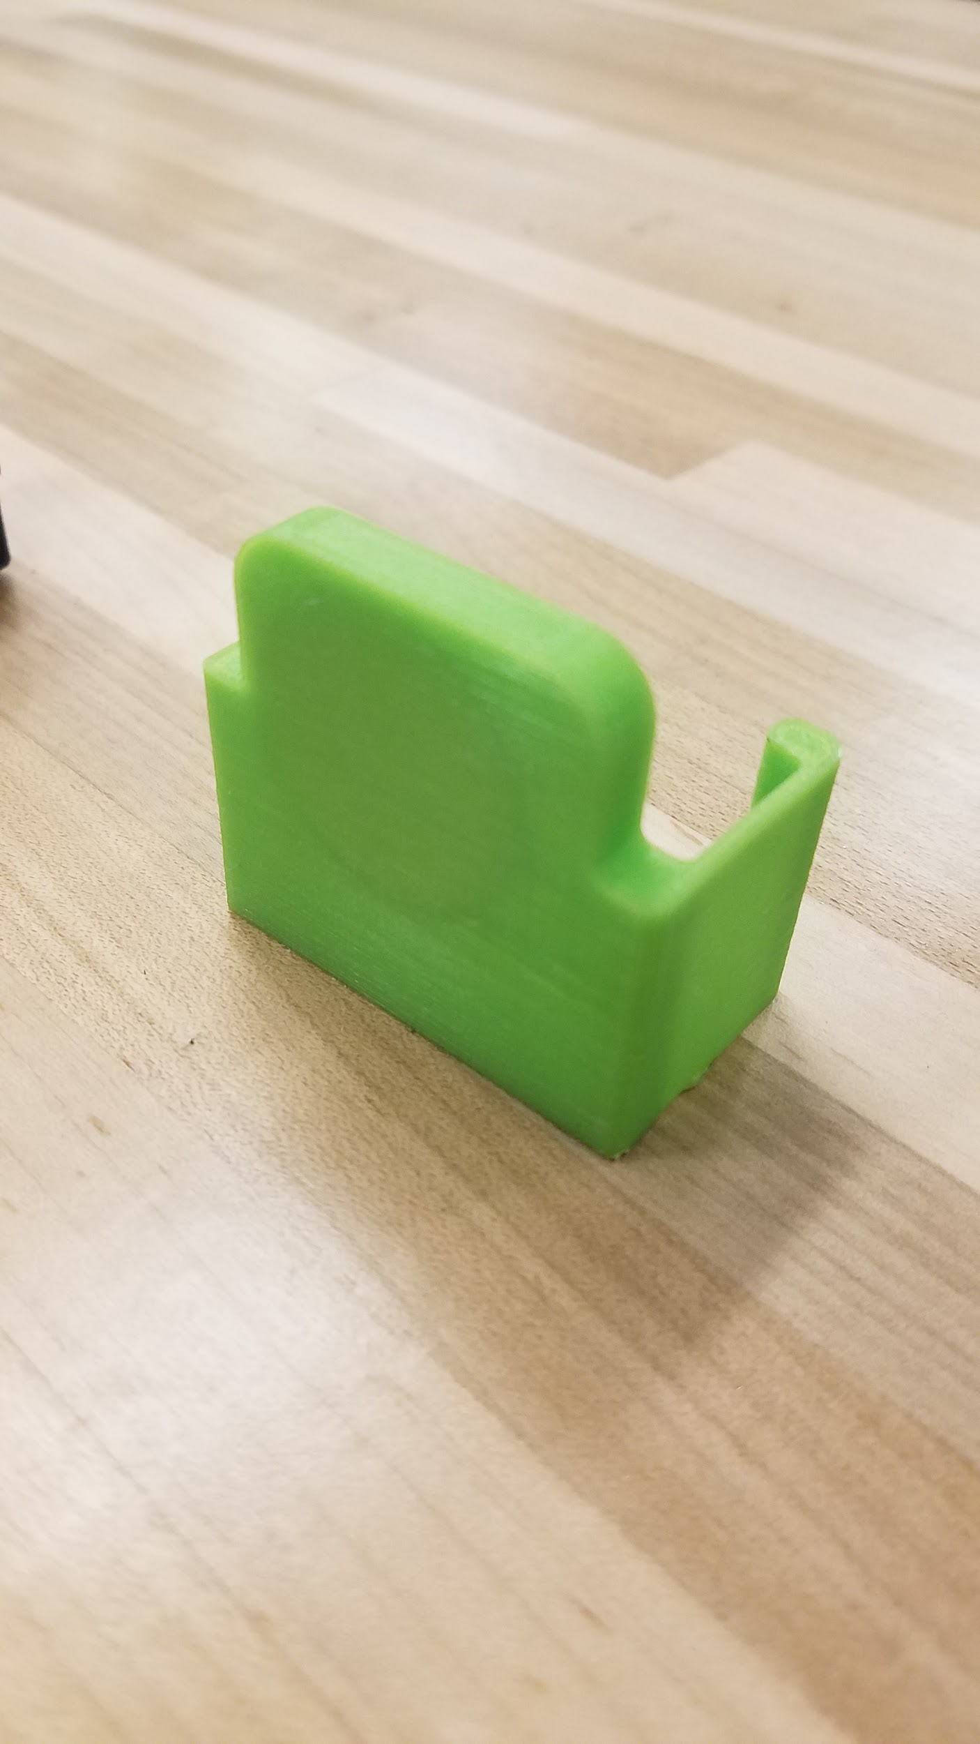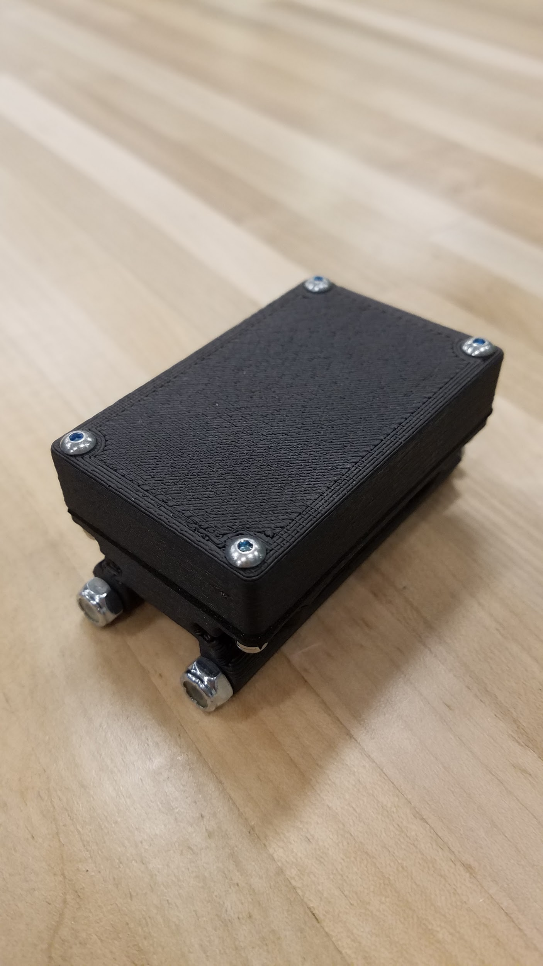

**Figure 21,22.** Right: Battery Clip, Left: Enclosure Assembly

**2.4.2** Take the hall effect sensor clip and stretch it over the sides of the enclosure assembly as shown. Be sure that the clip is facing the antenna end of the enclosure. Then Push down until you hear it clip into place.

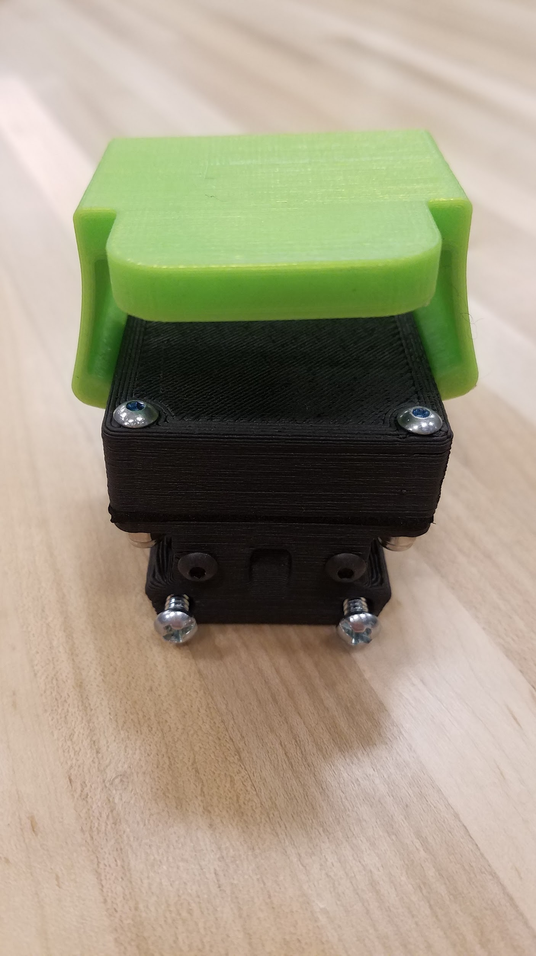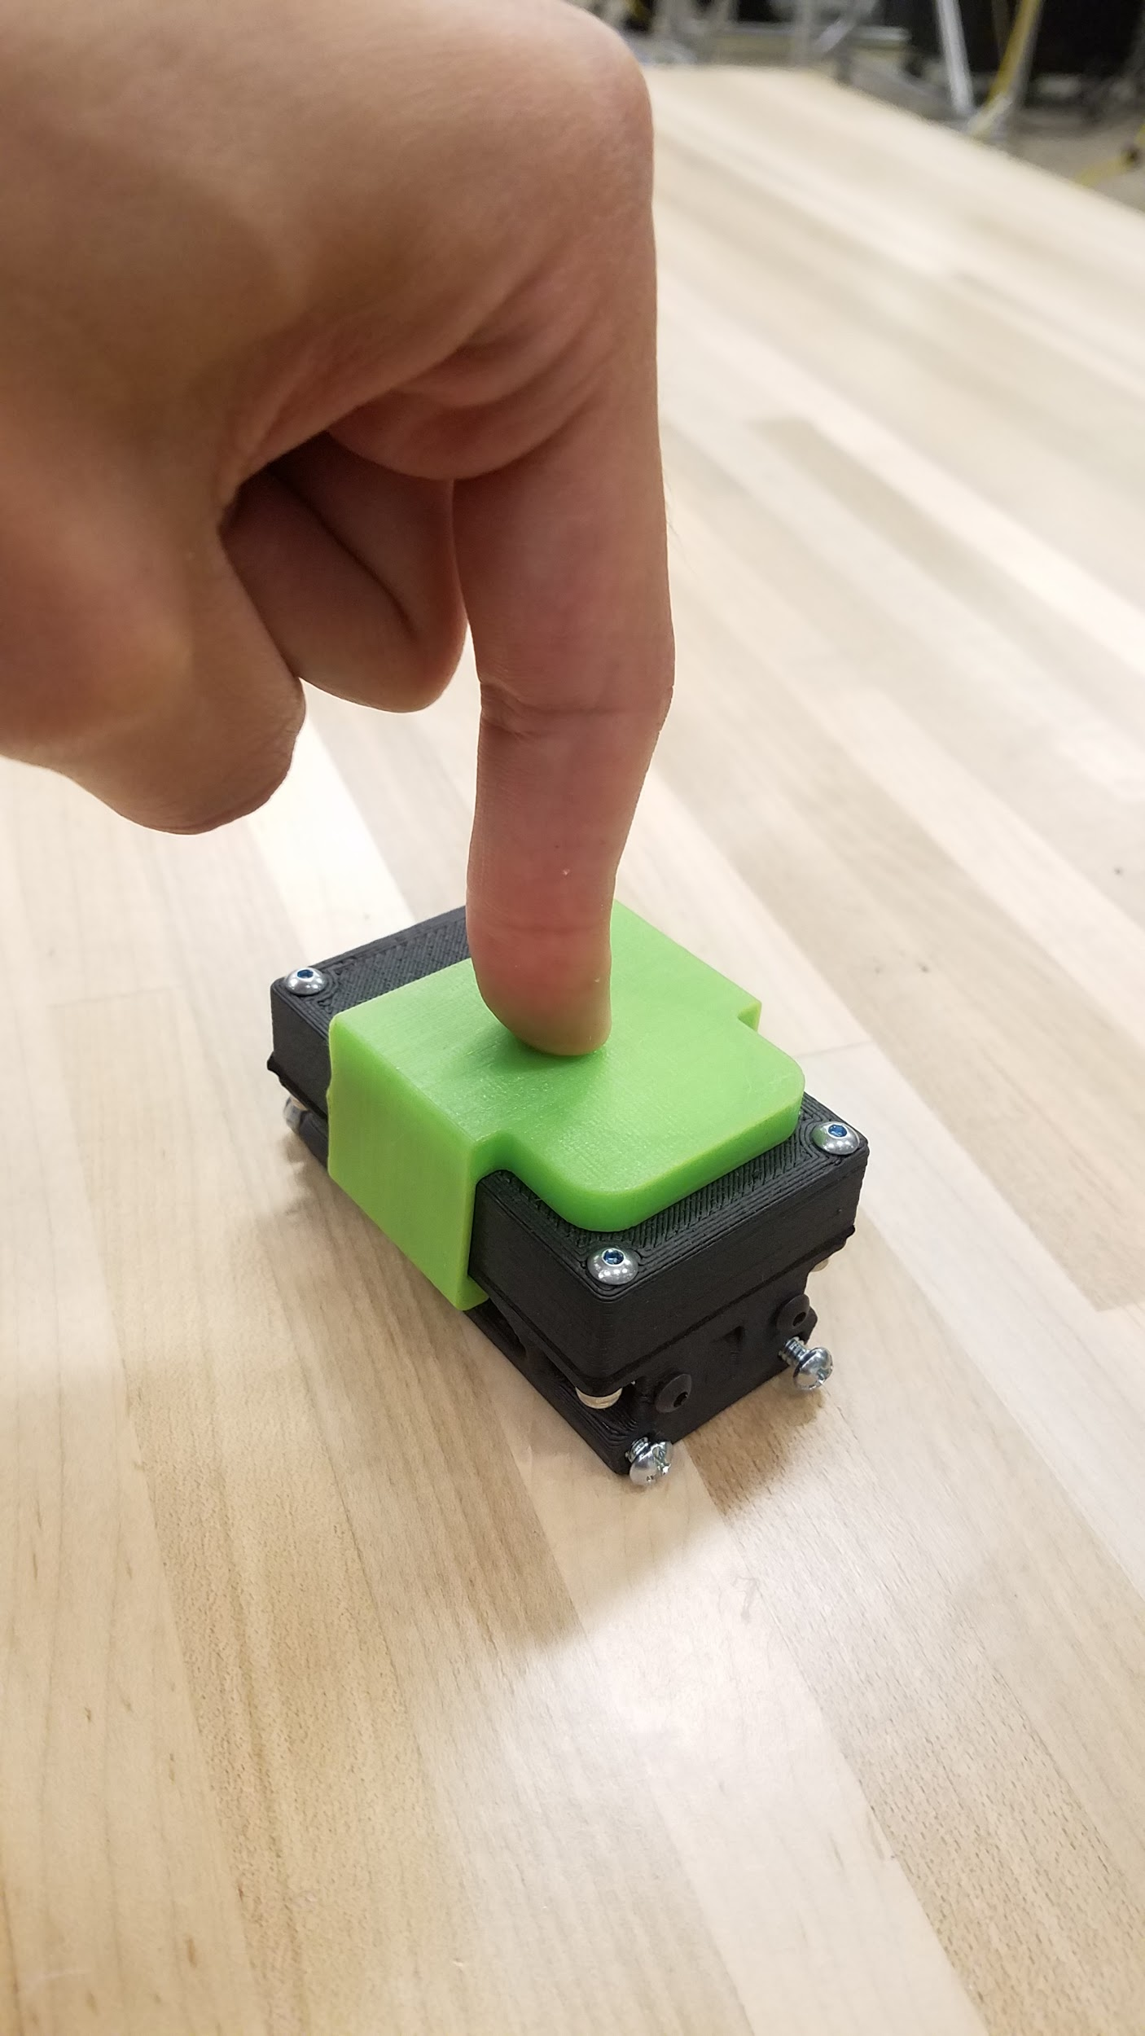

**Figure 23,24.** Right: Clip placed on top of enclosure, Left: Clip snapped into place

**2.4.3** After the clip is fixed in place, force it towards the end until the clip touches the heads of the fasteners, as shown.

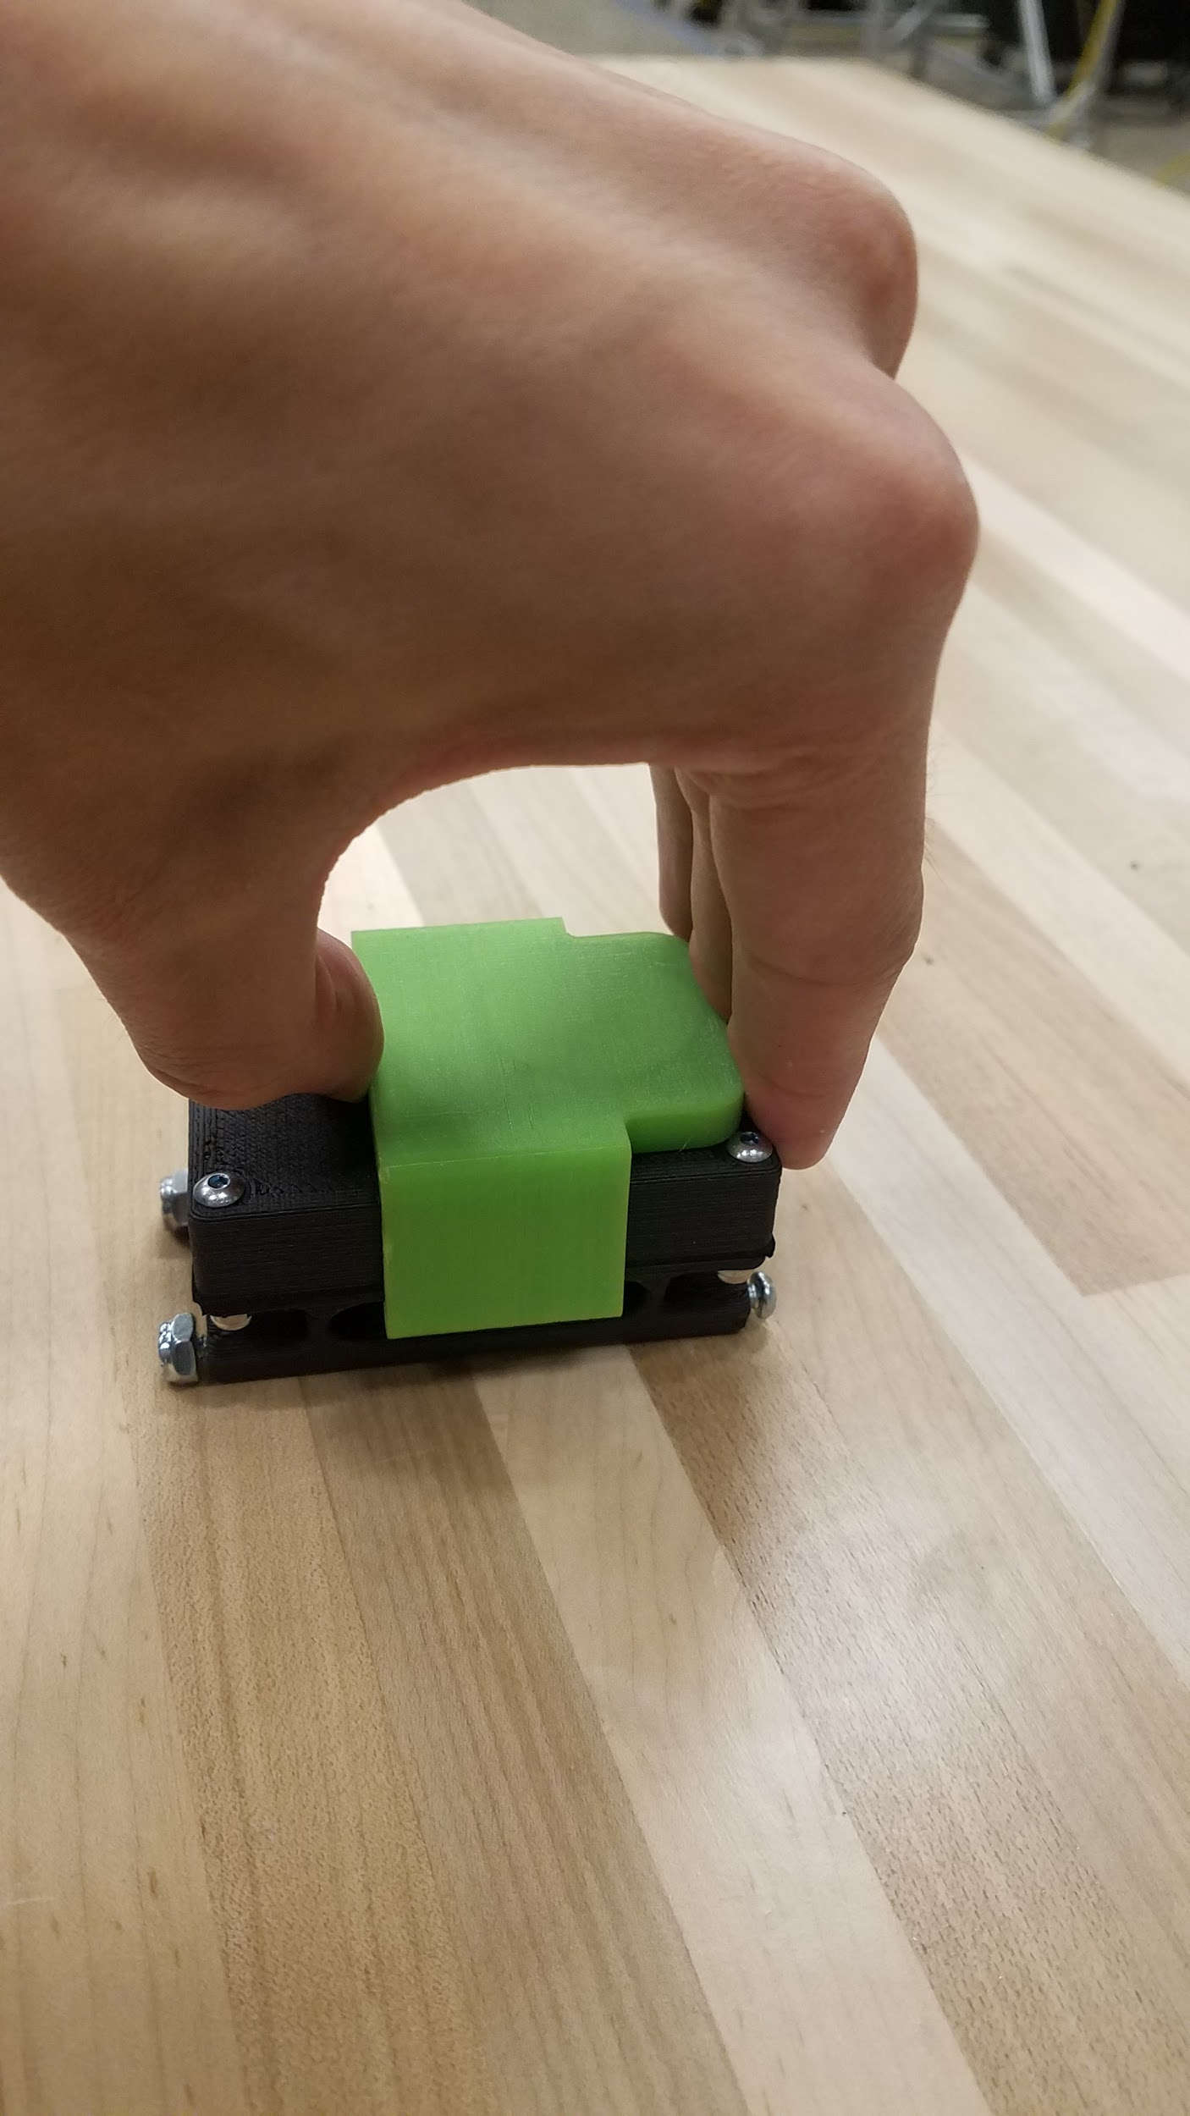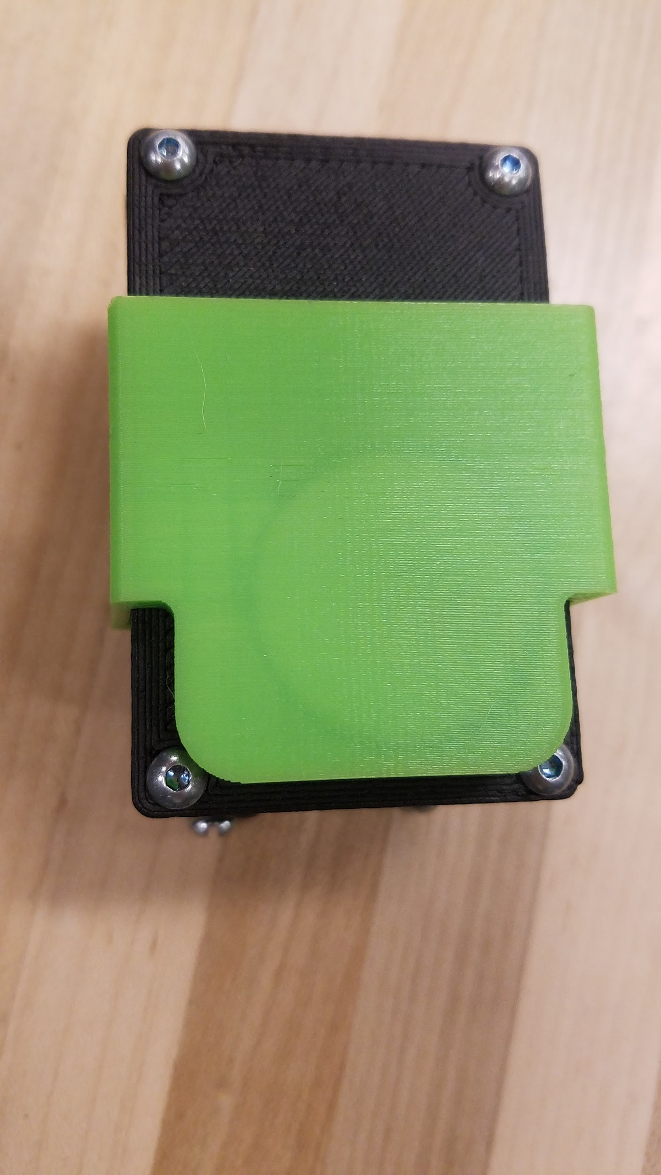

**Figure 25,26.** Right: Clip moving into place, Left: Clip in final position

**2.4.4** The hall effect switch is now activated and the collar is in sleep mode.

## 2.5 Collar Belting Manual Cutting

To manually cut the collar belting material, the following steps should be followed in sequence to obtain the optimal collar sleeve assembly. The same steps are used for the small collar, and the manual cutting file for the small collar is referenced in section 2.5.2.

**2.5.1** **Gather Required Materials**

Materials required to manually cut the collar belting are as follows: 1:1 hard copy of the 200mm collar side (2 - not scaled upon printing: select “print actual size”), 1:1 hard copy of the 110mm collar side (2 - not scaled upon printing: select “print actual size”), masking tape, collar belting raw sheet, razor blade, and a leather hole puncher.

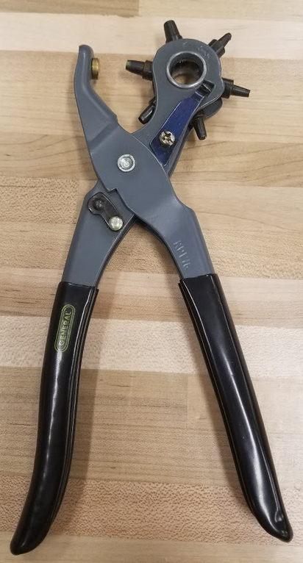 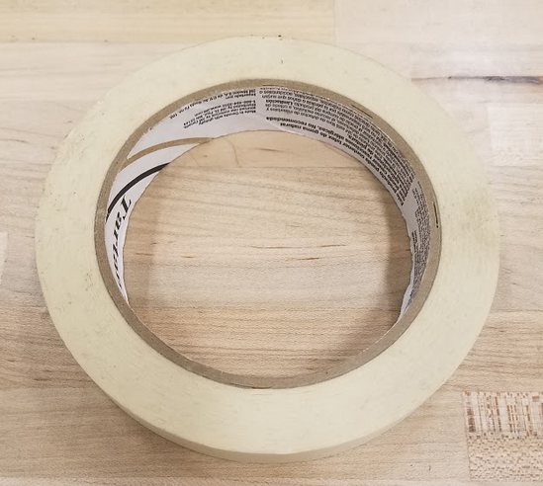 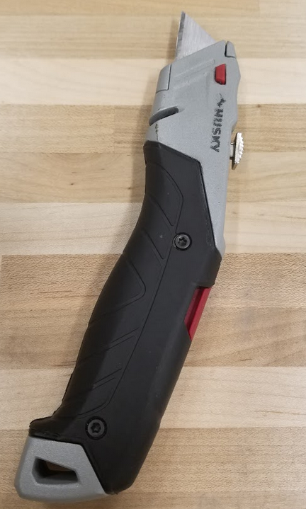

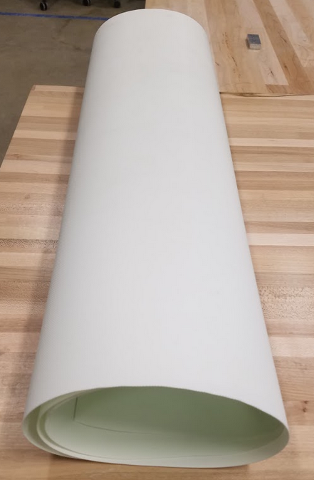 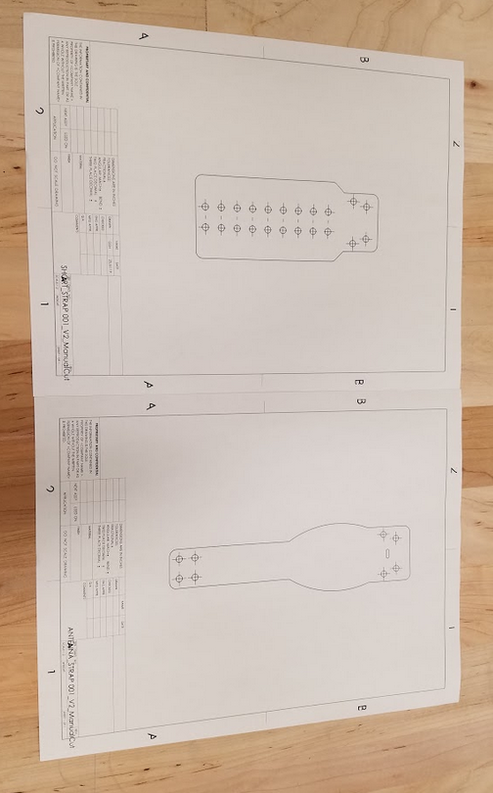

**Figure 27.** (Top left to bottom right) Leather Hole Puncher, masking tape, razor blade, raw Ultra Kool I belting, 1:1 drawings (Short and Antenna 001 drawings shown)

**2.5.2 Print 1:1 Scaled Drawings of Collar Sections (200mm and 110mm)**

As described above, open the ‘Manual Cutting’ drawings of the ANTENNA collar and the SHORT collar sides (ANTENNA_STRAP 001_V2_ManualCut.pdf, ANTENNA_STRAP 002_V2_ManualCut.pdf, SHORT_STRAP 001_V2_ManualCut.pdf, and SHORT_STRAP 002_V2_ManualCut.pdf). There are two versions of the strap that are validated, V2 and V3, either can be used. The small collar drawing can also be printed (SMALL_COLLAR_V0_ManualCut.pdf). Print the drawings, **ensure that the scaling option selected in the printing window is: “*Actual Size*”**.

**2.5.3 Trim Drawings of Collar Sections**

Using the razor blade, trim the drawings of the collar straps so that roughly 0.25-0.5” of blank space is present around the perimeter of the strap design on the drawing.

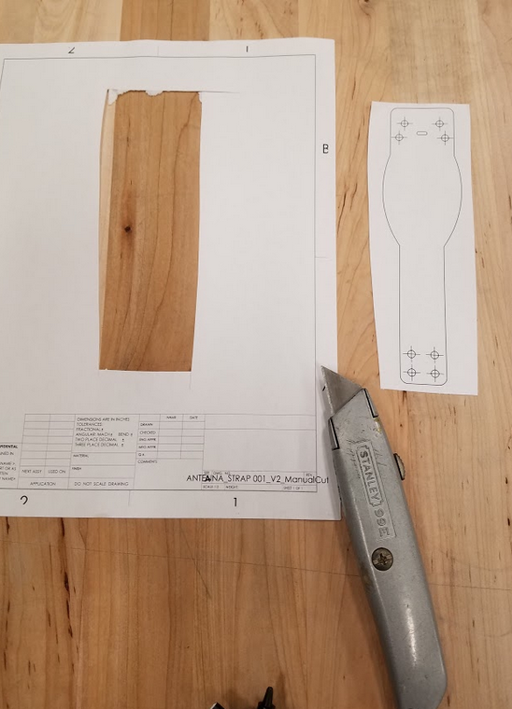 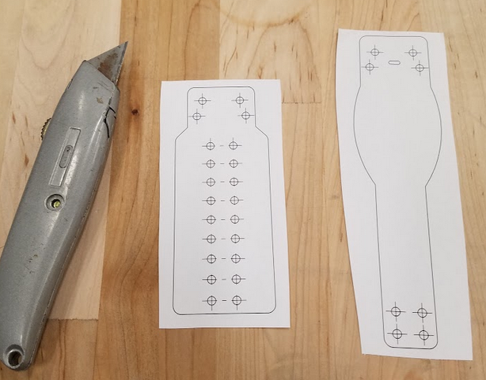

**Figure 28:** 1:1 Drawings Trimmed with Razorblade

**2.5.4 Tape Trimmed Drawings Onto Belting Material**

Tape the perimeter of the trimmed drawings so that the strap drawings are visible and flat on the raw belting. Tape all four sides of the trimmed drawings to the belting sheet so that each strap print is completely secured.

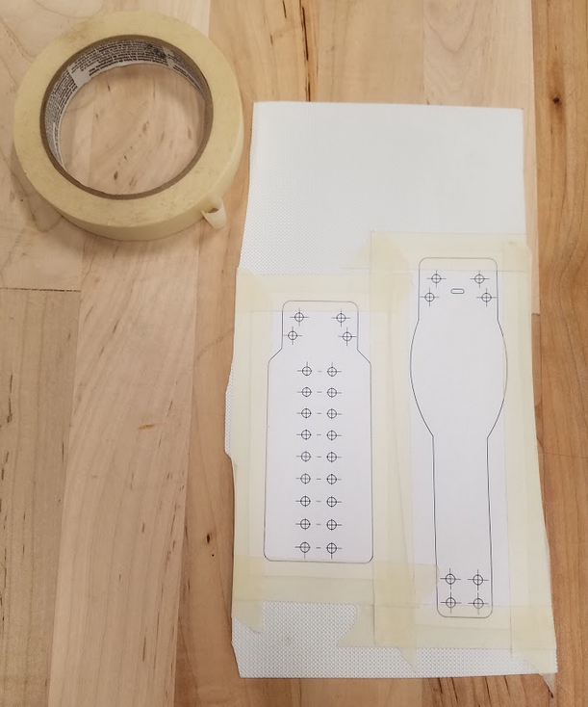

**Figure 29:** Trimmed Drawings Taped to Raw Belting Material

**2.5.5 Carefully Cut Belting Straps with Razorblade**

With the drawings of the collar strap sections taped to the belting, cut the collar sections out along the perimeter lines of the drawings.

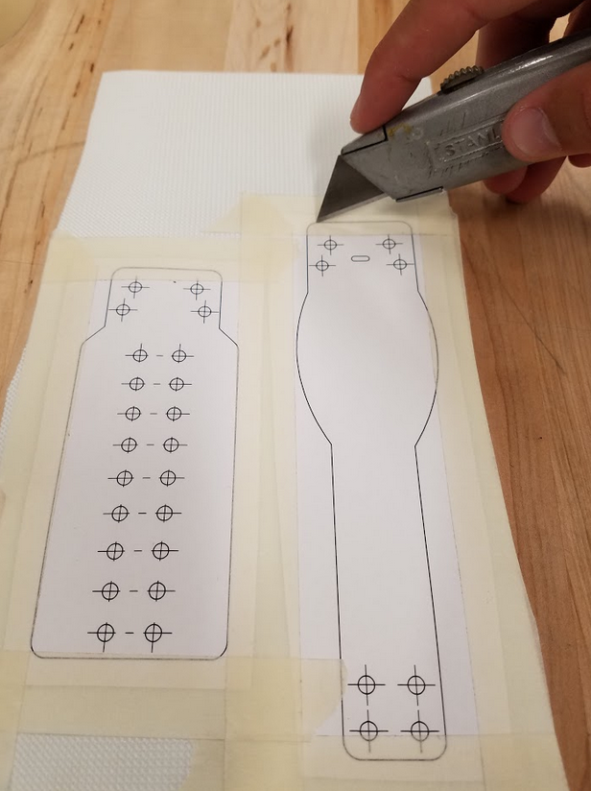

**Figure 30:** Cutting of the Collar Belting Straps

\*\***Steps 2.5.6 and 2.5.7 should be done after the fuzing of the belting material (Except for the SHORT_STRAP 001_V2_ManualCut strap - this may be cut prior to fuzing)\*\***

**2.5.6 Re-tape Collar Drawing on Belting Cutouts**

Tape the drawings back onto the sections of belting that were just cut out. Ensure that the perimeters of the drawing and belting collar cutout match exactly to ensure holes and be punched in their proper locations.

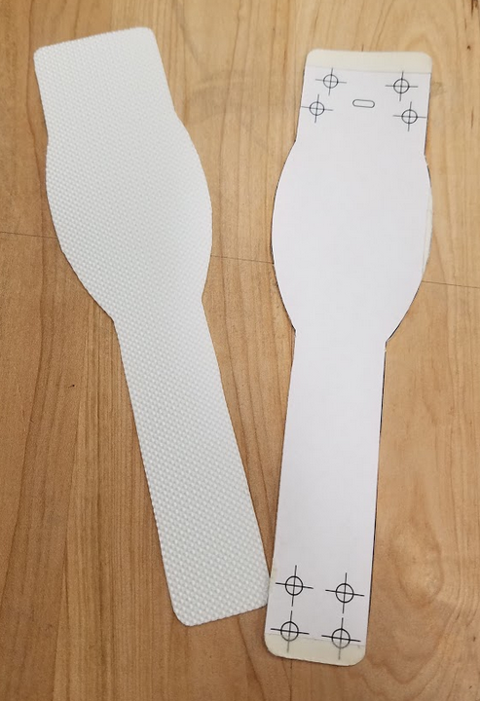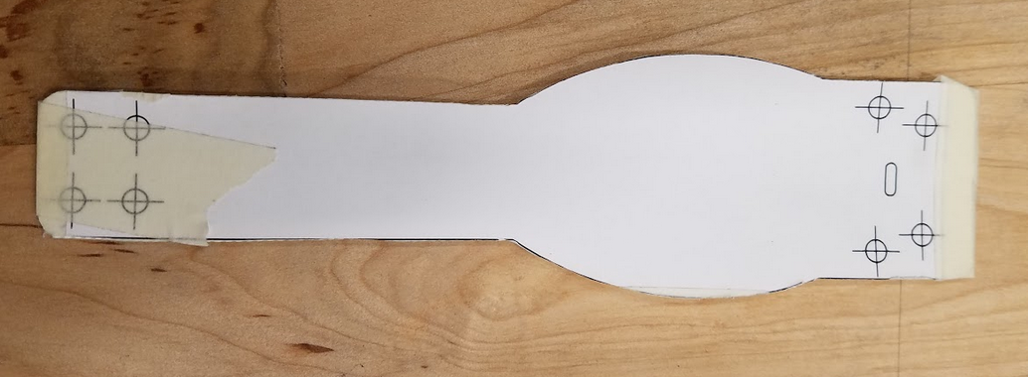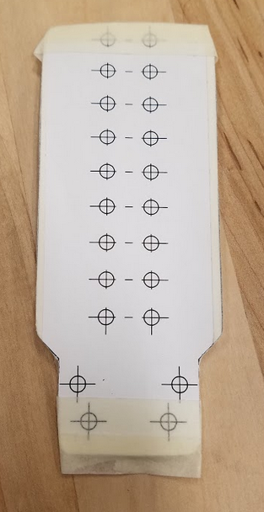

**Figure 31:** Drawing Cutouts taped back onto belting cutouts

**2.5.7 Hole Punch Required Holes in Sleeve**

Using the collar sections with drawings taped overtop, use a hole punch tool to cut the holes in each section of the collar (as necessary). Center the hole puncher on each hole, squeeze the puncher to penetrate the belting material, and twist the belting to shear off any excess attached material to cut the holes. Once holes are punched through the collar, the sections are ready to be dyed (Antenna Strap) or fused together (Small Strap).

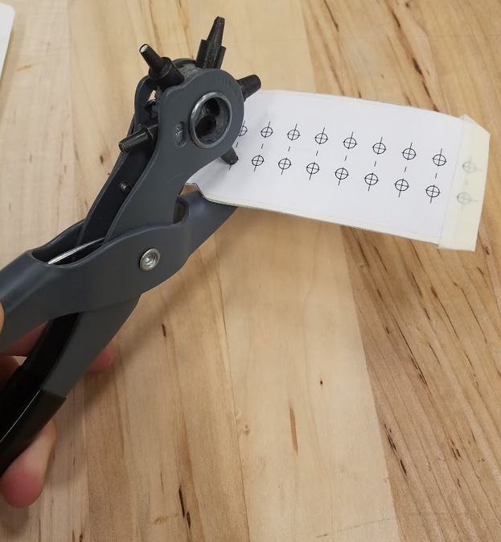

**Figure 32:** Punching of the collar straps

## 

## 2.6 Collar Belting Laser Cutter Setup

In-House laser cutting was investigated by the engineering team, and was not feasible with the school’s in-house laser cutter due to outdated setup software. The collar straps can easily be outsourced to any nearby laser cutting company (Lasers Unlimited Inc., Alro Plastics, Laser Dynamics, or any other laser cutting service company). Use the following files if pursuing outsourcing laser cutting of the collar belting: ANTENNA_STRAP 001_V2_LaserCut.pdf, ANTENNA_STRAP 002_V2_LaserCut.pdf, SHORT_STRAP 001_V2_LaserCut.pdf, SHORT_STRAP 002_V2_LaserCut.pdf, and for the small collar: SMALL_COLLAR_V0_LaserCut.pdf.

## 2.6 Collar Belting Sleeve Fusing

Fuzing of the collar sleeve material is optimally done with a fine-edged iron that can attain temperatures over 195°F. This ensures that the polyurethane layer of belting can be fully melted and allowed to solidify with the opposing collar layer, creating a uniform fuzed sleeve. The following steps should be followed to ensure the collar cutouts are fuzed together properly:

**2.6.1 Gather Required Materials**

Below are the materials needed to fuze the collar straps together, namely: the collar strap cutouts obtained in section 2.4, a fine edged iron, a C-clamp, a digital caliper, and a remnant 3.5” OD PVC piping for strap curvature.

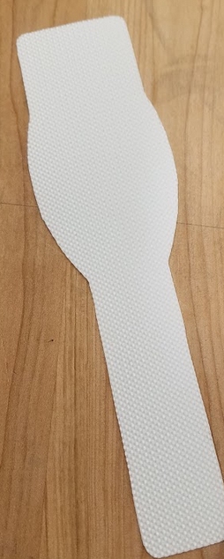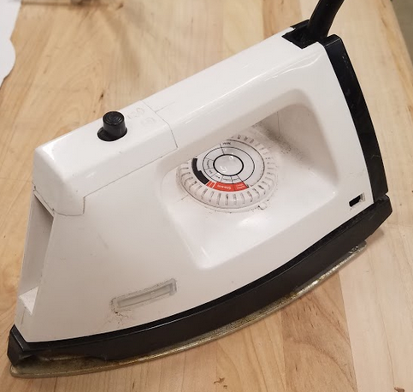

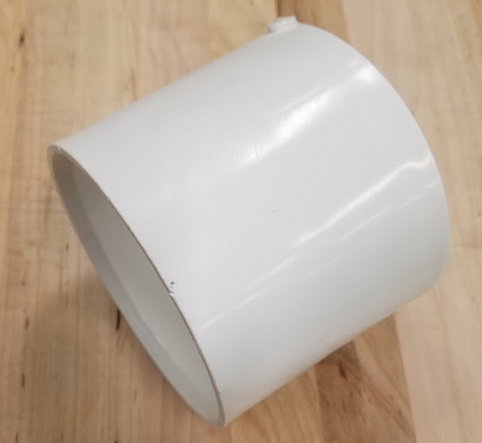

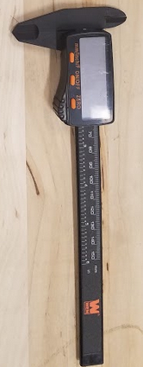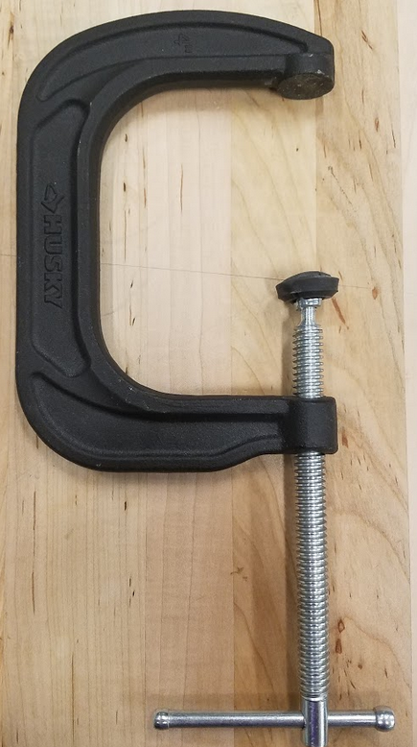

**Figure 33:** From top left to bottom right: Antenna Strap Cutout (only strap shown, 001 and 002 sections of each Antenna and Short Strap are needed), Fine Edged Iron, PVC remnant, digital caliper, and a C-clamp.

**2.6.2 Align Pieces of Belting Together and Lightly Secure with Tape**

Similar to step 2.5.6 in the cutting of the collar material, the collar layers are to be taped together on top of one another in preparation for fuzing. Tape the materials back-to-back with the rubber polyurethane side of the material facing the internal of the collar (the fabric-type side will be facing the outside of the collar).

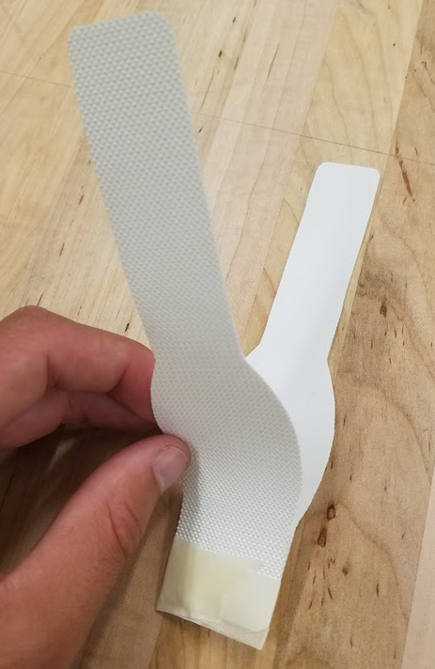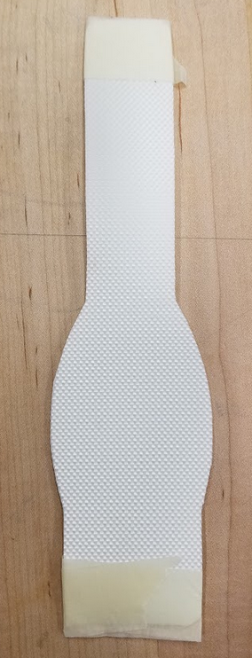

**Figure 34:** Example of collar layers taped together in preparation for fuzing: Antenna Strap

**2.6.2 Measure Fuze Line with Digital Caliper and Mark**

Using the digital Caliper and the recently aligned straps, measure roughly 0.125” from the collar edges and mark the line in which to fuze the collar. **NOTE: the Short Strap can be completely fuzed together, the Antenna Strap can only be fuzed on one side, the second side will be fuzed once the antenna is inserted into the collar in the complete assembly process (2.8.3).**

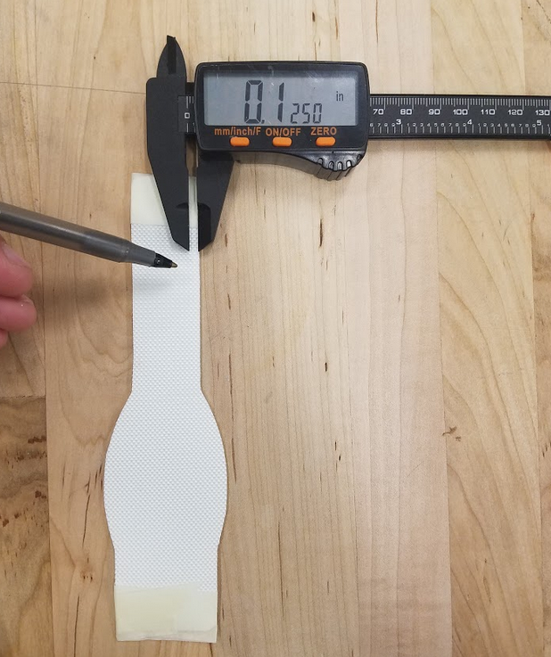 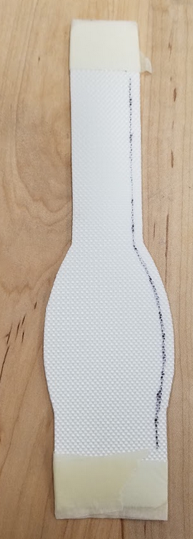 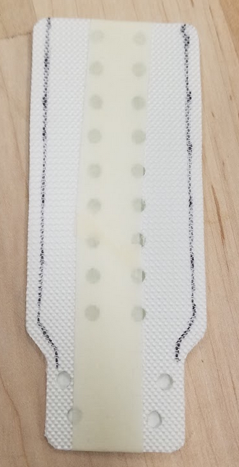

**Figure 35:** Straps marked and prepare for mounting onto PVC remnant

**2.6.2 Form Belting Pieces onto PVC piping for Curve Fitting, Secure with Tape**

Secure the PVC remnant onto a table with the C-clamp to ensure the fixture stays in place while performing the fuzing operation.

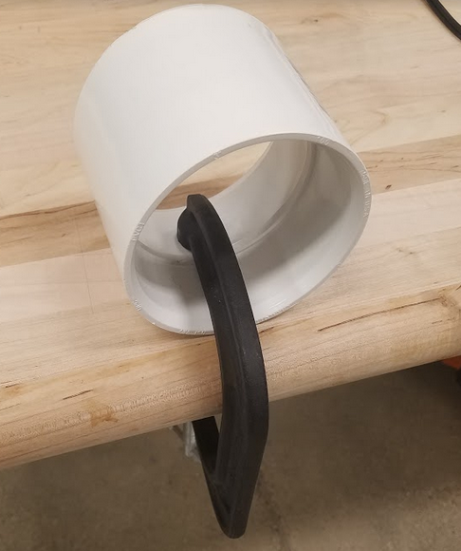

**Figure 36:** PVC Piping mounted to table with C-clamp

Secure the straps (one at a time) onto the PVC piping with tape.

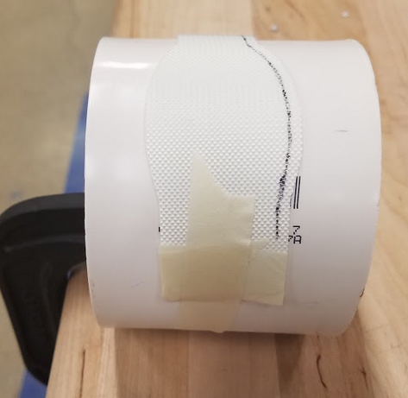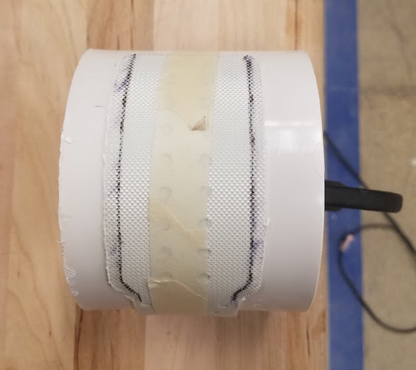

**Figure 37:** Collar straps taped onto PVC remnant

**2.6.3 Fuze Collar Sides**

Plug in the iron and allow it to heat up above the required 195°F (melting temperature of the polyurethane rubber layer of belting). Once the iron is heated to a sufficient temperature, carefully and slowly iron the edges of the straps. This may require some downward force on the collar to ensure the layers are melted together.

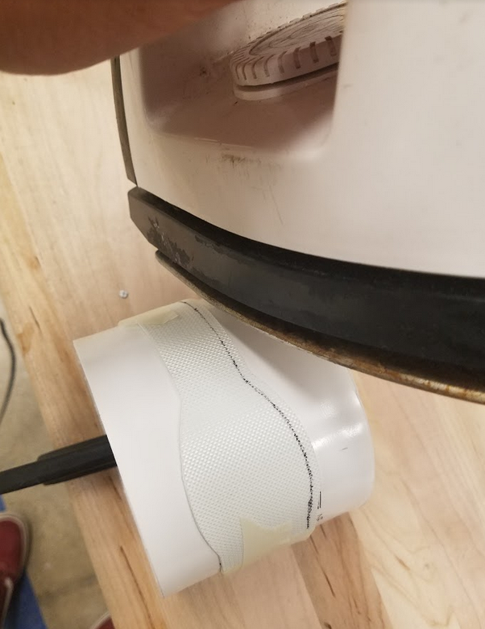

**Figure 38:** Fuzing of the collar layers together to create the sleeve (Antenna Strap).

**2.6.4 (OPTIONAL) Trim the excess melted polyurethane from the collar edges**

If there is a bunch of excess flashed polyurethane melt that has solidified outside of the strap perimeter, it can be trimmed off with a razor blade.

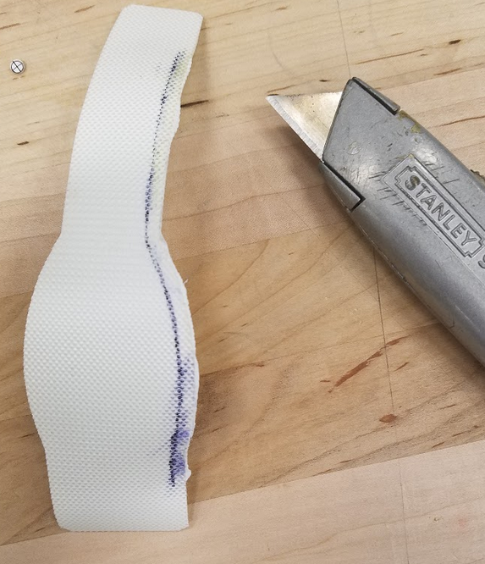

**Figure 39:** Optional trimming of the fuzed collar

## 2.7 Dying of Collar Muted Earth Tone

**2.7.1 Gather Materials**

Dying of the collar straps will require the fully fuzed short strap, and partially fuzed antenna strap (the small collar can also be dyed by the same process), pure brown epoxy pigment, a stirring stick (multiple are helpful), nitrile/rubber/chemical resistant gloves, and a well ventilated area. Put on the gloves and enter the ventilated area before beginning.

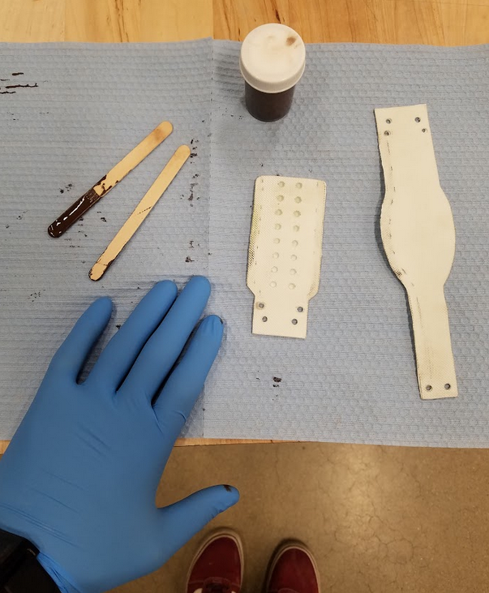

**Figure 40:** Materials in preparation for dying

**2.7.2 Prepare the dye**

Mix the dye thoroughly to ensure that the pigment is well mixed.

**2.7.3 Paint on belting material**

Paint the dye onto the belting material. Be careful to get even coverage over the whole surface. Some areas that are thicker will be rinsed off later. A liberal application is acceptable.

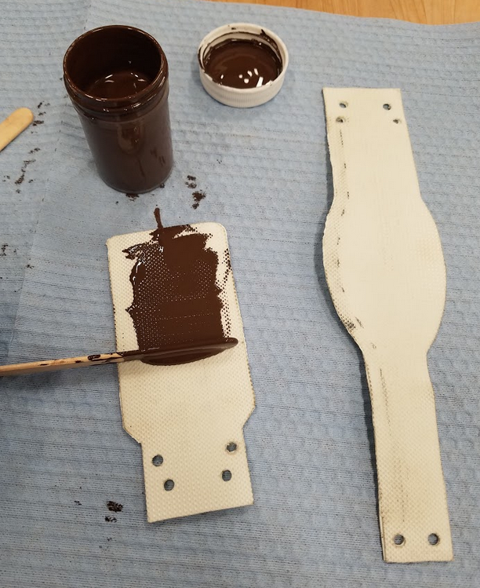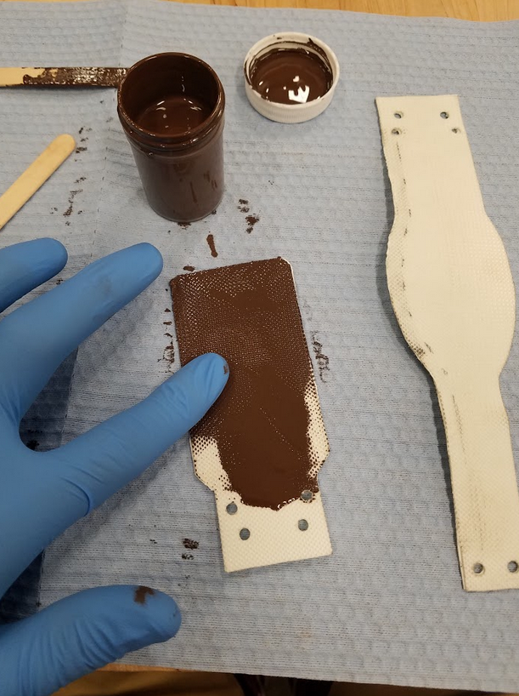

**Figure 41:** Dying of the collar straps; ensuring full coverage

**2.7.4 Let Dry and Finish**

Wipe any excess pigment from the straps using paper towel. Hang the straps by the holes in a well ventilated area (preferably with moving air) and let the belting material dry for 2-3 days to ensure the pigment has completely dyed the strap material. The belting is now dyed.

## 

## 2.8 Collar Assembly To Enclosure

**2.8.1 Gather materials**

Assembly will require a phillips head driver, a pair of needle nosed pliers or a wrench for 6-32 nuts, a 2mm hex wrench, 1 200mm strap (Half fused), 1 100mm strap completed, a completed lid with antennas and circuit board resin cast in place, and 1 bottom enclosure.

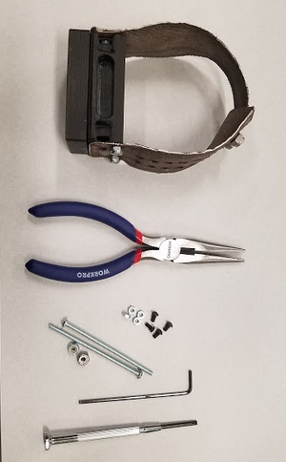

**Figure 42:** Materials and tools to assemble the collar strap to enclosure

**2.8.2 Route Antennas**

If gps antenna has not been soldered to the lead, do this after routing antenna wires from the lid through the gasket, bottom, and strap. Feed the antenna wires through half of the collar strap, and resotter the GPS antenna pad onto the cable.

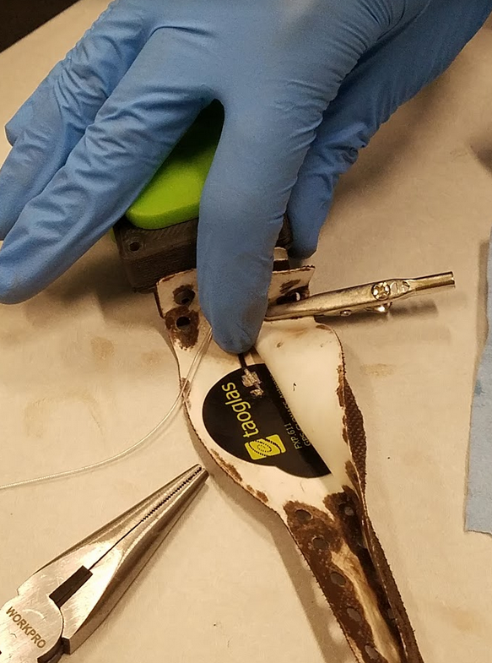

**Figure 43:** Rerouted Antennas and Resottering of Antenna

**2.8.3 Fuse Open Seams of Strap**

The 200mm strap will have an open edge to aide in the routing of the antennas. Fuse this seam with the antennas inside.

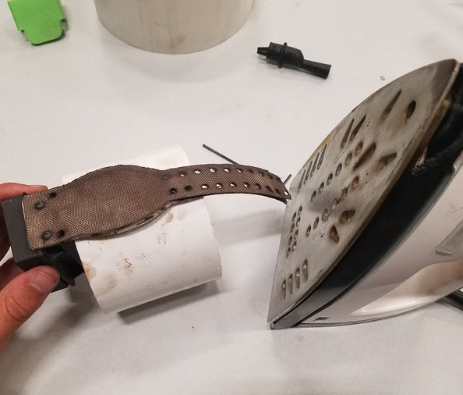

**Figure 44:** Fusing of open collar sleeve.

**2.8.4 Attach Lid to Bottom (see enclosure assembly instruction, section 2.3)**

Make sure the battery is attached and oriented properly. Attach the lid to the bottom of the enclosure with M3x20 fasteners as shown in section 2.3. Be sure that the gasket is properly deformed to complete watertight seal.

**2.8.5 Attach Straps**

The antenna strap should be in place already. Use 2x 6-32 fasteners with nylon locking nuts to hold straps in place as shown. On the antenna side, use 2x Mx6 screws to hold additional belting place over the antenna egress point.

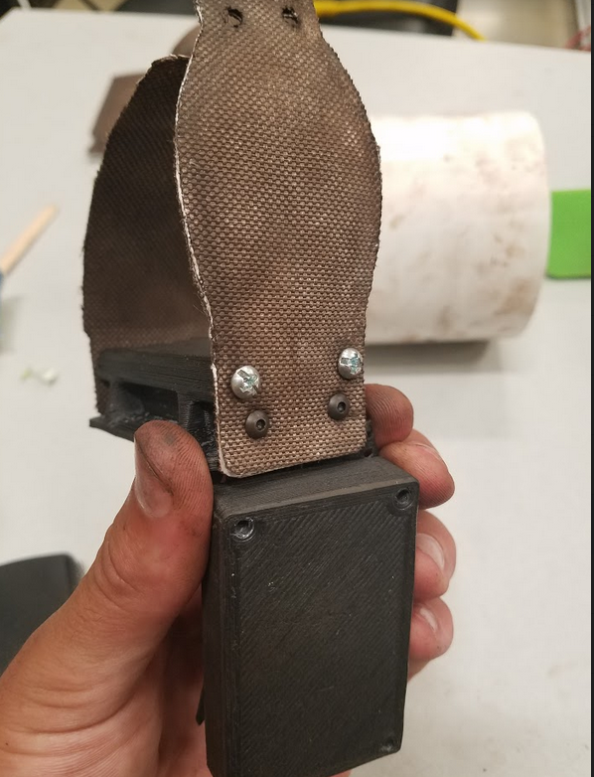

**Figure 45:** Attached collar strap to enclosure

**2.8.6 Collar is Assembled**

See 2.9 for collar strap adjustment.

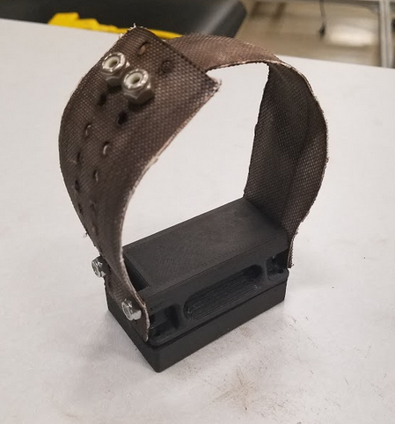

**Figure 46:** Assembled device

## 2.9 Adjusting Device Collar

**2.9.1** The assembled collar will have a stud plate and will be set to the largest size. To open the collar strap and adjust the size, a pair of pliers or an 11/32 socket driver, will be required.

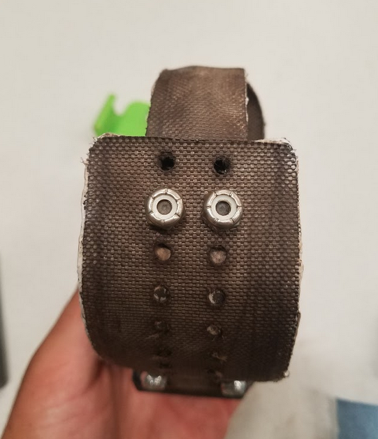

**Figure 47:** Stud plate secured in collar (2nd largest adjustment)

**2.9.2** Hold the strap and stud plate in place and loosen the 8-32 nuts. When the nuts are removed squeeze the shorter strap on either side, as shown below, and remove the end of the 200mm strap end. Then place the collar around the neck of the chosen specimen. Feed the end of the collar back into the 110mm strap, stud plate legs facing out. Select an appropriate size and force the legs through the holes to the outside.

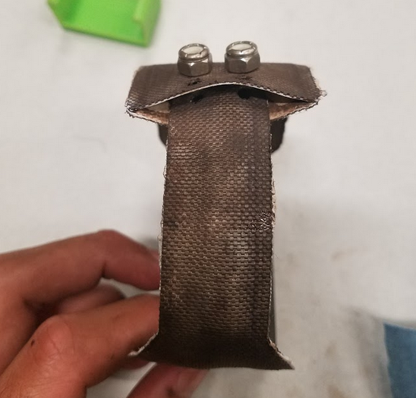

**Figure 48:** Inserted and secured stud plate & strap

**2.9.3** Re-attach the 8-32 nuts to the stud plates and tighten. The collar is now attached to the specimen chosen.

## 2.10 Stud Plate Fabrication

**2.10.1** **Obtain necessary materials for fabrication of the stud plate**

These materials include: 8/32 studs (2), a punch tool the stud plate punch fixture, a 3/16 punch tool, a digital caliper, and a small aluminum plate shown below. The stud plate dimensions are shown in drawing *StupPlate_Adjustor_v0.pdf* for reference.

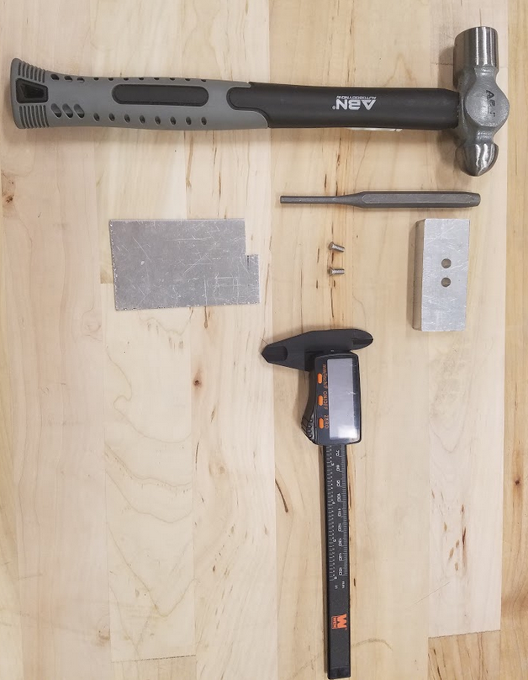

**Figure 49:** Materials needed for stud plate adjustor fabrication

**2.10.2 Measure Aluminum Plate to Dimension and Cut/Grind to Size**

Measure the aluminum raw material to the size of the adjustor referenced in the drawing above (7.63mm X 22.00mm).

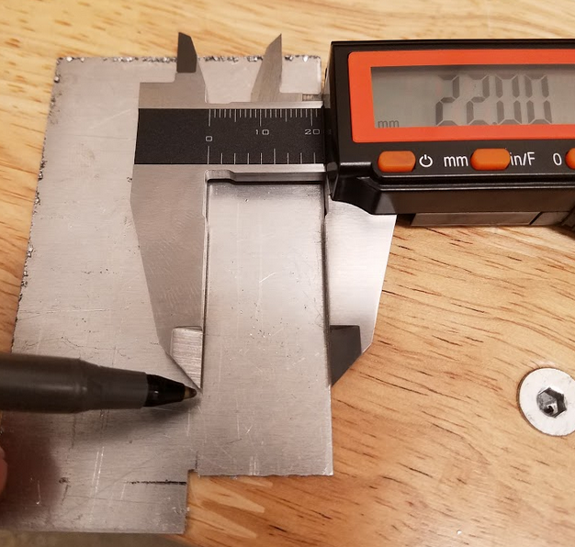

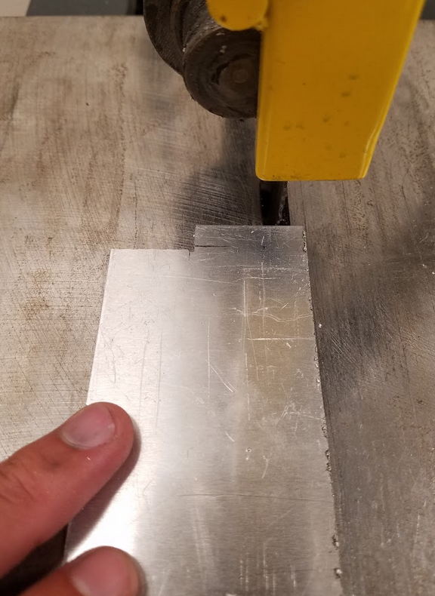

**Figure 50:** Measuring and cutting of aluminum plate

**2.10.3 Stud Hole Measurement**

Per the drawing referenced above, carefully measure and mark the placement of the stud holes on the cutout aluminum plate. With a hole quite punch, lightly punch the hole locations for reference in the drilling operation.

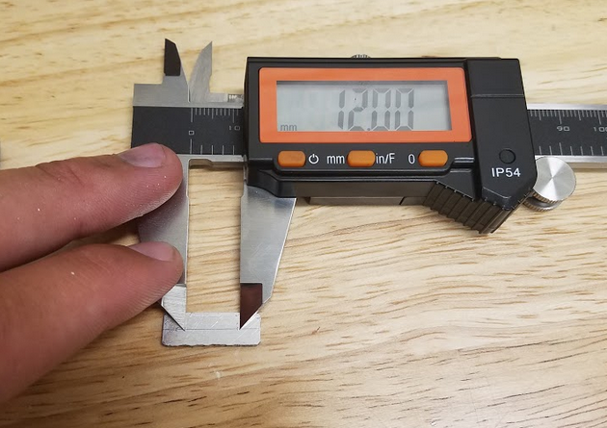

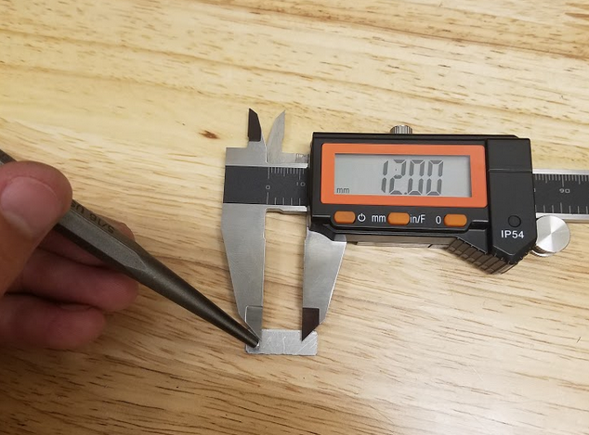

**Figure 51:** Measuring and punching of hole locations on aluminum plate

**2.10.4 Drilling of Stud Holes**

Drill the holes in the aluminum plate with a **#20 drill bit**. The drill bit size is crucial to the securing of the studs in the aluminum plate.

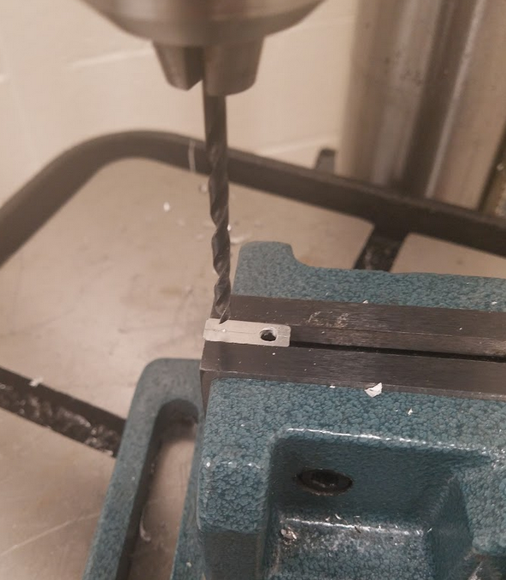

**Figure 52:** Drilling of holes in aluminum plate

**2.10.5 Punching of Studs in Place**

Using the stud plate punching fixture, the drilled plate, and the 8/32 studs align the plate and studs over the fixture to prepare for punching. Insert the studs into the plate so that the threaded portion of the stud is through the plate and into the through-holes in the punching fixture. Using the hammer and the 3/16 punch tool, punch the studs into the aluminum plate so secure them into place for use.

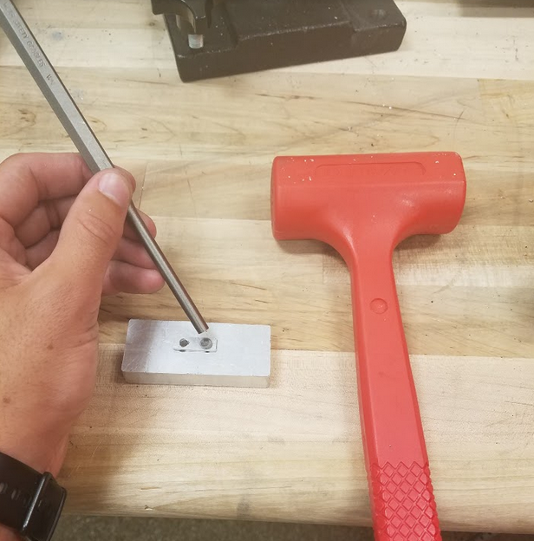

**Figure 53:** Punching of the studs into the aluminum plate

## 2.11 Epoxy Pouring and Curing of PCB into Enclosure

**2.11.1** DO NOT BEGIN EPOXY PROCESSING BEFORE ENSURING THAT THE ANTENNAS ARE ATTACHED TO THE PCB AND ARE PROPERLY ROUTED THROUGH THE LID, GASKET, ENCLOSURE BOTTOM, AND STRAP (it is recommended to solder the GPS antenna to the lead after potting so that the antennas can be routed through the gasket, bottom and strap after epoxy sets.) Failure to ensure that the wires are routed will result in collar not being able to be assembled properly. The antennas will require a backup gasket inside the enclosure just before the egress to the outside. This gasket prevents water from working its way along the insulation of the antenna wires.

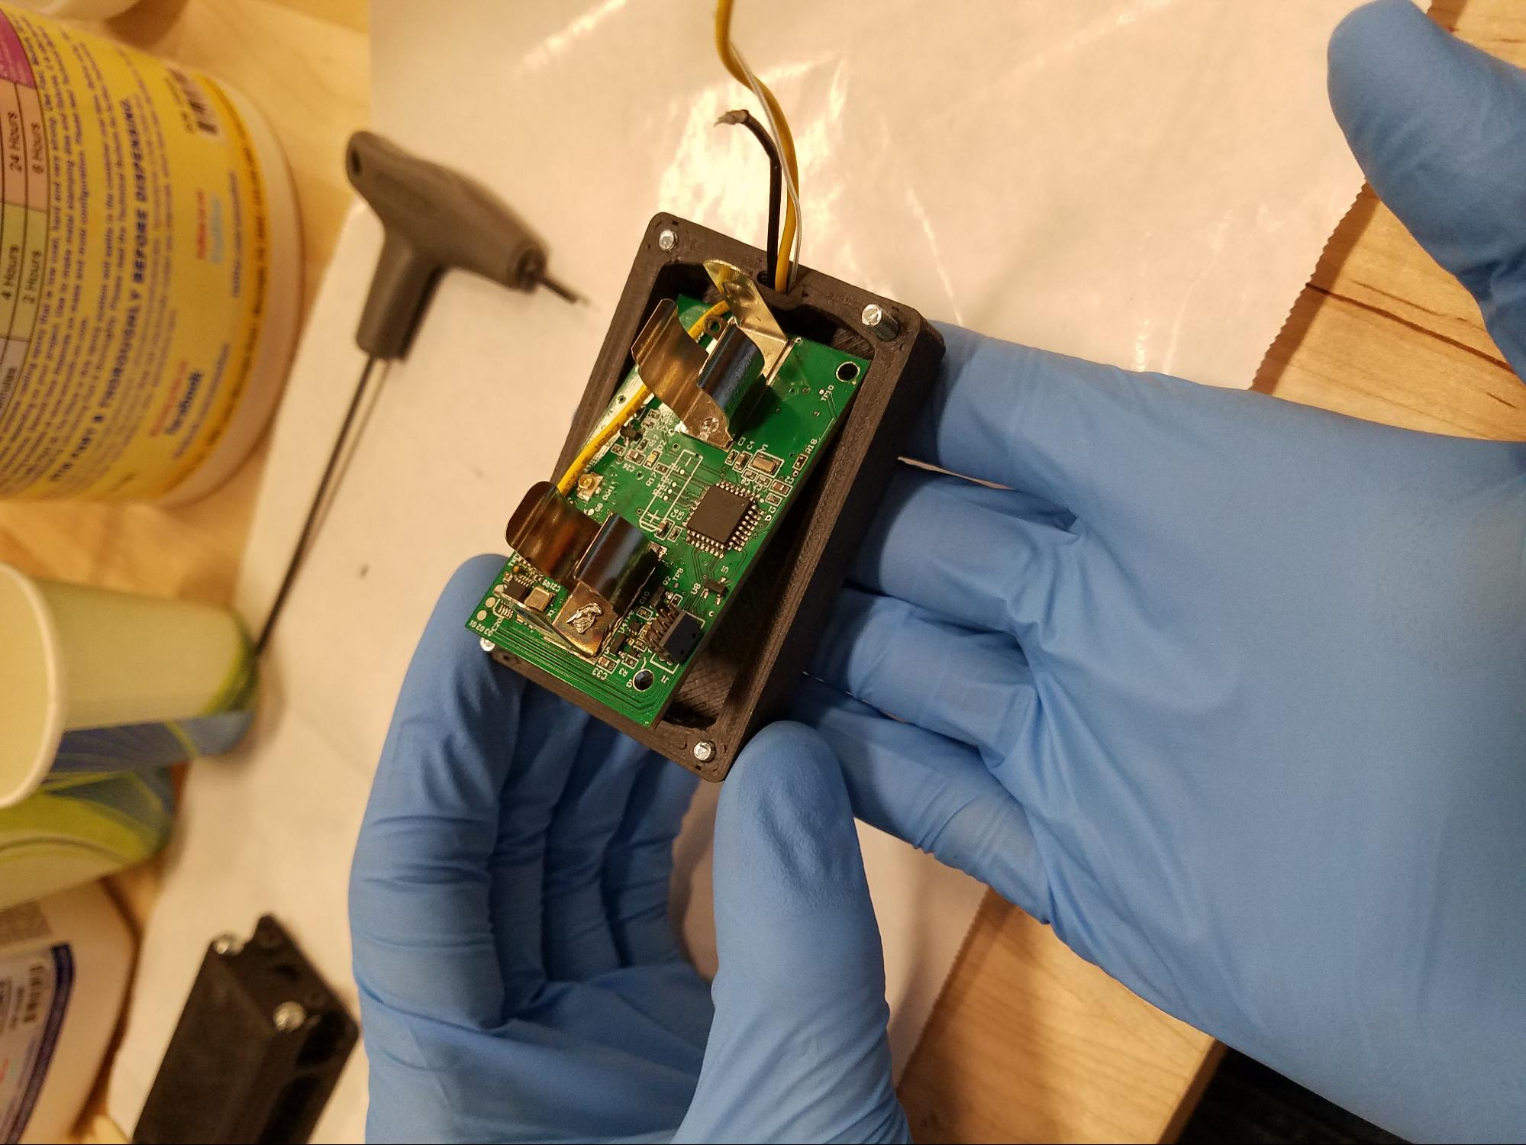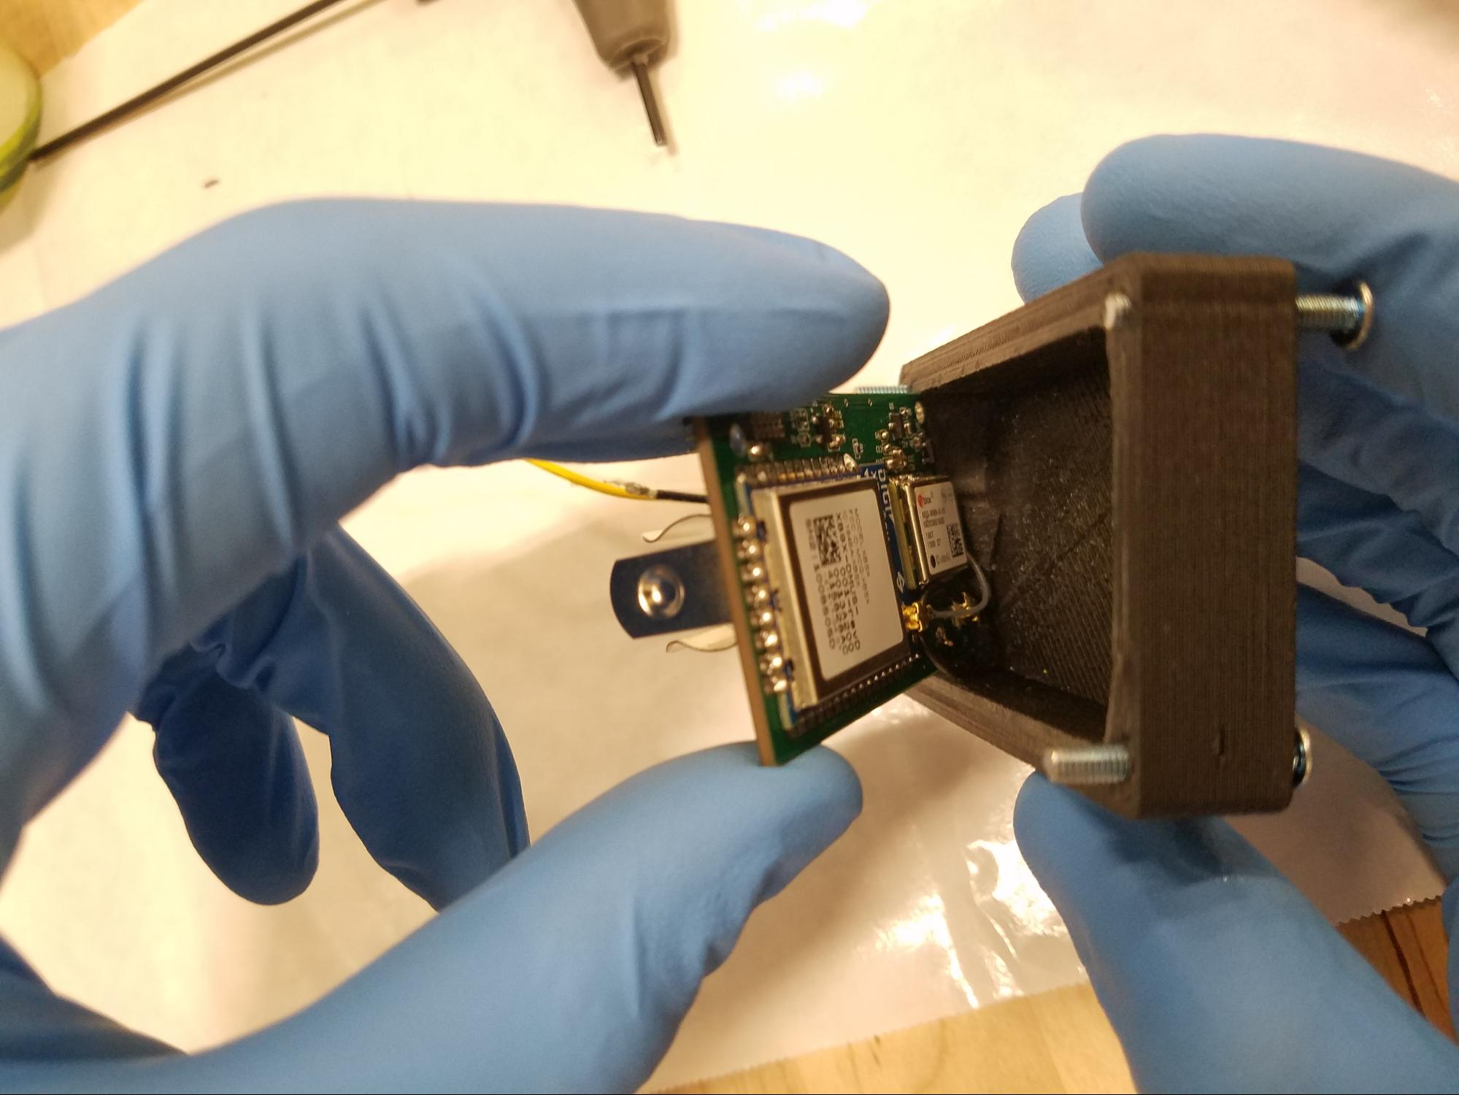

**Figures 54 and 55:** Enclosure inserted into enclosure lid with gasket around antennas

**2.11.2** Gather the EpoxAcast™ 650 and 101 Hardener. Rubber gloves, mask, gram scale, mixing stick, cup or mixing vessel, and proper ventilation will be needed. Pre mix the “Part A” before continuing using a paddle mixer or manually using a stirrer or 1-2 minutes or until filler particles are uniformly distributed.

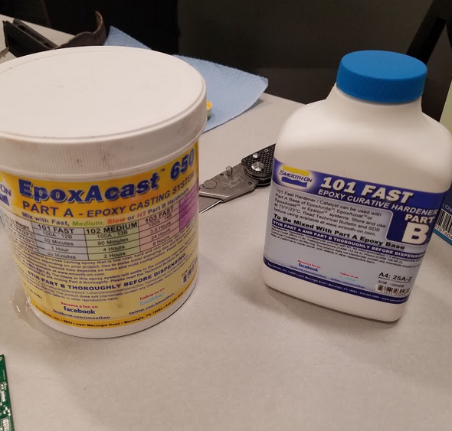

**Figure 56:** Staged potting epoxy resin

**2.11.3** 100 parts of epoxy part A will be mixed with 12 parts of the part B hardener by weight. Aggressively mix the two parts in a container with the mixing stick, being sure to get the sides and edges of the container. Mixing should take ~3 minutes.

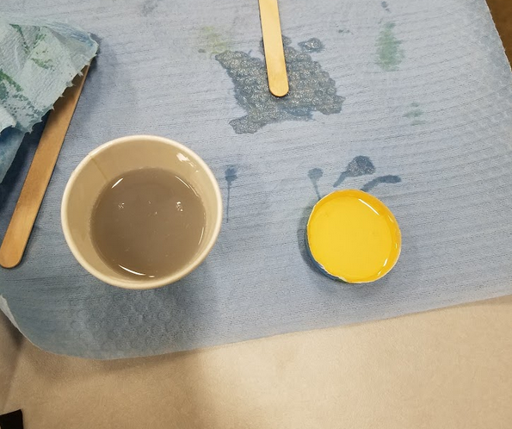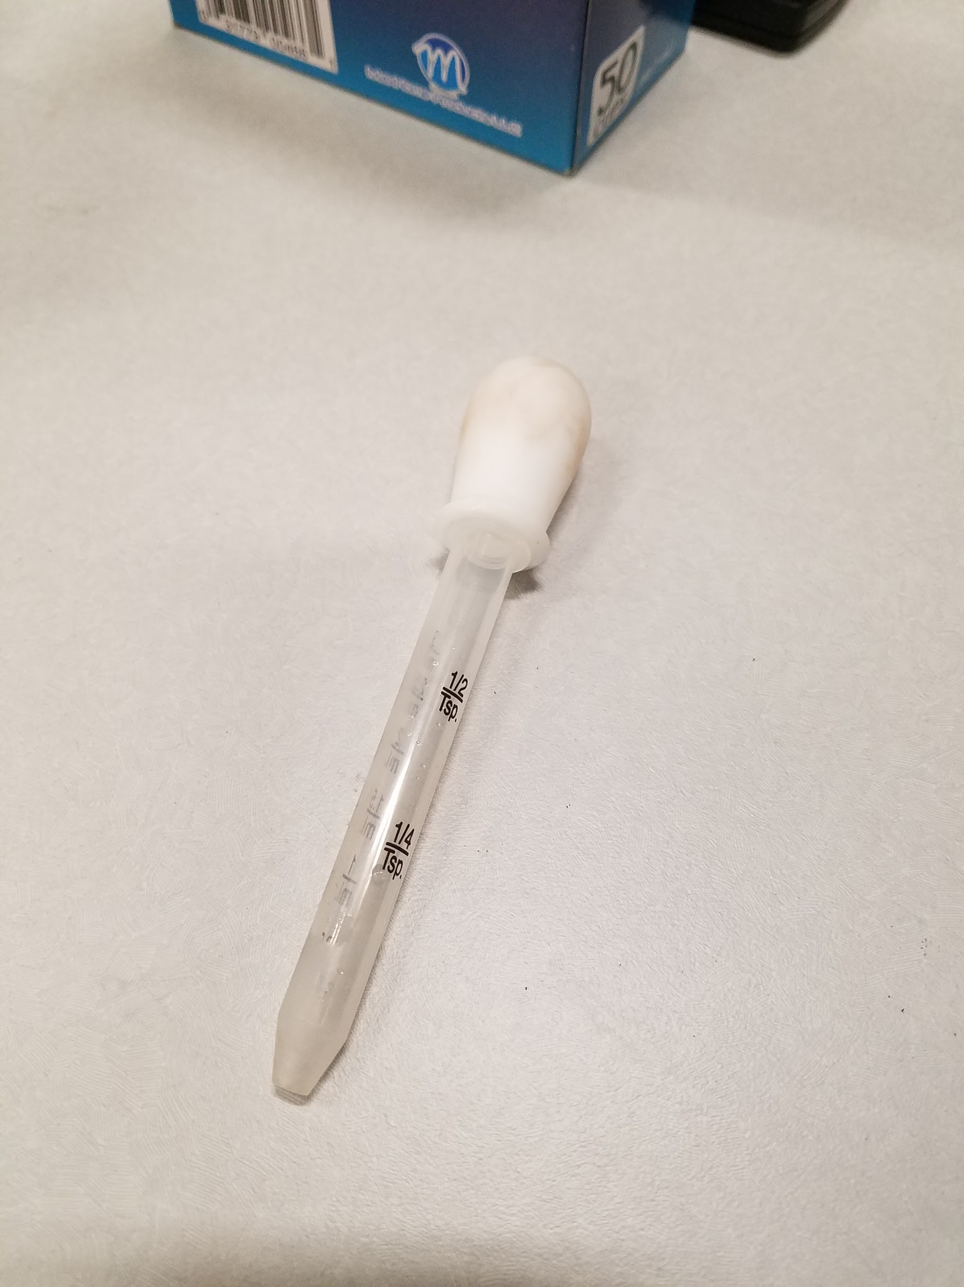

**Figure 57, 58, 59:** Portions of potting epoxy, cups, and pipet

**2.11.4** Pour the epoxy resin into the enclosure lid being sure that the entire circuit board is covered. It may be beneficial to paint the epoxy onto the back of the board before fully seating the board into the lid. Tilt the lid towards the end with egress for the antennas. THE HOLE WHERE THE ANTENNAS EXIT MUST BE COMPLETELY SEALED. FAILURE TO FOLLOW THIS INSTRUCTION WILL RUIN THE WATERTIGHT SEAL. Be sure that the SPI header is above the level of the epoxy or else the board will not be able to interface with a computer ever again. Note that using a pipet is useful in administering epoxy to all areas of the board evenly. The epoxy will run to the end of the enclosure, this is normal. Make sure that the gasket dam is saturated and antenna hole is filled. Wait until curing is complete before laying flat. Epoxy must be completely set in the tilted position.

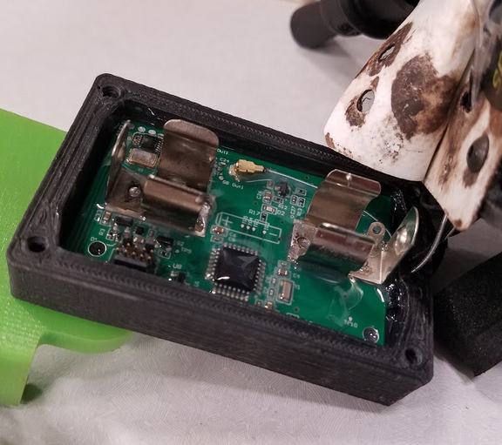

**Figure 60:** Potted PCB in Lid

**2.11.5** Inspect the epoxy potting. If there are imperfections or spots on the board that are not sealed, additional epoxy may be added. Epoxy potting is complete.

## 2.12 Small Collar Fabrication (Epoxy Coating, Shrink Tubing, and Fastening)

## 2.12.1 Epoxy Potting - (follow procedure 2.11 above for preparation instructions)

**2.12.1.2** DO NOT BEGIN EPOXY PROCESSING BEFORE ENSURING THAT THE ANTENNA IS ATTACHED TO THE PCB. Failure to complete this step will result in a nonfunctional collar.

**2.12.1.3** see 2.11.2

**2.12.1.4** see 2.11.3

**2.12.1.5** Allow epoxy resin to begin to cure. As it thickens apply epoxy to the circuit board with a brush. Either plug solder pads and cover SPI connector, as shown in the images below, or carefully avoid these areas with epoxy to ensure they can be accessed later. Using a disposable work surface like plastic film or wax paper is recommended.

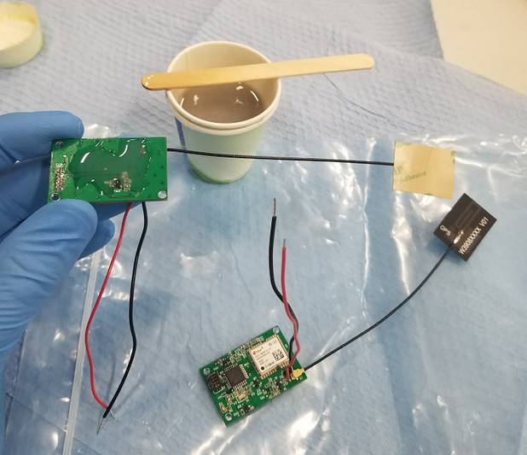

**Figure 61:** Slightly cured epoxy slowly coated onto PCBs

**2.12.1.6** When a thick coating of epoxy potting has been built up place the circuit board on the disposable surface to solidify. The board may need to be cut free after curing, if necessary, and sanded to remove excess resin.

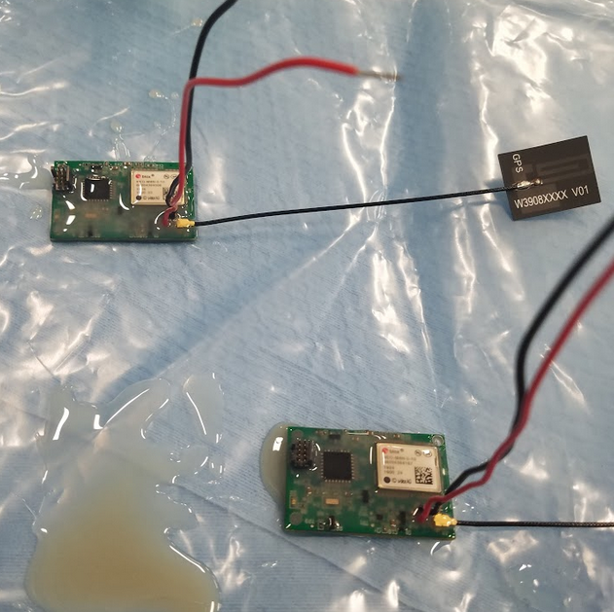

**Figure 62:** Small PCBs potted in epoxy on plastic surface

**2.12.1.7** The potting process is complete for the small collar circuit board. Dispose of excess and waste materials responsibly.

## 2.12.2 Battery and Antenna Placement

**2.12.2.1** The antenna and battery must be placed on top of the circuit board as shown below, for final assembly to fit within the specified 40mm x 25mm x 25 mm volume.

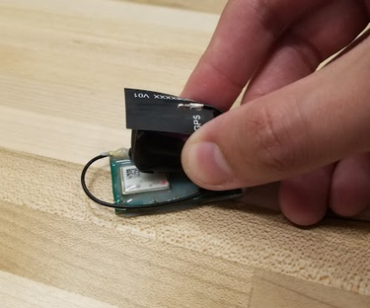

**Figure 63:** Configuration #1: Battery and antenna on top of board

**2.12.2.2** Alternative configurations, shown below, allow for a lower profiles but will require more shrink tubing. All configurations are acceptable, ask biologist for direction based on species being tracked.

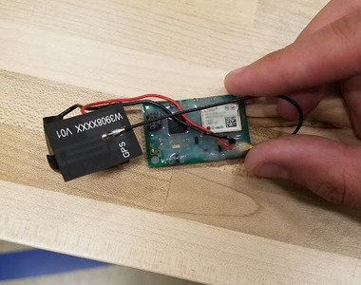

**Figure 65:** Configuration #2: Battery and antenna next to PCB

## 2.12.3 Shrink Tubing

**2.12.3.1** This operation must be done in a well ventilated area or under a fume extractor. Allow electrical technician to attach the battery to the terminals on the board before continuing. Gather shrink tubing and heat gun before continuing. Set heat gun temperature according to recommended settings in specifications sheet.

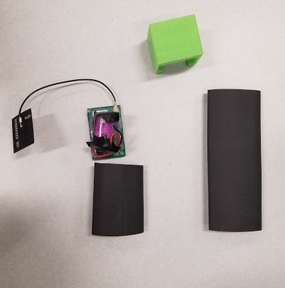

**Figure 66:** Materials gathered and battery connected (Small collar strap not present)

**2.12.3.2** Slide the circuit board, battery and antenna into the sleeve of the shrink tubing, allowing for some excess on the ends. Heat the tubing evenly and allow tubing to shrink wrap the assembly together as shown.

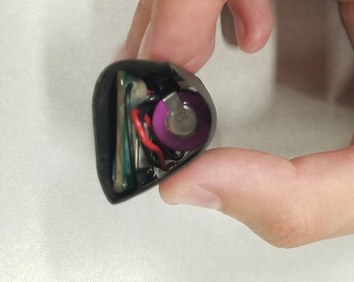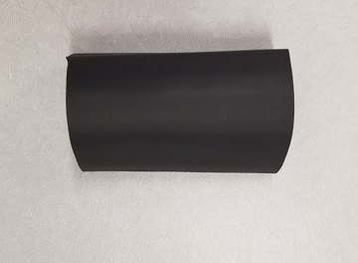

**Figure 67:** Board, antenna, and battery in shrink tubing

**2.12.3.3** If collar is being used independently add a second layer of shrink tubing the opposite direction and slide collar strap under the electronics assembly. Heat tubing again, adhering the strap to the small collar assembly.

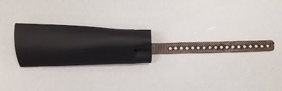

**Figure 68:** Second layer of heat shrink around collar (not secured)

**2.12.3.4** Heat shrinking is complete. Dispose of excess and waste materials responsibly. Turn off heat gun.

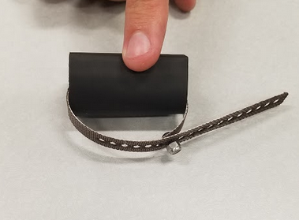

**Figure 69:** Final Small Collar

## 

## 2.12.4 Strap Assembly

**2.12.4.1** Gather strap, M3x6 fastener, and M3 nylon locking nut.

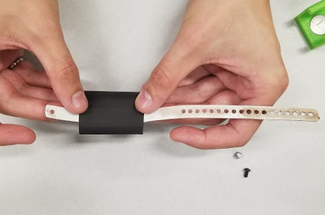

**Figure70:** Shrink wrapped strap, fastener, and locking nut

**2.12.4.2** Place M3x6 fastener through the single hole as shown below. Pass the threaded end through desired hole on the adjustment side of the strap. Tighten the M3 nylon nut onto the fastener. If desired, cut the excess strap when fitting to an animal.

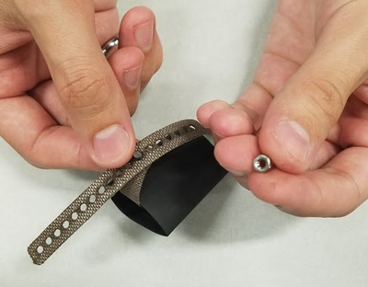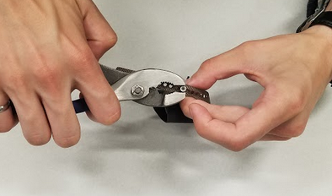

**Figure 71:** Strap with fastener securing into adjustment hole

**2.12.4.3** Strap assembly is complete.



**Figure 72:** Complete Small Collar

# 3. Electrical Fabrication, Assembly, and Verification

Fabrication, assembly, and verification of the electrical components for the Wildlife GPS Tracking collar is to be done by a knowledgeable person capable of populating printed circuit boards (PCBs) or purchased from a company capable of automating the production of the PCBs. The boards in question are spatially minimized for the application of the collar, thus it takes a steady hand to populate the PCBs with the desired components. A BOM of the components used for the circuit boards is given below:

**Table 2:** Large Collar PCB BOM

|  |  |  |  |  |  |  |  |
| --- | --- | --- | --- | --- | --- | --- | --- |
| Line # | Name | Description | Designator | Quantity | Value | Manufacturer 1 | Manufacturer Part Number 1 |
| 1 | KEYSTONE_99 |  | BT1 | 1 |  | Keystone Electronics | 99 |
| 2 | C0402 | 0402 Ceramic Chip Capacitor - Standard | C1, C3, C5, C9, C11, C12, C15, C16, C19, C25, C28, C31 | 12 | 0.1uF | Samsung | CL05F104ZO5NNNC |
| 3 | C0603 | 0603 Ceramic Chip Capacitor - Standard | C2, C4, C6, C13, C26, C29, C32, C33, C34, C35 | 10 | 4.7uF | Samsung | CL10A475KO8NNNC |
| 4 | C0402 | 0402 Ceramic Chip Capacitor - Standard | C7, C8 | 2 | 4.3pF | Murata | GRM1555C1H4R3CA01D |
| 5 | C0402 | 0402 Ceramic Chip Capacitor - Standard | C10, C21 | 2 | 1uF | Samsung | CL05A105MP5NNNC |
| 6 | C0402 | 0402 Ceramic Chip Capacitor - Standard | C14, C27, C30 | 3 | 0.022uF | Taiyo Yuden | EMK105B7223KV-F |
| 7 | Chip Capacitor | Chip Capacitor | C17, C22 | 2 | 10 pF | Murata | GCM1555C1H100FA16D |
| 8 | Chip Capacitor | Chip Capacitor | C18 | 1 | np |  |  |
| 9 | Chip Capacitor | Chip Capacitor | C20 | 1 | 100 pF | Murata | GRM1555C1H101JA01J |
| 11 | Chip Capacitor | Chip Capacitor | C23, C24 | 2 | 18 pF | KEMET | CBR04C180F5GAC |
| 13 | RB521S30T1G | Schottky Barrier Diode, 2-Pin SOD-523, Pb-Free, Tape and Reel | D1 | 1 |  | ON Semiconductor | RB521S30T1G |
|  | D0603 | 0603 SMD LED | D2 | 1 | B | Lite-On Inc. | LTST-C193TBKT-5A |
| 14 | 10 PIN | 10 Pin Programming Header | J1 | 1 |  | Samtec | FTSH-105-01-F-D-K |
| 15 | 73412-0110 | 50 Ohms, MCRF, PCB Vertical Jack Receptacle, SMT, 1.25mm Mounted Height | J2, J4 | 2 |  | Molex | 73412-0110 |
| 16 | 402 | 0402 Inductor | L1, L3 | 2 | 100 nH | TDK | MLG1005SR10JT000 |
| 17 | 402 | 0402 Inductor | L2 | 1 | 390 nH | TDK | MHQ1005PR39HT000 |
| 18 | 402 | 0402 Inductor | L4 | 1 | 91 nH | TDK | MLG1005S91NJT000 |
| 19 | NTR2101PT1G | Small Signal MOSFET, -8 V, -3.7 A, Single P-Channel, 3-Pin SOT-23, Pb-Free, Tape and Reel | Q1, Q3, Q4, Q5 | 4 |  | ON Semiconductor | NTR2101PT1G |
| 20 | 2N7002ET1G | Small Signal MOSFET, 60 V, 310 mA, Single, N-Channel, 3-Pin SOT-23, Pb-Free, Tape and Reel | Q2 | 1 |  | ON Semiconductor | 2N7002ET1G |
| 21 | R0402 | 0402 Chip Resistor - Standard | R1, R18 | 2 | 47k | Yageo | RC0402FR-0747KL |
| 22 | R0402 | 0402 Chip Resistor - Standard | R2, R17 | 2 | 220R | TE Connectivity | CRGCQ0402F220R |
| 23 | R0402 | 0402 Chip Resistor - Standard | R3, R4 | 2 | 500k | Panasonic | ERJ-2RKF4993X |
| 24 | R0402 | 0402 Chip Resistor - Standard | R5, R6, R11, R12, R14, R15 | 6 | 1.0M | Yageo | RC0402FR-071ML |
| 25 | R0402 | 0402 Chip Resistor - Standard | R7, R13, R16 | 3 | 220k | Bourns | CR0402-FX-1002GLF |
| 26 | Chip Resistor | Chip Resistor | R8 | 1 | NP |  |  |
| 27 | Chip Resistor | Chip Resistor | R9, R10 | 2 | 0 | Yageo | RC0402JR-070RL |
|  | STM32L071KZT6 | STMicro ARM M0+ Microcontroller | U1 | 1 |  | STMicroelectronics | STM32L071KZT6 |
|  | RF RCVR GNSS/GPS 1.575GHZ 24LCC | Concurrent GNSS LCC module, TCXO, Flash, SAW, LNA | U2 | 1 |  | u-blox | NEO-M8N-0 |
| 30 | DRV5032FBDBZT | Hall Effect Sensor | U3 | 1 |  | Texas Instruments | DRV5032FBDBZT |
| 29 | IC REG LINEAR 3.3V 200MA ESV | Linear Voltage Regulator IC Positive Fixed 1 Output 200mA ESV | U4 | 1 |  | Toshiba | TCR2EE33,LM(CT |
| 32 | Si4010-GT | Transmitter/MCU | U5 | 1 | - | Silicon Labs | SI4010-C2-GT |
| 33 | Gain Block |  | U6 | 1 |  | Infineon | BGA427H6327XTSA1 |
| 34 | XB9X-DMUS-001 |  | U7 | 1 |  | Digi International | XB9X-DMUS-001 |
| 35 | STM809TWX6F | IC MPU RESET CIRC 3.08V SOT23 | U8 | 1 |  | STMicroelectronics | STM809TWX6F |
| 36 | Crystal |  | X1 | 1 | 10 MHz | ECS International | ECS-100-10-30B-CKL-TR |
| 37 | 32.768kHz | NDK RTC 12.5pF Crystal SMD | Y1 | 1 |  | NDK | NX3215SA-32.768K-STD-MUA-8 |
| 24 | RF ANT 1.6GHZ FLAT PATCH IPEX | GPS Antenna | N/A | 1 | 1.6 GHz | Taoglas Limited | FXP611.07.0092C |
| 25 | RF ANT 915MHZ WHIP STR U.FL CONN | XBEE Antenna | N/A | 1 | 915 MHz | Anaren | 66089-0906 |

**Table 3:** Small Collar PCB BOM

|  |  |  |  |  |  |  |  |
| --- | --- | --- | --- | --- | --- | --- | --- |
| Line # | Name | Description | Designator | Quantity | Value | Manufacturer 1 | Manufacturer Part sNumber 1 |
| 1 | C0402 | 0402 Ceramic Chip Capacitor - Standard | C1, C3, C4, C6, C8, C12 | 6 | 0.1uF | Samsung | CL05F104ZO5NNNC |
| 2 | C0402 | 0402 Ceramic Chip Capacitor - Standard | C2 | 1 | 1uF | Samsung | CL05A105MP5NNNC |
| 3 | C0603 | 0603 Ceramic Chip Capacitor - Standard | C5, C7, C9, C13, C16, C17, C18, C19 | 8 | 4.7uF | Samsung | CL10A475KO8NNNC |
| 4 | C0402 | 0402 Ceramic Chip Capacitor - Standard | C10, C11 | 2 | 4.3pF | Murata | GRM1555C1H4R3CA01D |
| 5 | C0402 | 0402 Ceramic Chip Capacitor - Standard | C14 | 1 | 22nF | Taiyo Yuden | EMK105B7223KV-F |
| 6 | C0402 | 0402 Ceramic Chip Capacitor - Standard | C15 | 1 | 100nF | Samsung | CL05F104ZO5NNNC |
| 7 | RB521S30T1G | Schottky Barrier Diode, 2-Pin SOD-523, Pb-Free, Tape and Reel | D1 | 1 |  | ON Semiconductor | RB521S30T1G |
| 8 | D0603 | 0603 SMD LED | D2 | 1 | B | Lite-On Inc. | LTST-C193TBKT-5A |
| 9 | 10 PIN | 10 Pin Programming Header | J1 | 1 |  | Samtec | FTSH-105-01-F-D-K |
| 10 | 73412-0110 | 50 Ohms, MCRF, PCB Vertical Jack Receptacle, SMT, 1.25mm Mounted Height | J2 | 1 |  | Molex | 73412-0110 |
| 11 | NTR2101PT1G | Small Signal MOSFET, -8 V, -3.7 A, Single P-Channel, 3-Pin SOT-23, Pb-Free, Tape and Reel | Q1, Q3 | 2 |  | ON Semiconductor | NTR2101PT1G |
| 12 | 2N7002ET1G | Small Signal MOSFET, 60 V, 310 mA, Single, N-Channel, 3-Pin SOT-23, Pb-Free, Tape and Reel | Q2 | 1 |  | ON Semiconductor | 2N7002ET1G |
| 13 | R0402 | 0402 Chip Resistor - Standard | R1, R8 | 2 | 220R | TE Connectivity | CRGCQ0402F220R |
| 14 | R0402 | 0402 Chip Resistor - Standard | R2, R3 | 2 | 500k | Panasonic | ERJ-2RKF4993X |
| 15 | R0402 | 0402 Chip Resistor - Standard | R4, R9 | 2 | 47k | Yageo | RC0402FR-0747KL |
| 16 | R0402 | 0402 Chip Resistor - Standard | R5, R6 | 2 | 1.0M | Yageo | RC0402FR-071ML |
| 17 | R0402 | 0402 Chip Resistor - Standard | R7 | 1 | 220k | Bourns | CR0402-FX-1002GLF |
| 18 | IC REG LINEAR 3.3V 200MA ESV | Linear Voltage Regulator IC Positive Fixed 1 Output 200mA ESV | U1 | 1 |  | Toshiba | TCR2EE33,LM(CT |
| 19 | DRV5032FBDBZT | Hall Effect Sensor | U2 | 1 |  | Texas Instruments | DRV5032FBDBZT |
| 20 | STM32L071KZT6 | STMicro ARM M0+ Microcontroller | U3 | 1 |  | STMicroelectronics |  |
| 21 | RF RCVR GNSS/GPS 1.575GHZ 24LCC | Concurrent GNSS LCC module, TCXO, Flash, SAW, LNA | U4 | 1 |  | u-blox | NEO-M8N-0 |
| 22 | STM809TWX6F | IC MPU RESET CIRC 3.08V SOT23 | U5 | 1 |  | STMicroelectronics | STM809TWX6F |
| 23 | 32.768kHz | NDK RTC 12.5pF Crystal SMD | Y1 | 1 |  | NDK | NX3215SA-32.768K-STD-MUA-8 |
| 24 | RF ANT 1.6GHZ FLAT PATCH IPEX | 1.6GHz Galileo, GLONASS, GPS Flat Patch RF Antenna 1.559GHz ~ 1.61GHz 3dBi U.FL (UMCC), IPEX MHF1 Adhesive | N/A | 1 |  | Taoglas Limited | FXP611.07.0092C |

## 3.1 Hardware Overview

**3.1.1** Both boards are four layer, 1.6mm PCBs. Both are populated with 0402 size passive components. Each board also has a stencil for applying solder paste. These should be ordered together if the provided stencils are not used.

## 3.2 Board Population/Production

**3.2.1** The necessary components must be ordered from the BOMs in Table 2 and 3, these can then be populated onto a PCB.

**3.2.2** The printed circuit boards can be ordered from an outside supplier. The gerbers are located in the Fabrication Files folder, named “largeCollar_AA_gerbers.zip” and “smallCollar_AA_gerbers.zip.” A standard 1.6mm, FR-4 board with either HASL or ENIG finish is acceptable. The board is four layers.

**3.2.3** Assuming that the technician has experience populating circuit boards, the components can be soldered onto the circuit boards ordered. A stencil has been provided for each board. Some through hole components will need to be hand soldered.

## 3.4 Flashing Microcontroller Firmware

To begin, the STM ST-LINK Utility must be downloaded from STMicroelectronic’s website. Once installed and loaded, the opening screen with look like this:

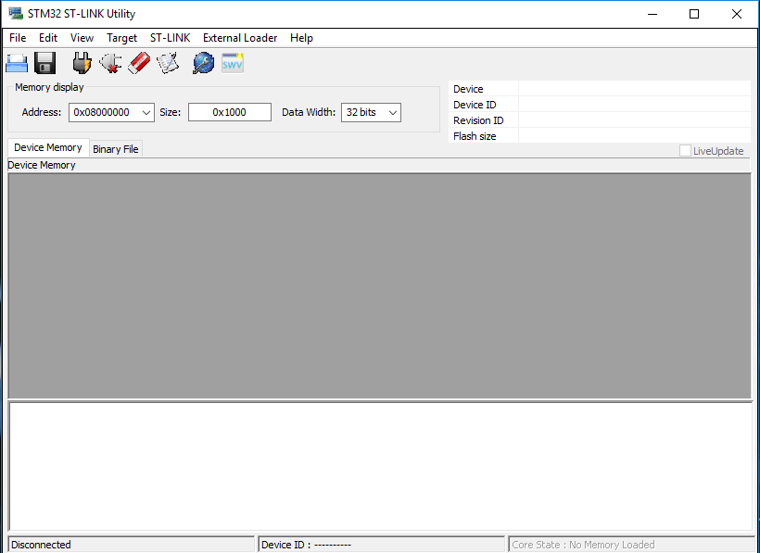

**Figure 73:**  ST-LINK Utility

Two .hex files are provided: AnimalCollar_Large_XX_YY-YY-YY.hex and AnimalCollar_Large_XX_YY-YY-YY.hex, where XX is the revision (e.g. “AA”) and YY-YY-YY is the revision date (e.g., 07-29-19). In the ST-LINK Utility, go to File → Open and navigate to one of these files. Once done, the program will look something like this:

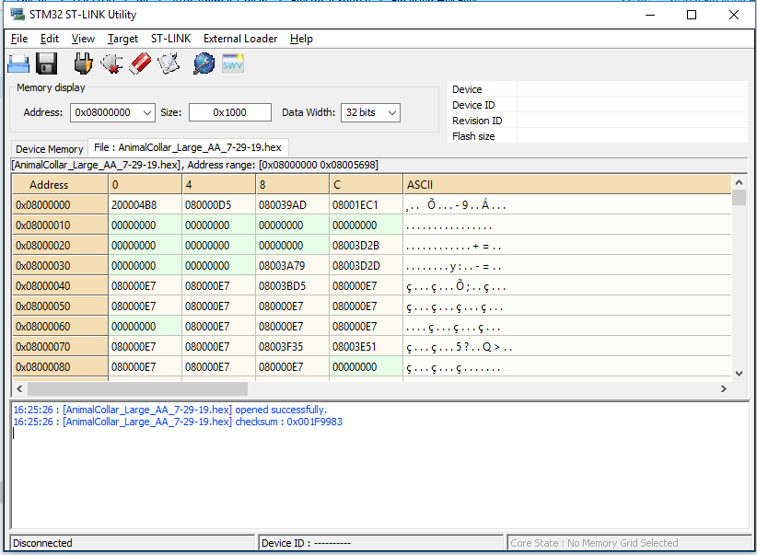

**Figure 74:** ST-LINK Utility with loaded firmware

Next, ensure that the ST-LINK programmer is connected to the PC and the programming board, and the programming adaptor is connected to both the USB-USART dongle and the collar. The printing on the adaptor shows the orientation of the large, 20 pin connector. The arrow shows the location of the bump on the connector.



**Figure 75:** Programming Adaptor Showing Cable Orientation

Although the USB-USART adaptor should’ve been supplied with a cable attached, ensure the following connections are made properly:

**Table 4:** USB-USART & Programming Adaptor Connections

|  |  |
| --- | --- |
| Programming Adaptor | USB-USART Dongle |
| VBUS | 3V3 |
| RX | TX |
| TX | RX |
| GND | GND |

Please note that the TX/RX lines do not match up across devices.

Once the programmer is connected, connect the small ribbon cable to the programming adaptor and the collar. The ribbon connector only connects one way. Once everything is connected, return to the ST-LINK Utility. Go to Target → Settings and ensure “Reset Mode” is set to “Software System Reset.”

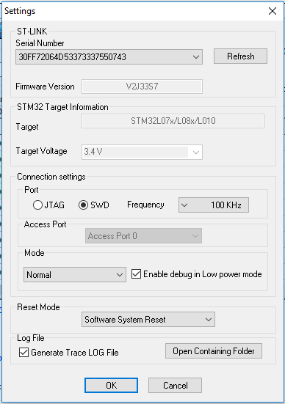

**Figure 76:** Target Settings

Once this is set, go to Target → Program & Verify. A new window will open. Press “Start.”

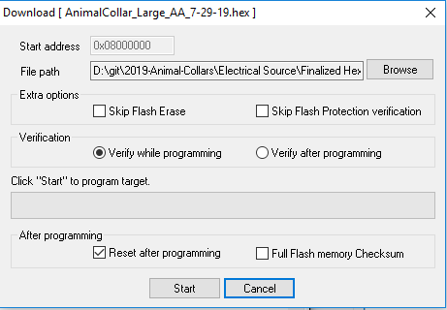

**Figure 77:** Program & Verify Dialog Box

Once this process is finished, the firmware is loaded onto the collar.

## 

## 3.5 Flashing VHF Beacon Software

## 3.5.1 Hardware Required for Programming

For proper configuration of the VHF module, specific hardware is required and is either provided or available in the GVSU engineering laboratories. Programming the module requires the 2019 Animal Collar PCBA, the 2019 Animal Collar Programming adaptor and it’s associated programming cable, the Silicon Labs USB Debug Adaptor, a USB type A to USB type B cable, the MSC-BA4 Burning Adaptor Board, and the cable to interface between the Burning Adaptor board and the 2019 Animal Collar Programming Adaptor.

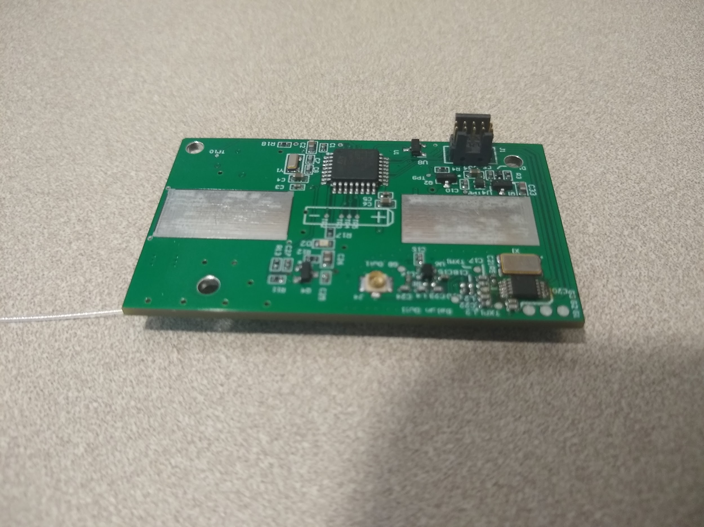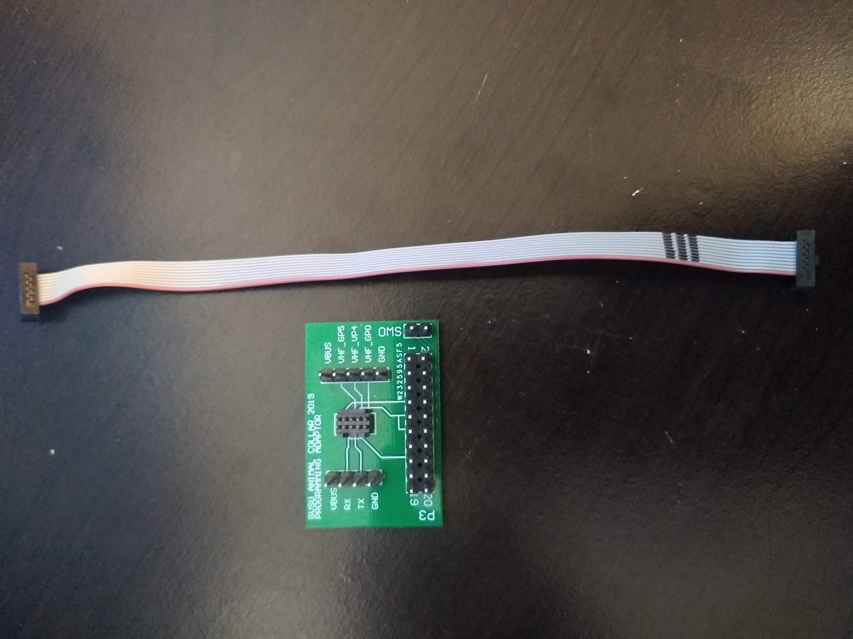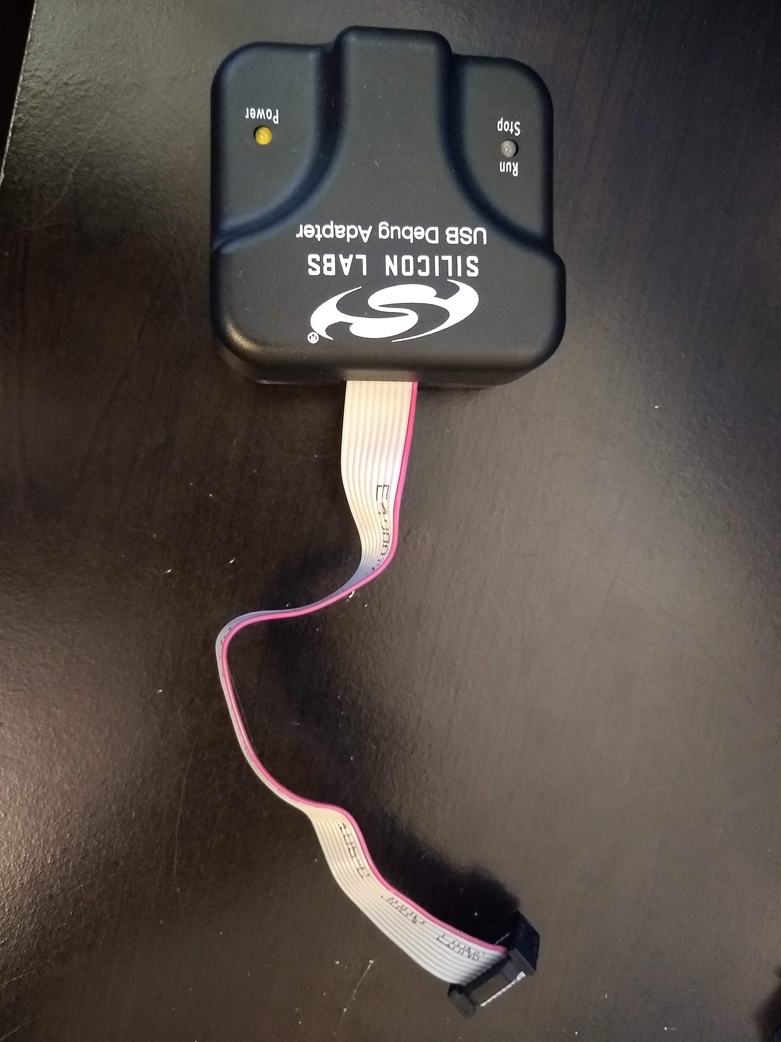

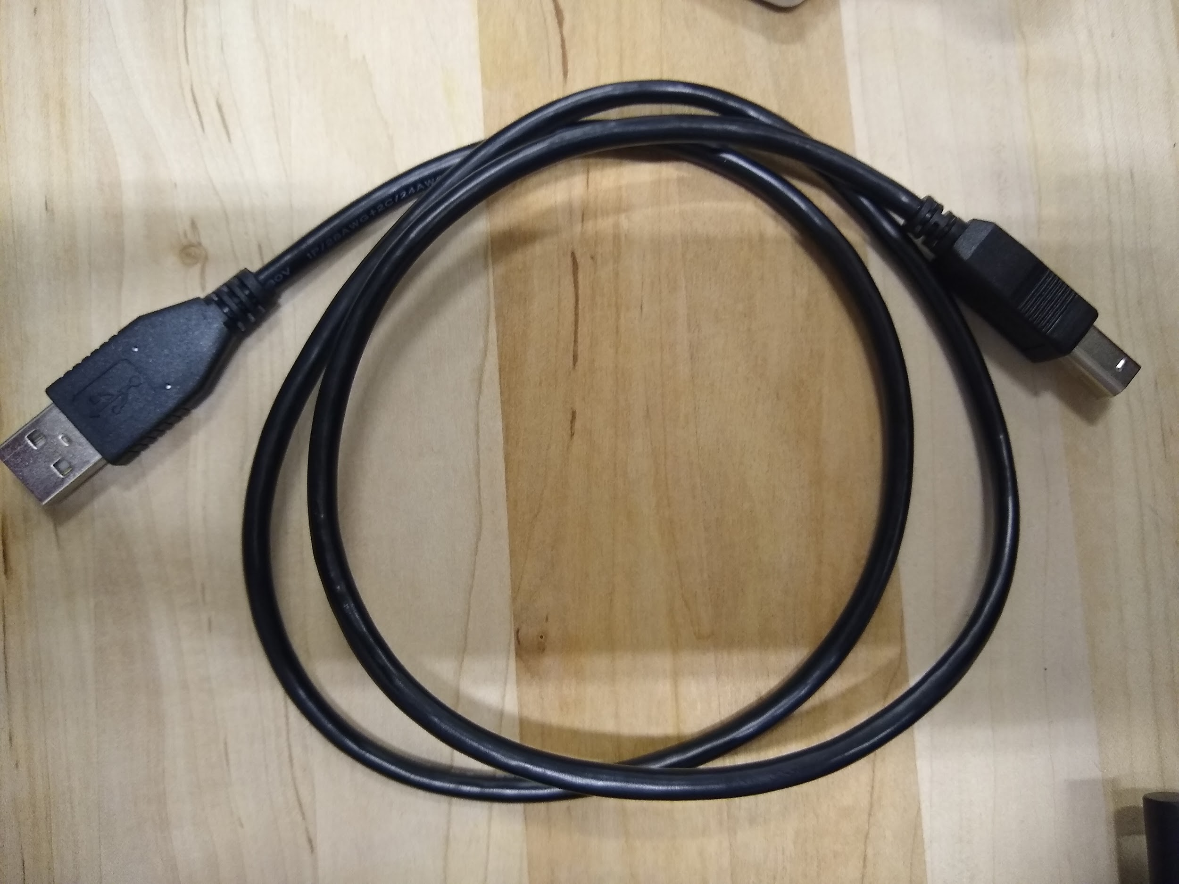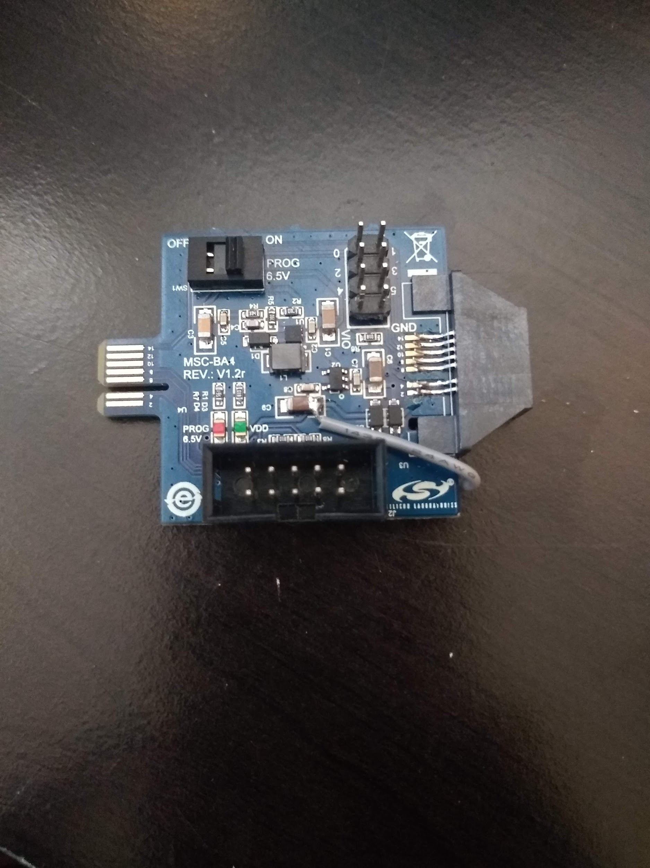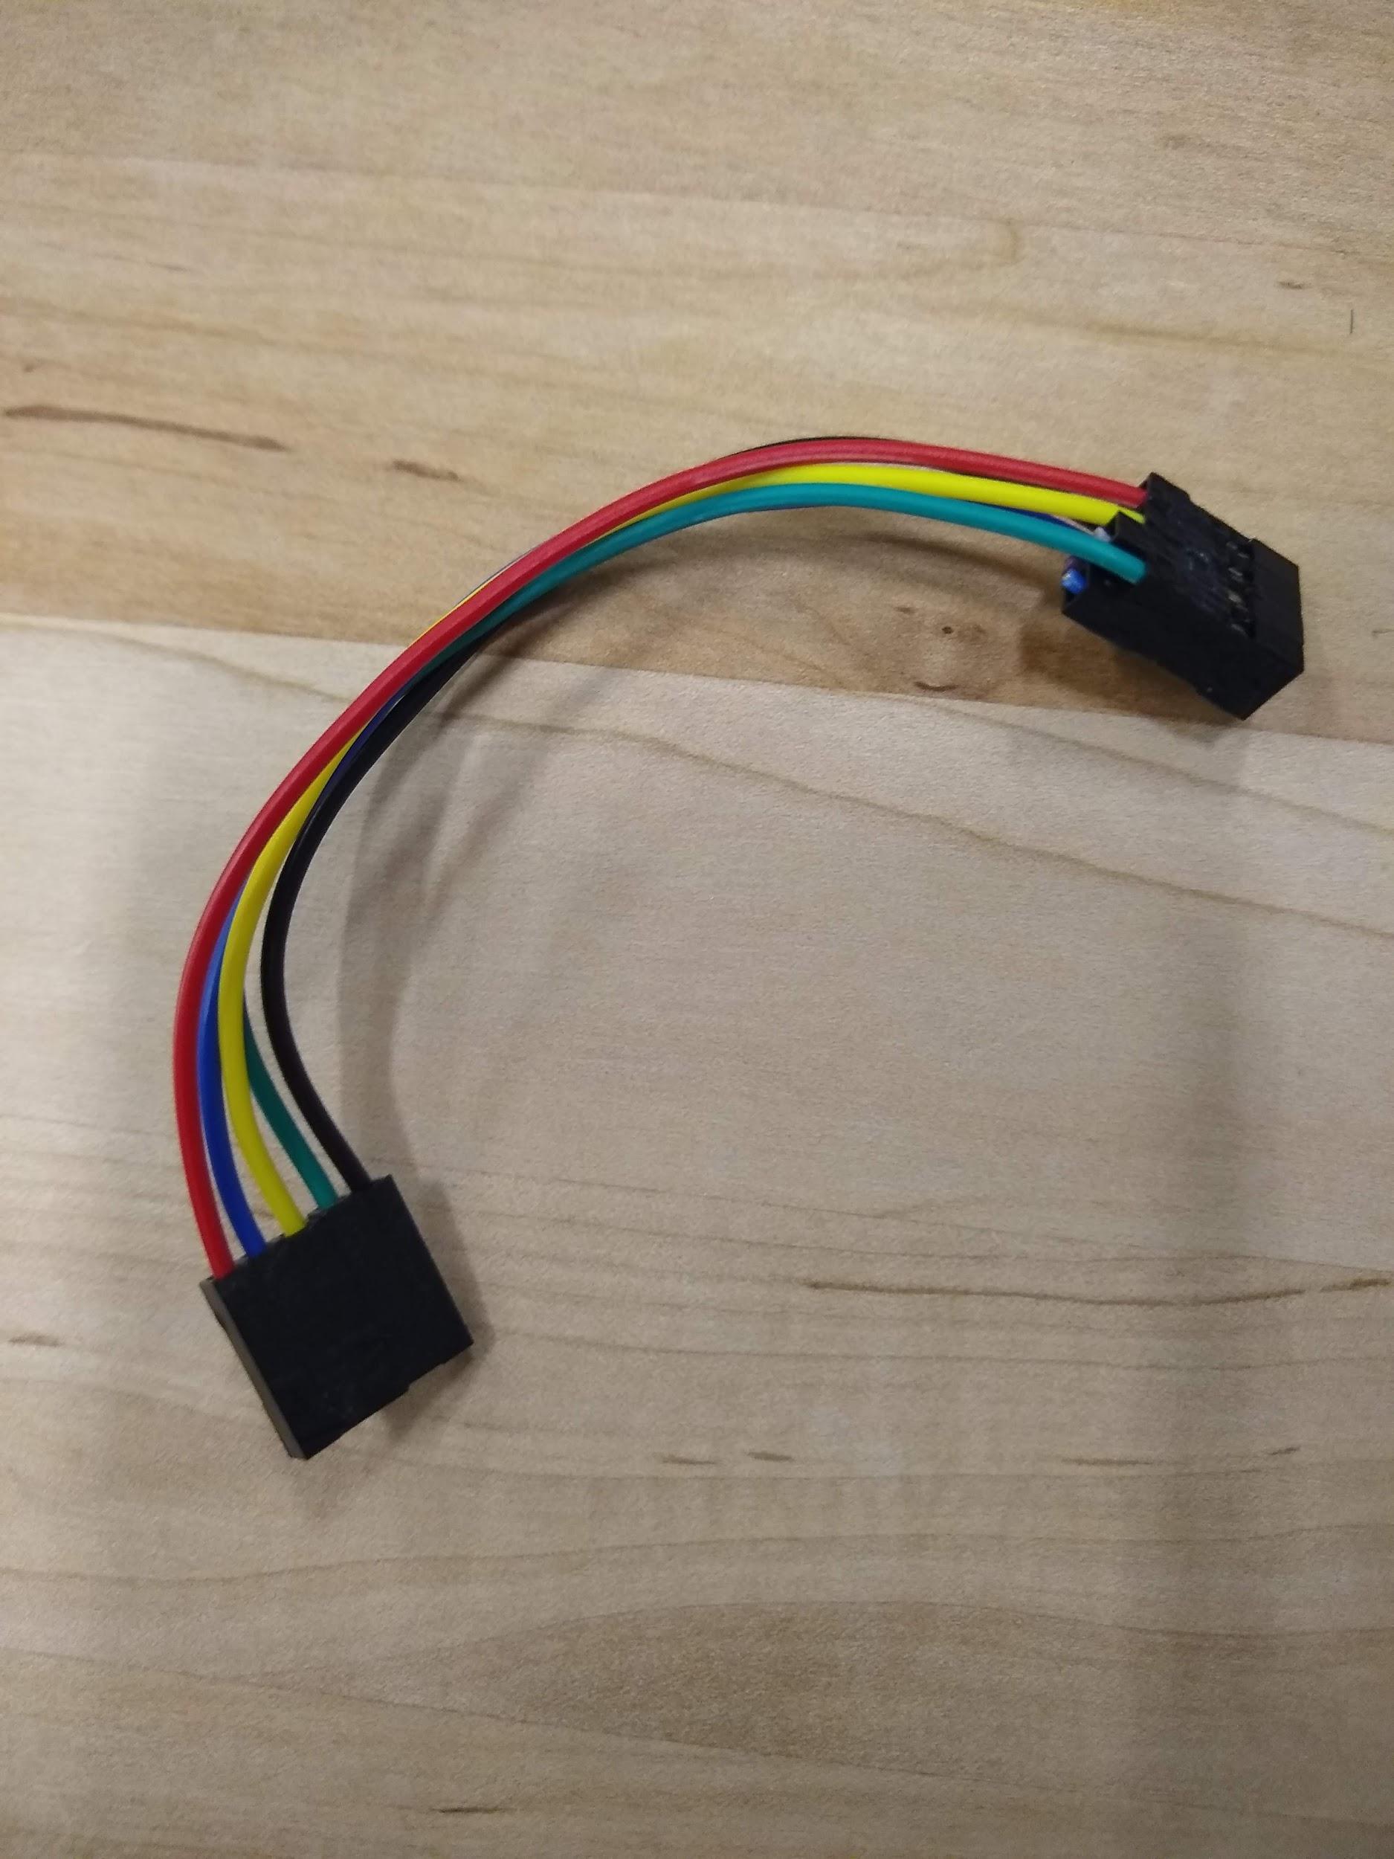

**Figure 78.** 2019 Animal Collar PCBA (top left), 2019 Animal Collar Programming Adaptor with Programming Cable (top middle), Silicon Labs USB Debug Adaptor (top right), USB type A to USB type B cable (bottom left), MSC-BA4 Burning Adaptor Board (bottom middle), Interface cable between Burning Adaptor board and 2019 Programming Adaptor (bottom right)

## 3.5.2 Software Required for Programming

Three programs need to be downloaded to be able to program the VHF module, or they can be loaded directly from the flash drive provided. The programs required are the Silicon Labs IDE, the NVM Programming Utility, and the Keil software used by the Silicon Labs IDE for compiling. If the programs need to be installed, a guide is provided in Section 3.5.7.

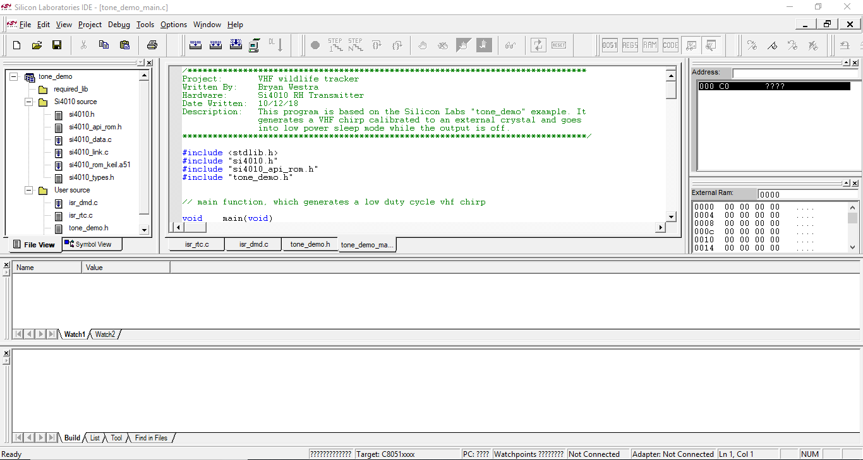 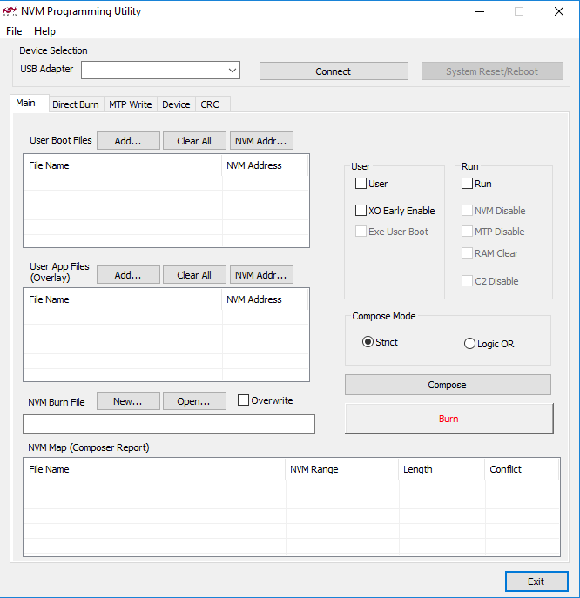

**Figure 79.** Silicon Labs IDE (left) and NVM Programming Utility (right)

## 3.5.3 Hardware Required for Testing

Certain hardware is required to properly test the VHF module to verify that the programming has been done properly. The testing will need the programmed PCBA, a spectrum analyzer, an antenna, and an adapter to attach the antenna to the spectrum analyzer. If a different antenna is used then the adapter may not be necessary, or a different adapter may be necessary.

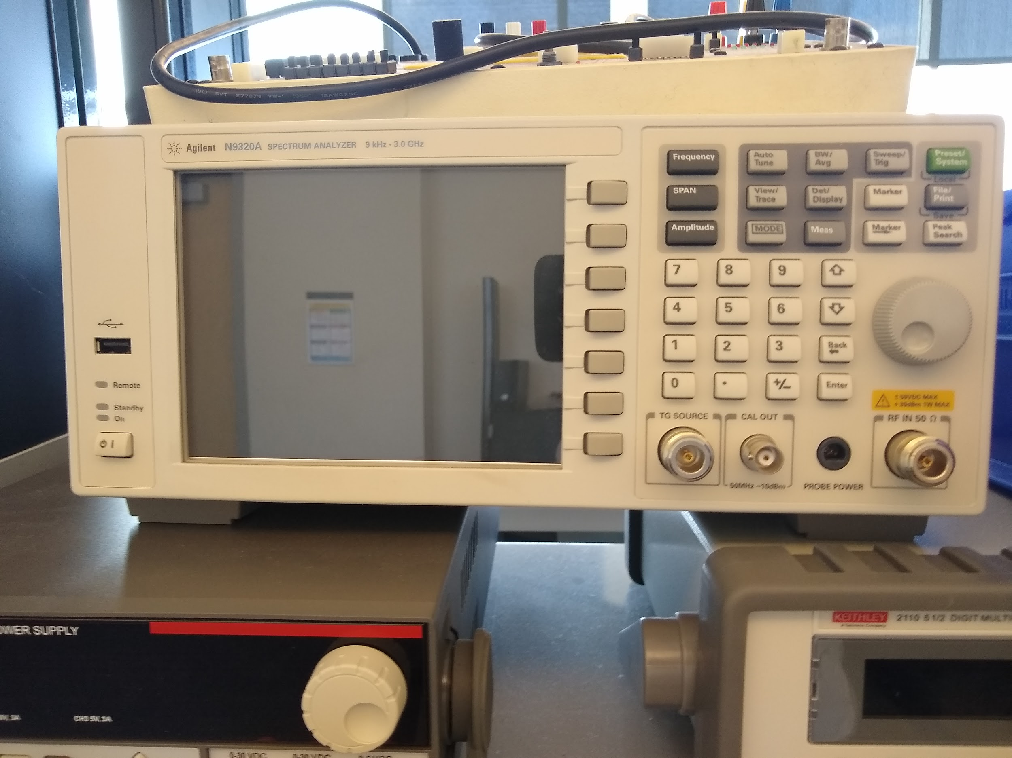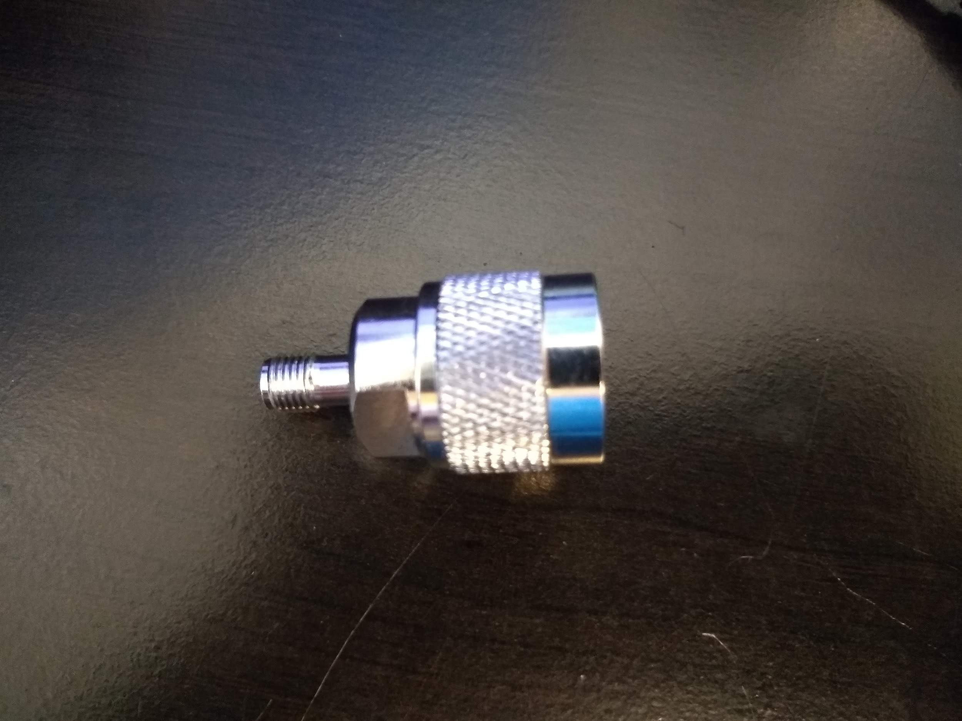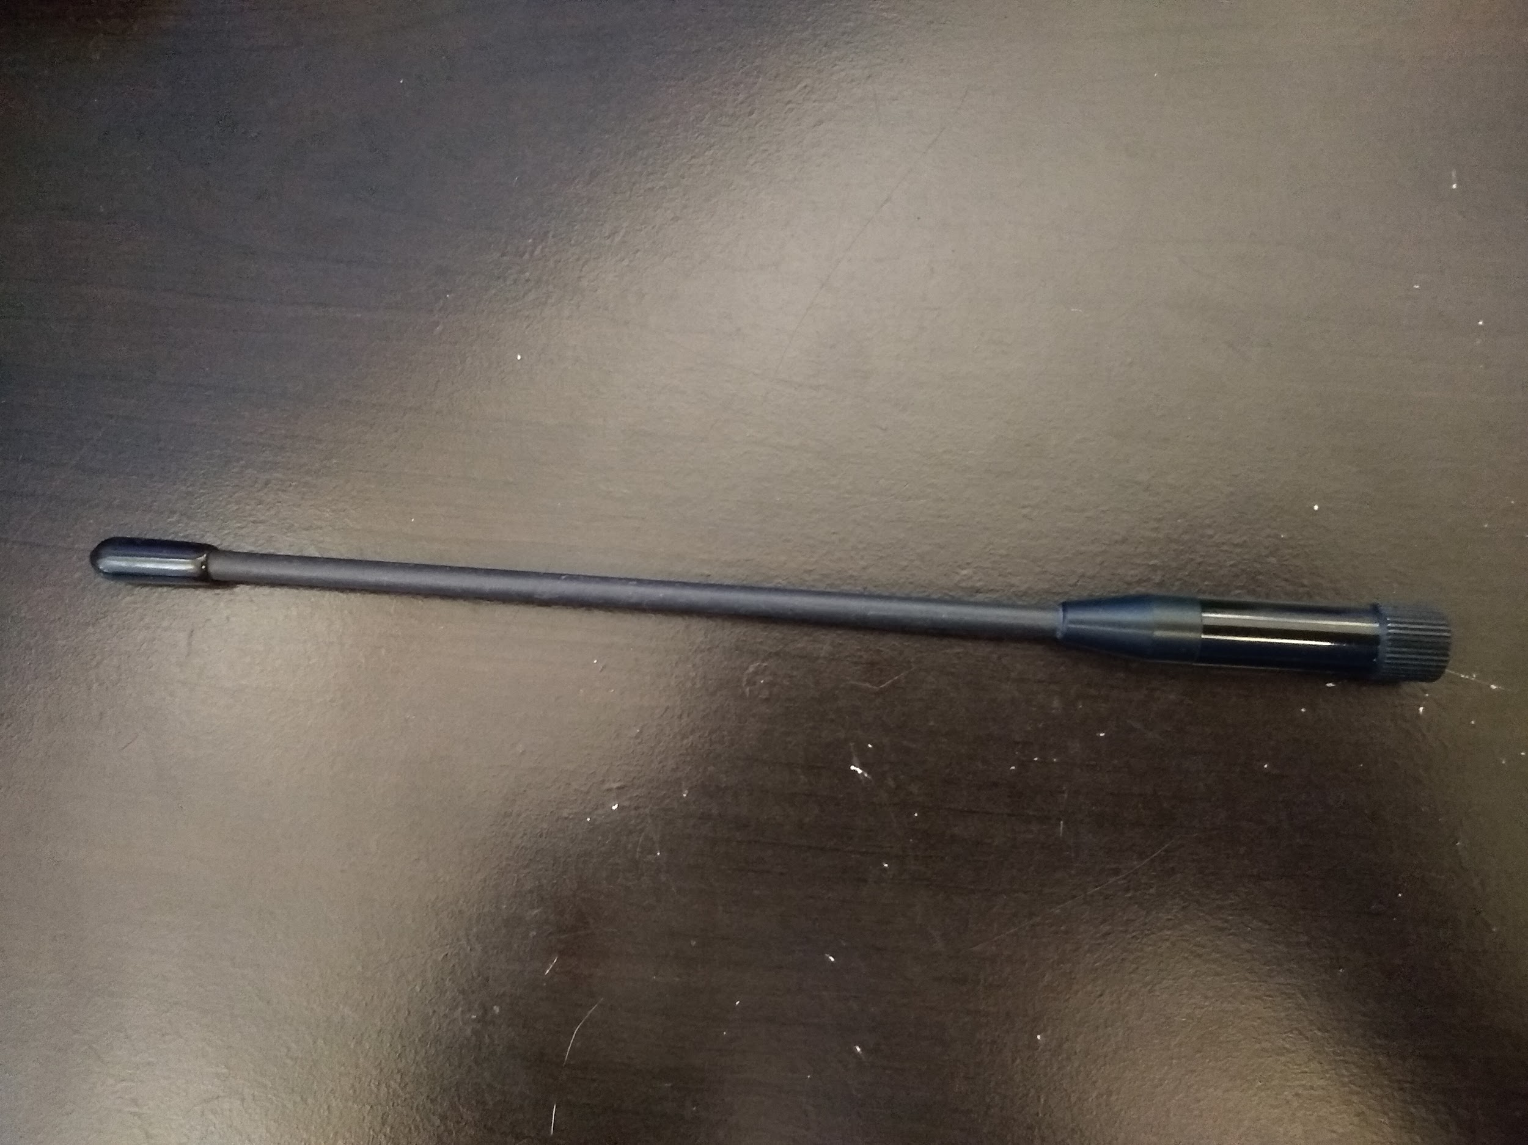

**Figure 80.** 2019 Animal Collar PCBA (top left), Spectrum Analyzer (top right), Antenna Adapter (bottom left), and Antenna (bottom right)

## 3.5.4 Setup for Programming VHF Beacon

Before programming it is necessary to ensure that the animal collar PCBA is properly hooked up to the computer. First, connect the animal collar PCBA to the programming adapter with the programming cable, as shown in figure 80.

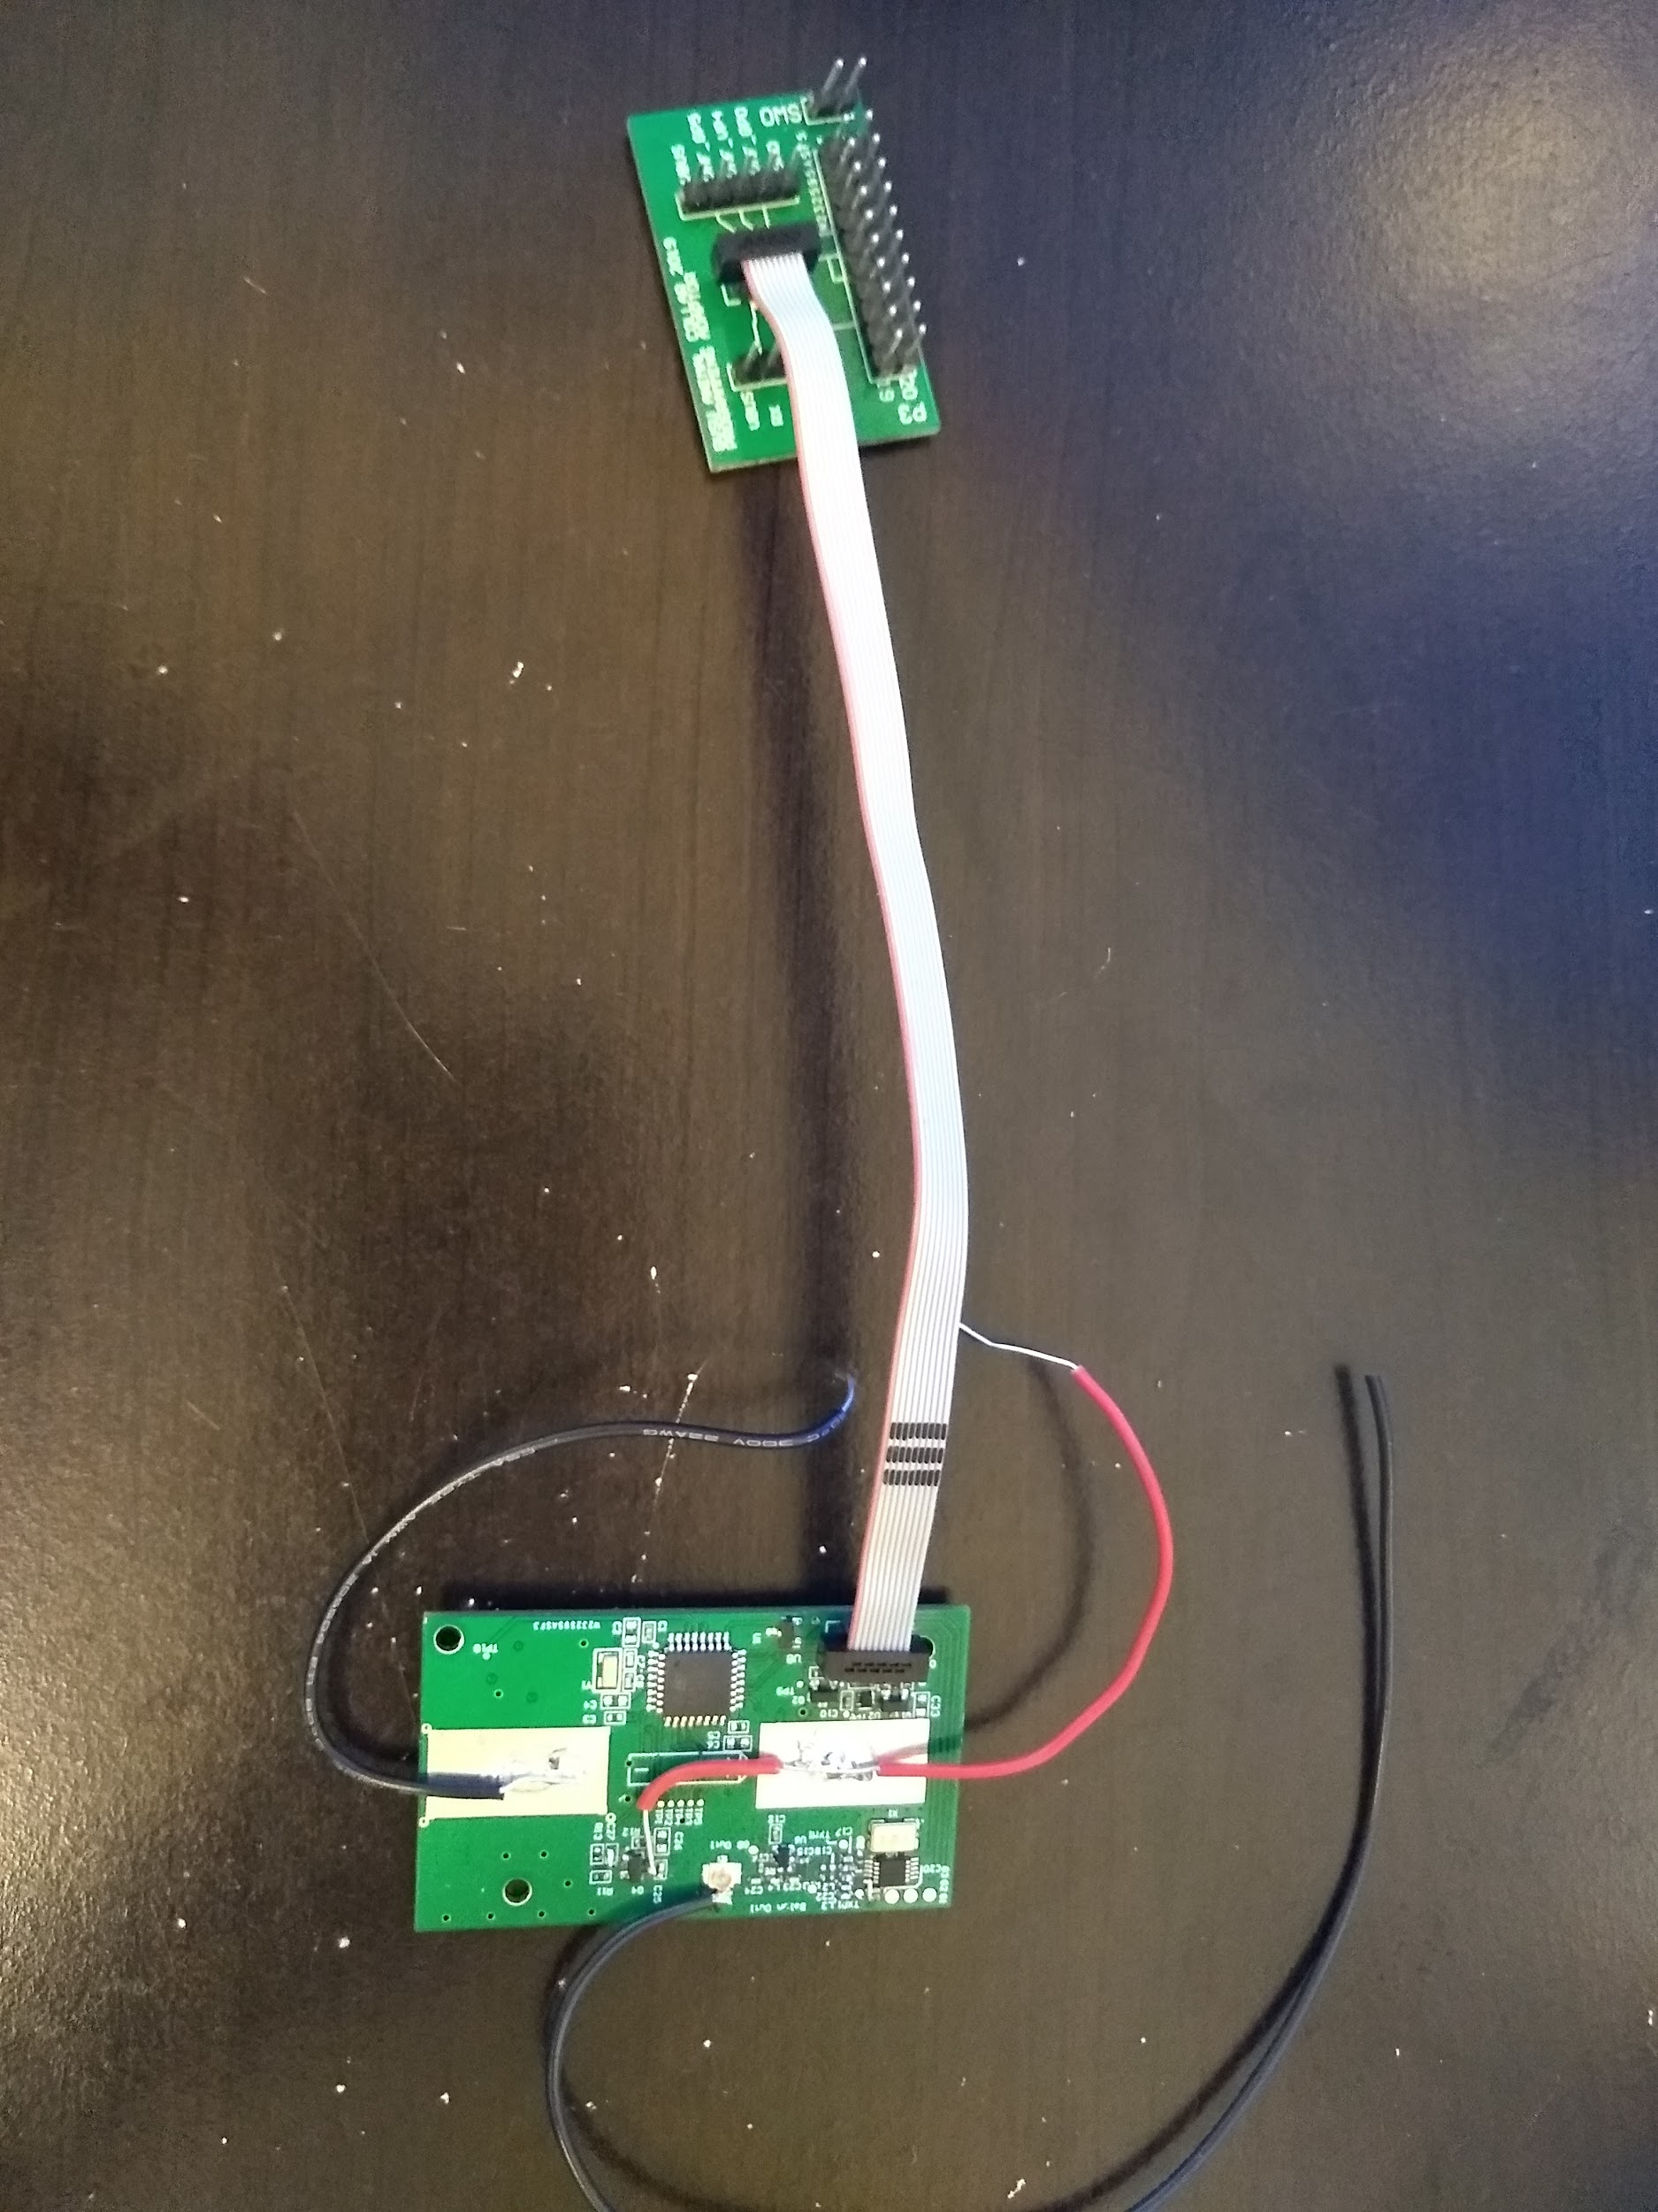

**Figure 81.** Animal Collar PCBA connected to Programming Adaptor

Next, connect the programming adaptor to the burning adaptor board using the provided cable, as shown in figure 81. Ensure that when connected the red wire lines up with Vbus on the animal collar PCBA and VIO on the burning adaptor board and the black wire lines up with GND on both boards. If the provided cable is lost or damaged, it can be replaced with standard pin-to-pin wire connectors. When connecting ensure that Vbus is connected to VIO, VHF_GP5 is connected to 5, VHF_VP4 is connected to 4, VHF_GP0 is connected to 0, and GND is connected to GND.

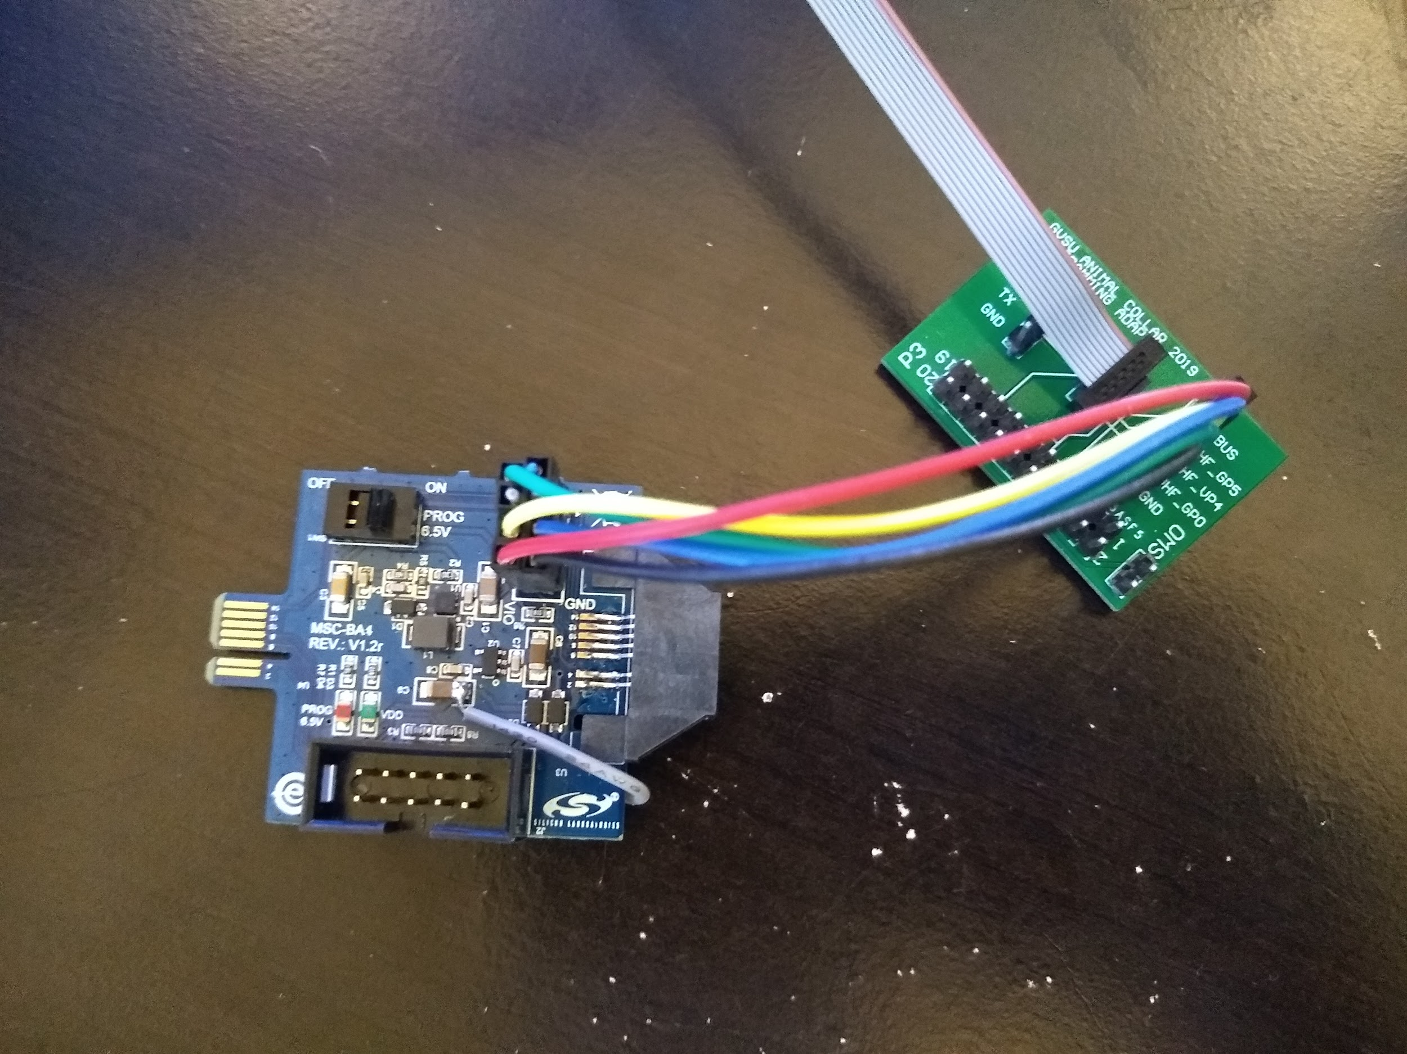

**Figure 82.** Programming Adaptor connected to MSC-BA4 Burning Adaptor Board

Finally, use the cable built into the USB debug adaptor to connect to the burning adaptor board and the USB type B to USB type A cable to connect the USB debug adaptor to the computer, as shown in figure 82.

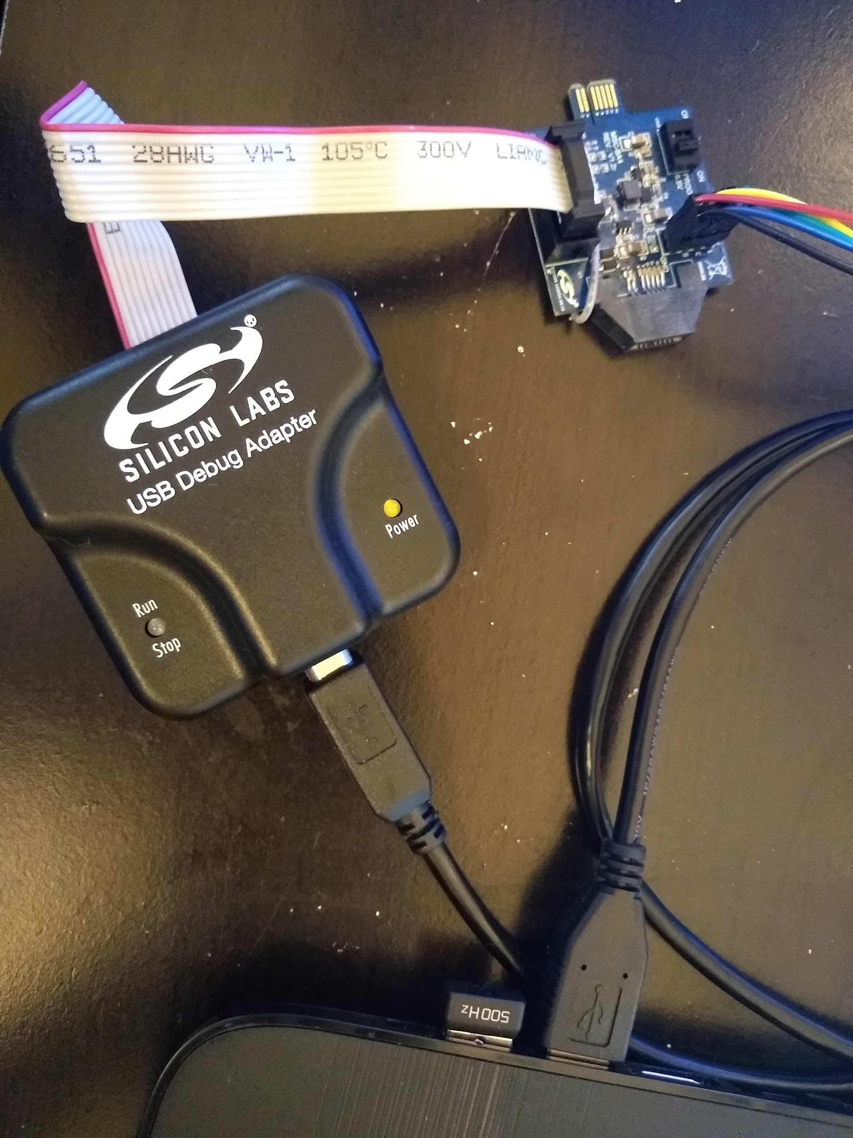

**Figure 83.** Burning Adaptor Board connected to the USB Debug Adaptor connected to the Computer

## 3.5.5 Programming the VHF Module

Once the animal collar PCBA has been properly connected to the computer, open the Silicon Labs IDE. On the top bar, click on “Project” and select the “Open Project” option.

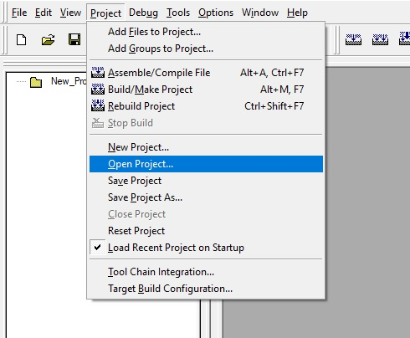

**Figure 84.** Open Project Path

Locate the project named “tone_demo” in the file path and select it. The file path is “VHF” -> “Program_Files” -> “Si4010_Application” -> “bin” -> “tone_demo”.

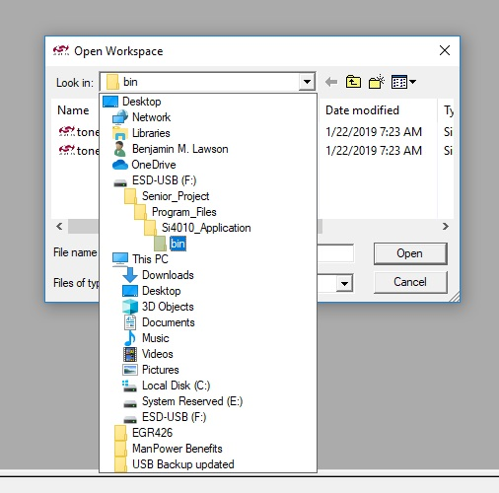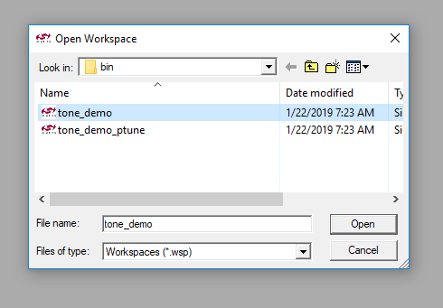

**Figure 85.** Project File Location and Selection

Click “Open”; the file named “tone_demo_main.c” should open automatically. If it doesn’t, locate the file in the project tree on the left side of the window and open it.

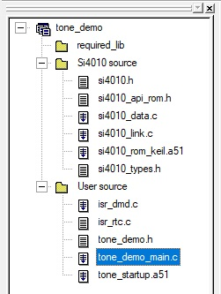

**Figure 86.** Project Tree

Once “tone_demo_main.c” is open, locate the line of code where frequency is set (line 28). Change the frequency to the desired frequency between 148 and 152MHz. **Do not change anything besides the frequency**.

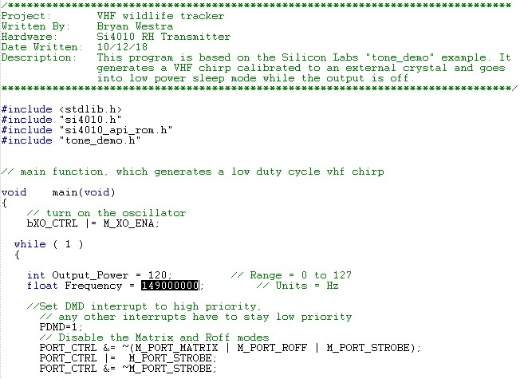

**Figure 87.** Code for Frequency Adjustment

When the desired frequency has been input, save the code. Open “Tool Chain Integration” from the “Project” drop-down window.

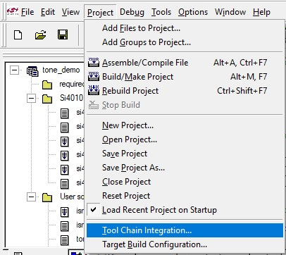

**Figure 88.** Tool Chain Integration Location

Adjust the file paths of the assembler, compiler and linker to match what is shown in the figures below. The only change that will need to be made is to change the letter at the beginning of the file path to match with the actual drive location the USB drive is plugged into (if the program was downloaded and the USB drive is not the source of the IDE, then see section 3.5.7 for the file path configuration).

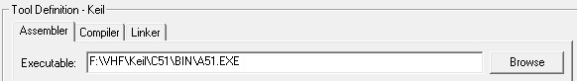

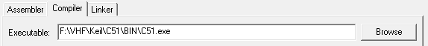

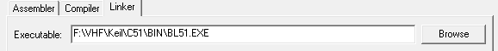

**Figure 89.** File path for Assembler (top), Compiler (middle), and Linker (bottom)

Once the file paths are properly setup, click on the “Build/Make project” button on the options bar.

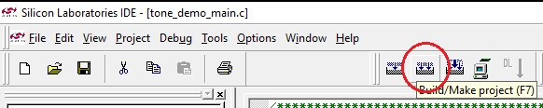

**Figure 90.** Build/Make project Button

When the build is complete a .hex file will be created in the “out” folder with the name “tone_demo.hex”.

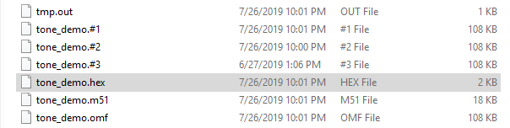

**Figure 91.** Tone_demo.hex file

Once the .hex file has been generated, open the “Si4010_NVM_Burner” program. This software is located in “VHF” -> “NVM_Burner” -> “Si4010_NVM_Burner”. At the top of the program window, click the drop down box for “USB Adapter” under “Device Selection”. This may be filled automatically if the USB Debug Adaptor is properly connected to the computer; if not select “EC3005A03ED” from the drop down box. If no other debug tools are connected to the computer then it will appear as the only option in the drop down box.

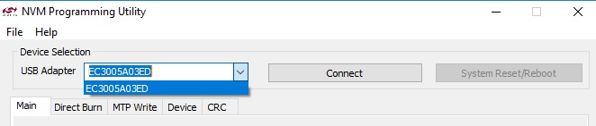

**Figure 92.** USB Debug Adaptor Selection

Once the proper device is selected, click “Connect”. Then click “Add…” next to the box labeled “User Boot Files”. Navigate to the “out” folder and select the “tone_demo.hex” file generated before. The file is located in “VHF” -> “Program_Files” -> “Si4010_Application” -> “out” -> “tone_demo.hex”. Click “Open”. The .hex file should appear in the window under “File Name”.

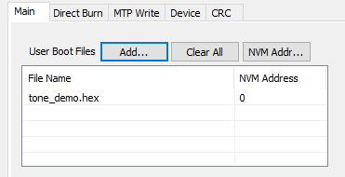

**Figure 93.** Added .hex file

Next, look at the check boxes on the right side of the program window. Check the box labeled “Run” and leave the other boxes unchanged.

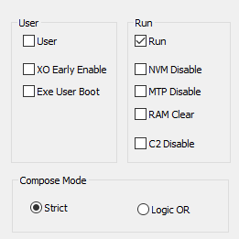

**Figure 94.** Configuration of Check Boxes

The box labeled “User App Files (Overlay)” is left empty. Go to the box labeled “NVM Burn File” and select “New…”. The save location for the new file should default to the “out” folder of the program. Name the file as desired (example: NVM_Burn_149MHz).

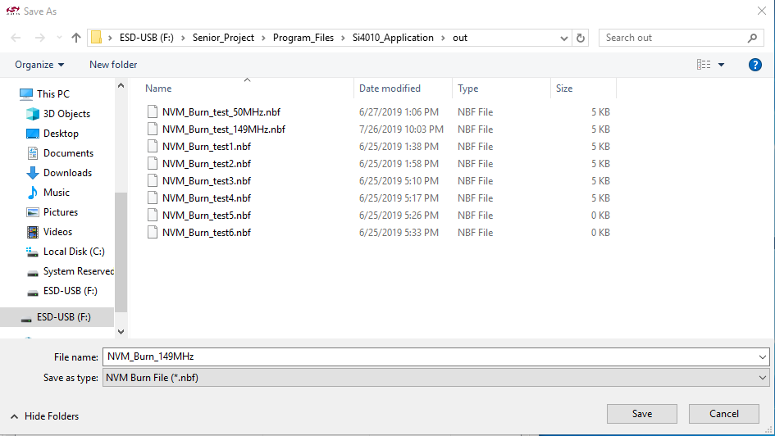

**Figure 95.** Example File Name and Location for NVM Burn File

All of the options and files are now set to program the VHF module. Click on “Compose” and wait a few seconds; a window will appear reading “Compose run completed successfully”. Next click on “Burn” and a progress bar should appear. After a few seconds a window will appear with the message “Burn succeeded”. The VHF module is now programmed and is ready to be tested.

## 3.5.6 Testing the VHF

The frequency that is set in the code for the VHF module does not exactly match the actual frequency output from the device. Therefore, testing on a spectrum analyzer is necessary to obtain the actual output frequency so that the researchers receiver device can be properly tuned. The test equipment used for development testing and that is shown in the figures was located in the GVSU Kennedy Hall of Engineering, in room 344.

First, use the provided antenna and adaptor to connect the antenna to the spectrum analyzer to the port labeled “RF IN 50 Ω”.

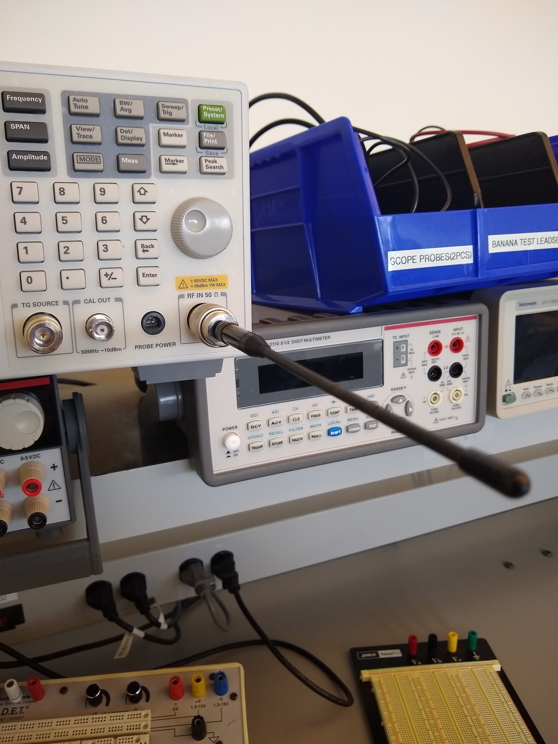

**Figure 96.** Spectrum Analyzer with Antenna Connected

Next, adjust the settings of the spectrum analyzer to match with the programmed frequency. See figure 96 for how to navigate the settings. Set the center frequency to be equal to the programmed frequency, and adjust the frequency span to 100kHz. Adjust the video bandwidth and resolution bandwidth to 1kHz for both settings. Set the trace to max hold and make sure that only one trace is active.

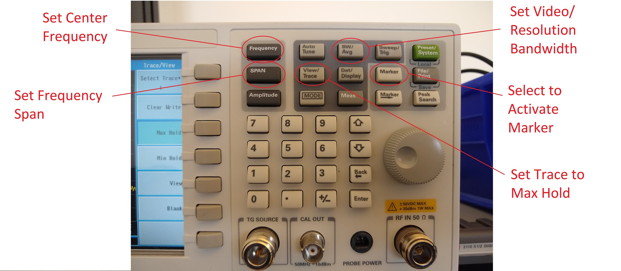

**Figure 97.** Navigation of Spectrum Analyzer

Then, take the Animal Collar PCBA and program it with the VHF test code provided. See the previous section on “Flashing Microcontroller Firmware” for steps to do so. This code will keep the VHF active constantly while disabling all other features of the collar, so be sure to reprogram with the proper Animal Collar software when the testing is done. Provide power to the PCBA by either inserting a AA battery into the battery clips or by using a power supply set to 3.7V and attaching to the battery clips. It may take a few minutes for the spectrum analyzer to pick up the VHF signal due to the duty cycle of the VHF and the scan rate of the spectrum analyzer not matching. When the VHF signal is read by the spectrum analyzer, use the marker to find the peak of the signal, and the frequency of the peak will be the frequency used with the researchers receiver device.

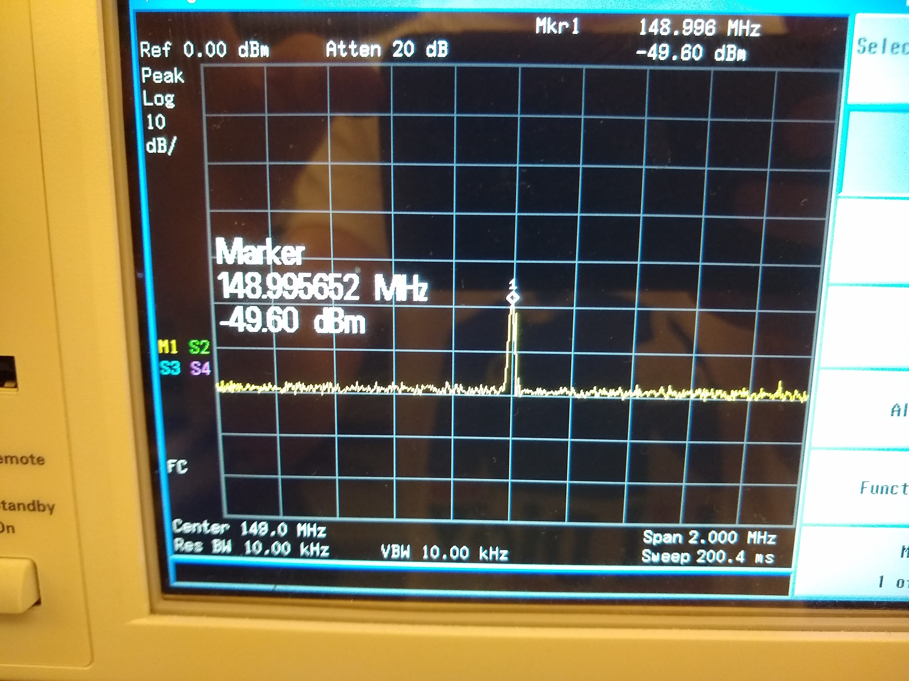

**Figure 98.** Marker Showing the Actual VHF Output Frequency

## 3.5.7 Software Downloads for VHF

If the software for programming the VHF that is downloaded on the flash drive is not working, the software can be downloaded following these steps. To download the Silicon Labs IDE, go to this website:

<https://www.silabs.com/products/development-tools/software/8-bit-8051-microcontroller-software#ide>

Scroll down to the section of the webpage labeled ‘Silicon Labs IDE’. Click on the link for “Download Software”. Follow the steps to download the software. The Silicon Labs IDE does not include its own compiling software, which will need to be downloaded separately. To do so, go to this website:

<http://www.keil.com/c51/ca51kit.asp>

Click on the “Download” button. The website will prompt you to enter your contact information to continue. Once entered it will redirect you to a website with the download link. Click on the link “C51V960A.EXE”. When prompted for selecting the destination folder, make sure that it is “C:\Keil”.

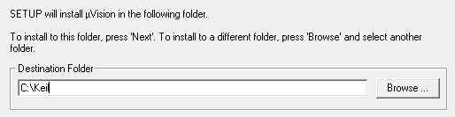

**Figure 99.** Keil C51 Destination Folder

Finish the download. To verify that the compiler was saved in the correct location, open the Silicon Labs IDE and open the “Project” dropdown on the top bar, and then select “Tool Chain Integration…”. Verify that the file path for the “Assembler”, “Compiler”, and “Linker” match with the actual locations of those executables.



**Figure 100.** Tool Chain Integration Location

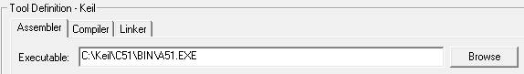

**Figure 101.** Tool Chain Integration Window for File Path Verification

If the file path observed in the Tool Chain Integration window does not match the actual location of the compiler, assembler, and linker executables, either move them into the location set by the file path, or change the file path to match with the actual location of the executables.

To download the NVM Programming Utility, go to this website:

<http://www.silabs.com/Support%20Documents/Software/Si4010_Burn_Tools.exe>

Select where the program should be downloaded to, and click ‘Unzip’. One of the files that was unzipped is the “Si4010_NVM_Burner” program that will program the VHF module.

## 3.6 Setting Device Parameters and Navigating GUI

*\*REFERENCE FIELD RESEARCHER MANUAL\**

## 

## 3.7 Software Overview

\**REFERENCE TO DETAILED DESIGN DOCUMENT\**

# 4. Firmware Troubleshooting

Much of the serial interactions that the software has with the collar can be emulated via a serial terminal. This terminal communication can be used to troubleshoot issues with the collar and program interaction. Some useful commands follow.

**ACK? -** This is the handshake command, when a new com connection is established on the board and it is receiving power from the comport, the device LED starts flashing and it awaits this command. When the command is received it enters full programming mode and the LED remains in an on state. At this point, the collar should respond with “ACK?”

**GPG? -** Get program, this command will return a byte encoded string of 5 characters. These characters are **NOT** ASCII encoded. Instead they are as follows:

1. Flag register of active weekdays (BIT 0 - Monday, BIT 6 - Sunday)
2. Start hour of VHF window
3. End hour of VHF window
4. Hours between fixes
5. Minutes between fixes

These values are encoded via the GUI and the collar program.

**TMP? -** Gets the current timestamp value from the processor RTC.

**CFG?xxxxxxxxxxxxxx? -** Where “CFG?” is the initial command and the “x” field is the serial number of the new collar target. The device will timeout of this command if the serial number is not sent in time.

**GFG? -** Gets the current target serial number of the onboard XBee device.

**GSN? -** Gets the serial number of the XBee device onboard.

**ERS? -** Clears the EEPROM stored address of the current fix write. This effectively clears fix storage

**DTA? -** Returns the properly CSV formatted fix data stored on the device.

Github Repository Information:

The technical user may need to access the documentation, CAD files, code and general documentation through the Github repository.

DO NOT CHANGE THE CREDENTIALS FOR LOG IN, OR IF YOU DO, CHANGE THE DOCUMENTATION TO REFLECT THE NEW PASSWORD.

USERNAME: animalCollar2019

PASSWORD: keenlance2019